© Kevin Horecka 2018

Spatiotemporal Reconstruction and Navigation and Relational Memory in the Hippocampus

By

Kevin Michael Horecka

Dissertation

Submitted in partial fulfillment of the requirements  
for the degree of Doctor of Philosophy in Neuroscience  
in the Graduate College of the  
University of Illinois at Urbana-Champaign, 2018  
  
  
  
  
  
  
  
  
Urbana, Illinois

Doctoral Committee:

Professor Neal J. Cohen, Chair  
 Visiting Principle Research Scientist Rama Ratnam  
 Associate Professor Aron K. Barbey  
 Associate Professor Arne Ekstrom, University of Arizona

# Abstract

<TODO>

*To my wife, friends, and family*

*And*

*All of my mentors and teachers*

# Acknowledgements

<TODO>

Contents

[Abstract 3](#_Toc497155992)

[Acknowledgements 5](#_Toc497155993)

[Contents 6](#_Toc497155994)

[General Introduction 8](#_Toc497155995)

[Domains and Entities: Building Systematic Understanding of Reconstruction 9](#_Toc497155996)

[Properties of Domains 10](#_Toc497155997)

[Properties of Entities 11](#_Toc497155998)

[Illustratability Does Not Define Domains of Information 12](#_Toc497155999)

[Domains Other than Space and Time 12](#_Toc497156000)

[Overview of Properties of Domains and Entities 13](#_Toc497156001)

[2D Spatial Reconstruction – The iPosition Task 14](#_Toc497156002)

[Relational Invariance under Transformations 15](#_Toc497156003)

[Precision and Identity Information 17](#_Toc497156004)

[Sampling and Encoding During Study 18](#_Toc497156005)

[Overview of Chapters 19](#_Toc497156006)

[Reconstructing Relational Information 19](#_Toc497156007)

[Memory during Time Travel: Spatiotemporal Navigation, Contextual Boundaries, and Relational Memory Errors in Virtual Reality 20](#_Toc497156008)

[Spatiotemporal Navigation, Sampling, and Information Encoding in Virtual Reality 21](#_Toc497156009)

[Reconstructing Relational Information 23](#_Toc497156010)

[Introduction 23](#_Toc497156011)

[Materials and Methods 26](#_Toc497156012)

[Participants 26](#_Toc497156013)

[Experimental Paradigm 27](#_Toc497156014)

[Identity Remapping 29](#_Toc497156015)

[Global Error Transformations 29](#_Toc497156016)

[Location Placement Evaluation 30](#_Toc497156017)

[Compound Identity Error Evaluation 31](#_Toc497156018)

[Gestalten Shape-Like Information 32](#_Toc497156019)

[Statistical Analysis 33](#_Toc497156020)

[Reanalysis of Watson et al. (2013) Set Size Data 33](#_Toc497156021)

[Results 33](#_Toc497156022)

[Differences in Misplacement Accounted for by Global Errors 33](#_Toc497156023)

[First-Order and Higher-Order Relational Errors 35](#_Toc497156024)

[Differences in Accuracy of Item-Location Associations across Set Sizes 36](#_Toc497156025)

[Discussion 37](#_Toc497156026)

[Memory during Time Travel: Spatiotemporal Navigation, Contextual Boundaries, and Relational Memory Errors in Virtual Reality 42](#_Toc497156027)

[Introduction 42](#_Toc497156028)

[Methods 44](#_Toc497156029)

[Participants 44](#_Toc497156030)

[Design and Procedures 44](#_Toc497156031)

[Analysis Metrics 45](#_Toc497156032)

[Statistical Analysis 46](#_Toc497156033)

[Results 46](#_Toc497156034)

[Overall Accuracy 46](#_Toc497156035)

[Relational Memory Errors 47](#_Toc497156036)

[Temporal Context Boundary Effects 48](#_Toc497156037)

[Discussion 50](#_Toc497156038)

[Spatiotemporal Navigation, Sampling, and Information Encoding in Virtual Reality 53](#_Toc497156039)

[Introduction 53](#_Toc497156040)

[Methods 56](#_Toc497156041)

[Participants 56](#_Toc497156042)

[Design and Procedures 56](#_Toc497156043)

[Proposed Navigation Analysis Metrics 58](#_Toc497156044)

[Proposed Order Analyses 59](#_Toc497156045)

[Statistical Analysis 60](#_Toc497156046)

[Results 60](#_Toc497156047)

[Overall Accuracy and Navigation 60](#_Toc497156048)

[Proposed Navigation Analysis Metrics Predictions 60](#_Toc497156049)

[Proposed Order Analyses Predictions 60](#_Toc497156050)

[Discussion 61](#_Toc497156051)

[General Discussion 63](#_Toc497156052)

[Summary of Results 63](#_Toc497156053)

[Separable vs. Separate Hippocampal Representations 65](#_Toc497156054)

[Artificial Intelligence and Spatial Reconstructions 65](#_Toc497156055)

[Behavioral Inference, Sampling, and Task Richness 66](#_Toc497156056)

[Conclusion 67](#_Toc497156057)

[References 68](#_Toc497156058)

# General Introduction

There are numerous ways to quantify memory efficacy, but when it comes to recollective memory few methods are richer or more detailed than navigation (Eichenbaum, 2017b) and reconstruction tasks (Huttenlocher & Presson, 1979). Reconstruction tasks ask individuals to study some set of information and then, after a delay, recreate the information they saw it. Traditionally, individuals are given a set of items which are to be reconstructed in space (Jeneson, Mauldin, & Squire, 2010; M. Lou Smith & Milner, 1981; Watson, Voss, Warren, Tranel, & Cohen, 2013). The strength of these paradigms is that not only can one assess which aspects of the original information were or weren’t remembered, but also the degree to which they were remembered, as well as whether there are any systematic distortions in that memory. Ultimately, we are unable to know what precise thoughts, strategies, or information the participant did or did not have when performing the task just from the behavioral data, but by carefully picking the assumptions we are willing to make, we can strongly infer what was not done in the reconstruction (because if it were, the performance should have been better). Moreover, by systematically analyzing the performance in reconstruction, we can begin to hypothesize new models and test existing models of memory organization (Eichenbaum, 2016) and representation (Eichenbaum, 2004, 2017a; O’Reilly & Rudy, 2001; Schapiro, Turk-Browne, Botvinick, & Norman, 2017) across many different domains of information (Konkel, Warren, Duff, Tranel, & Cohen, 2008).

In addition to a theoretical introduction to assumptions and perspectives on reconstruction tasks, the work presented in this document will show how performance on reconstruction tasks can be broken down into specific and sensitive metrics of performance to elucidate some aspects of memory in two particular domains, space and time. Relational memory theory posits that the hippocampus is critical for the binding of arbitrary relations into rich memory representations, as well as for the flexible usage of these representations, regardless of the domain from which the information originates (Neal J. Cohen & Eichenbaum, 1993; Monti et al., 2015). Previous work has shown that binding of the identity of an item to a location in space (i.e. identity-location binding) may be one critical example of an arbitrary relation which is severely impaired in hippocampal damaged patients (Watson et al., 2013), with other accounts suggesting that not all relational information is impaired without specifying the precise nature of the deficits (Jeneson et al., 2010). Though these previous accounts hinted at specific aspects of information in reconstruction being impaired and spared, the analysis methods differed significantly, making it difficult to determine the precise nature of the deficits in reconstruction in hippocampal damaged patients. The work presented here attempts to reconcile these accounts with a novel methodological framework constructed from a principled approach to reconstruction data. The data show that certain (but not all) *types* of relational information are impaired in hippocampal damaged individuals (Chapter 1), but, critically, arbitrary identity-location information is impaired (i.e. the information was not derivable from other relations or elements which may have been remembered) while the location information (i.e. the ability to reconstruct items in studied locations regardless of the identity of the item) is not. This runs somewhat contrary to the historical account of the primary function of the hippocampus being in mapping space (see Eichenbaum & Cohen, 2014 for a more detailed discussion of the spatial versus declarative account).

Additionally, in a separate reconstruction task (Chapter 2), the data presented here show that in healthy adults, there may be differences in how representations of spatial vs. temporal information are structured. This deeply relates to the debate over the overall function of the hippocampus, especially since the recent identification of time cells in the hippocampus (Eichenbaum, 2014; B. Kraus, Robinson, White, Eichenbaum, & Hasselmo, 2013), which showed definitively that the cellular function of the region is not dominated exclusively by spatial representations. Finally, in either domain, additional sources of information (such as contextual information) can bias representations (Ezzyat & Davachi, 2014; Zacks, Speer, Swallow, Braver, & Reynolds, 2007a), and these additional sources of information are critical in understanding the overall organization of memory and the hippocampal system, with most modern models of the region including cortical region interactions which involve the addition of these additional information sources (Kumaran, Hassabis, & McClelland, 2016; Sederberg, Howard, & Kahana, 2008; Wang, Cohen, & Voss, 2015).

Finally, although most of the aforementioned work focuses primarily on representation and retrieval, the encoding stage of the task (i.e. study) is an equally critical element in overall performance. In previous work involving spatial sampling, eye movements, which are often thought of as “visual exploration” of an environment/scene (Voss, Bridge, Cohen, & Walker, 2017), in hippocampal damaged individuals and healthy individuals indicated both memory for an entire previously viewed scene and relations among elements in the scene; however, when the relations between items were changed, only healthy individuals showed differences in eye movements relative to the change, while hippocampal damaged patients did not (Neal J. Cohen & Banich, 2003). Similar sampling deficits in spatial navigation have been shown in rodents with hippocampal damage in the Morris Water Maze (R. G. M. Morris, Garrud, Rawlins, & O’Keefe, 1982). However, more recent work in humans shows that this deficit in navigation may be exclusive to precise, high-resolution information as humans with hippocampal damage in a Virtual Morris Water Maze were able to navigate to the correct quadrant of the spatial area but were impaired in finding the precise location of the target (Kolarik et al., 2016; Kolarik, Baer, Shahlaie, Yonelinas, & Ekstrom, 2017). The hippocampus’ role in spatial navigation has been compared extensively across species (especially rodents and humans), and the subject is still hotly debated (Eichenbaum, 2017b). However, as stated in the previous paragraphs, hippocampal function is not exclusive to spatial processing and is critical for all domains of information. As such, this work (Chapter 3) examines exploration and navigation in a domain which has never been examined before, the temporal domain. Temporal exploration (aka Time Travel) may seem like a farfetched idea, but as many other authors all the way back to Tulving, 2002a have said, memory is time travel, with further evidence that MTL neurons “jump back in time” in response to repeated stimulus (Howard, Viskontas, Shankar, & Fried, 2012).

## Domains and Entities: Building Systematic Understanding of Reconstruction

As the bulk of this work focuses on reconstruction (with navigation and sampling serving as the study component to reconstruction), it is critical that we form a more comprehensive understanding of the informational content which can be inferred (or not) from behavioral reconstruction data. Previous explorations of reconstruction have attempted this within working memory (Jeneson et al., 2010) and even relational memory (Watson et al., 2013) theoretical frameworks, but neither approached the reconstruction analysis from the ground up with an attempt to make minimal assumptions in a principled way. In order to be more systematic about our effort to understand reconstruction, we should first break down our problem into its most fundamental components. By establishing a confident understanding of the basic elements of reconstruction, we can better decide upon the appropriate assumptions and strengthen our inferences. First, we can define reconstruction, in its most basic form, as containing two main components: a *domain,* which can have a variety of properties which we will outline shortly; and *entities* which are embedded in this domain which, themselves, can have a variety of physical and categorical properties. It is interesting to see the similarities between this classification and the dorsal and ventral “where” and “what” pathways of the perceptual system, which converge in the hippocampal system (Insausti, Amaral, & Cowan, 1987; Squire & Zola-Morgan, 1991; Van Hoesen, Rosene, & Mesulam, 1979). While, of course, multiple types of domains and entities interact in memory, for the sake of our understanding of the memory representations which are involved in reconstruction, it is helpful to at first restrict our focus to instances in which only one domain and one type of entity are present, at least when developing our methodological and theoretical framework.

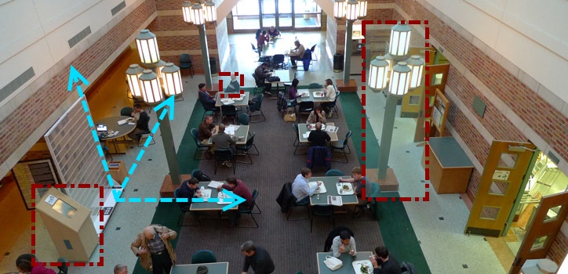

Figure 1. The Beckman Institute; an example of a 3D spatial domain populated by numerous entities which occupy specific points in space and have various identities. Red squares highlight entities which occupy the spatial domain. Some occupy fixed locations while others move at different time scales. The blue arrows illustrate the three spatial dimensions which comprise the spatial domain.

#### Properties of Domains

Let us take a specific example to which we can link the abstract terms defined in the previous paragraph to clarify their meaning. Imagine a 2D spatial domain on a table. Within this spatial domain exist items, i.e. discrete entities which have a precisely defined location on the table and locations relative to one-another. If we consider the number of restrictions we have already made, we can begin to understand how difficult the problem of a systematic breakdown of reconstruction is. First, the reader may have implicitly assumed (likely, rightfully so due to my examples) that the 2D space in question is finite. However, this was never explicitly stated. An infinite space opens up a variety of new problems of scale and geometry which we may or may not want to address. For example, is this space a toroidal ring like we see in video games such as the classic, Asteroids (Wolf, 2010)? Is it a 2D space wrapped on a sphere like we experience on maps from day-to-day (i.e. the earth; Snyder, 1987)? Similarly, although I have explicitly defined the number of dimensions, I was not clear on the topology and geometry of these dimensions. Is this a Euclidean space? A hyperbolic space (a la a Penrose diagram in theoretical physics; Hawking & Ellis, 1973) where distance becomes asymptotically large as I approach the boundaries? Or something more exotic (Coxeter, 2008)?

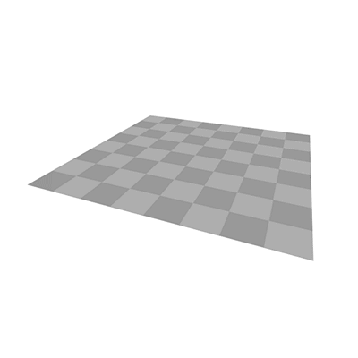 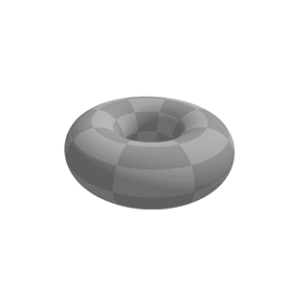 

Figure 2: Examples of spaces with different geometries. Euclidean, toroidal, and hyperbolic. From <http://blog.andreahawksley.com/170517301/> originally and latest from <https://en.wikipedia.org/wiki/File:Torus_from_rectangle.gif> and <https://en.wikipedia.org/wiki/File:H2chess_246a.png> . Also see <https://upload.wikimedia.org/wikipedia/commons/c/cb/Hyperbolic_domains_3222.png> .

Properties of Entities  
Now what of the entities? They have already been restricted to have a precisely defined location, so entities which occupy multiple locations simultaneously have been eliminated. However, do the entities have identities or are they anonymous? Are they equally likely to be positioned in the center of the space or near the boundaries? Can they be positioned in precisely the same location? Many of these questions are simply assumed to be answered a particular way when the experiment could have just as easily been designed another way. These systematic assumptions that both experimenter and participant make may seem unimportant as, if both parties make the same assumptions, it should not confound the results. However, what of participants which are unable to remember some information due to an impairment like hippocampal damage? Perhaps, without the ability to precisely remember information about the locations of the entities, patients with hippocampal damage will fall back to these core assumptions and perform the task via heuristic. There is mounting evidence that hippocampal damage impairs precision in spatial memory (Kolarik et al., 2016, 2017; Yonelinas, 2013a), so this suggestion is not farfetched. How accurate can one be with only the heuristic that items will not often be near the boundary and will never be too close together? Alternatively, patients might actually be able to maintain relational information of some sort via alternative methods. Patients might, for instance, remember Gestalten perceptual features, i.e. configural features which constitute parts of a unified whole, rather than specific types of relations in order to reconstruct (Corsi, 1972; Kessels, van Zandvoort, Postma, Kappelle, & de Haan, 2000; Uttal & Chiong, 2004). Although we might be tempted to call heuristic performance “random”, or perceptually based performance “imprecise”, by acknowledging when our own assumptions of our task might become violated in a systematic way, we might gain insight into the sorts of information processing which are and are not impaired with damage to certain brain regions, and, by extension, we may better understand neural information processing as a whole.

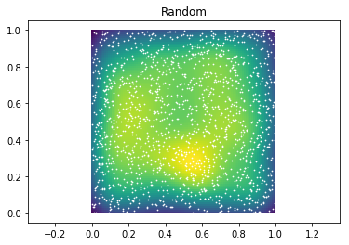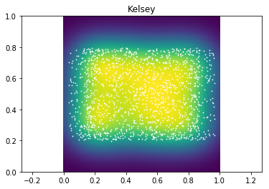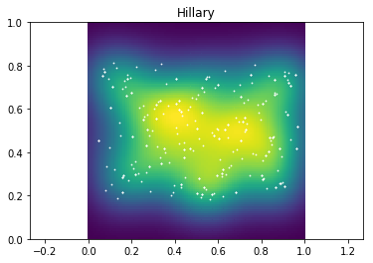 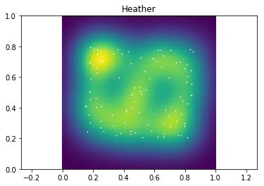

Figure 3: Examples of heatmaps of item placement with different constraints. From left to right: random placement, random placement with aspect ratio constraint, random placement avoiding boundaries, random placement with a distance constraint (i.e. items must be a certain distance apart).

#### Illustratability Does Not Define Domains of Information

Another critical assumption often made in reconstruction is the types of domains and entities which might be involved. Typically, reconstruction tasks have involved space (as illustrated above) and items (sometimes with identities). However, this is, once again, an arbitrary imposition on what reconstruction is, especially given the evidence that the hippocampus is critical for all domains of information (Konkel et al., 2008). Before enumerating examples of domains and entities which go beyond these examples, it’s useful to take a moment to consider why space (and sometimes time) may be so dominant. Reality, as we observe it, is intrinsically experienced in 3 spatial dimensions and 1 temporal dimension. All information of any type which we observe will exist, embedded in these 4 dimensions. This is often used as an argument as to why these must be the critical dimensions to neural systems, and perhaps, on some level, they are. However, it is incredibly restrictive to allow the definitions of domains which could be encoded to only be those which can be illustrated. Illustration requires, by its very nature, embedding whatever domain or idea is being observed into the observable 4D world. However, the set of all possible representable information need not be bound to what can be illustrated. An analogous situation happens when we imagine the dimensionality of data. We cannot easily illustrate data beyond 3 dimensions (see Abbott, 1884 for a playful exploration of attempting to visualize alternate numbers of dimensions). We can add color, animation, shape, size, and all sorts of other illustrative methods, but we can always add more dimensions to the data. If we stopped accepting dimensions beyond those that can be illustrated as easily as we stop accepting domains of information, much of the powerful mathematics used in the world today would be out of our reach. It is not a necessary precondition for a brain to represent information which can be illustrated.

#### Domains Other than Space and Time

Social space, as defined by the relative affiliation and power between individuals (Eichenbaum, 2015; Tavares et al., 2015), is another possible abstract space and has been investigated in the context of hippocampal function, finding that hippocampal fMRI activation located characters in a 2D power-affiliation “map”. Color can be thought of as an abstract space independent of space and time (Warren, Duff, Cohen, & Tranel, 2015). Of course, it is tempting to fall back into old habits and think of color as being on a 1D line, with the x axis defined as hue, and social space being illustrated via a scatter plot in 2 dimensions. These are useful illustrations, but domains of information are only illustrated to help us understand them. Their illustration does not define them. Additionally, although time has been discussed as if it can be easily lumped in with space up until now, it obviously has its own interesting properties. Time is intrinsically unidirectional. Time is continuous, and motion through it is obligatory. Few other domains have this property, and as such, time may be of special interest. Moreover time cells have been identified in the hippocampus (B. Kraus et al., 2013) which act much like place cells but activate corresponding with particular moments in time. Although it is difficult to disentangle temporal firing from spatial or distance firing, via careful task design, cells which fire to time and distance in exclusion of one another (as well as cells which fire for both) have been identified (B. J. Kraus et al., 2015a) in the hippocampus. Together these pieces begin to paint a picture of a hippocampus in which entities can be bound within and across a variety of domains. Indeed, previous work has shown the hippocampus is critical for all manner (i.e. domain) of relations (Konkel et al., 2008). As such, our methodological framework should attempt to be agnostic to domain as much as is possible so that domain representation differences can be identified using the same metrics.

#### Overview of Properties of Domains and Entities

Before proceeding to the interactions of domains and entities and how we measure memory for these elements, let’s enumerate some of the properties of domains and entities which are being assumed in some way:

|  |  |
| --- | --- |
| Domains | Entities |
| **Finite vs. Infinite** (i.e. there are boundaries or not)  **C:\Users\Kevin\AppData\Local\Microsoft\Windows\INetCache\Content.Word\finite_infinite.png** | **Precisely Located**  (i.e. their position can be defined by one point) & **Encapsulated/Finite**  (i.e. they occupy a finite space)  C:\Users\Kevin\AppData\Local\Microsoft\Windows\INetCache\Content.Word\position.png |
| **Continuous vs. Discrete** (i.e. any location is valid or only some are)  **C:\Users\Kevin\AppData\Local\Microsoft\Windows\INetCache\Content.Word\discrete_continuous.png** | **Distribution**  (i.e. entities are more likely in some areas)  C:\Users\Kevin\AppData\Local\Microsoft\Windows\INetCache\Content.Word\scatter.png |
| **Dimensionality** (i.e. there are multiple of the same domain type)  C:\Users\Kevin\AppData\Local\Microsoft\Windows\INetCache\Content.Word\dimensions.png | **Constraint**  (i.e. positions of entities are relative to others) |
| **Geometry/Topology**  (i.e. Euclidean, toroidal, hyperbolic)  C:\Users\Kevin\AppData\Local\Microsoft\Windows\INetCache\Content.Word\H2chess_246a.pngC:\Users\Kevin\AppData\Local\Microsoft\Windows\INetCache\Content.Word\Untitled-1.png | **Identity**  (i.e. they are anonymous or labelled)   C:\Users\Kevin\AppData\Local\Microsoft\Windows\INetCache\Content.Word\identities.png  C:\Users\Kevin\AppData\Local\Microsoft\Windows\INetCache\Content.Word\transform relations.png |
| **Single Domain vs. Multi-Domain**  (i.e. two domains are simultaneously present)  C:\Users\Kevin\AppData\Local\Microsoft\Windows\INetCache\Content.Word\rainbow.png |
| **Disjoint vs. Connected**  (i.e. can all space be reached from anywhere)  C:\Users\Kevin\AppData\Local\Microsoft\Windows\INetCache\Content.Word\3dfigs.png |

#### 2D Spatial Reconstruction – The iPosition Task

Table 1: Properties of Domains and Entities. This list is not necessarily exhaustive, but these properties represent some critical assumptions being made during any reconstruction task.

Now, with a specific example, we can begin to form a clear definition of what information within a reconstruction we can infer and using what techniques. We will begin with a common scenario: a finite, continuous, 2D, Euclidean, spatial, connected domain (i.e. a computer screen) populated with 6, precisely located, finite, randomly distributed pictures of real-world objects which will not overlap/appear on top of one another and are sampled from a finite set of possible objects. This scenario has been used in several publications at this point (Jeneson et al., 2010; Lucas et al., 2016; Monti et al., 2015; Schwarb et al., 2017a; Schwarb, Johnson, McGarry, & Cohen, 2016; Watson et al., 2013) and has a proven track record of having hippocampal-dependent performance components. So theoretically, the question becomes: what information is present in this scenario – in other words, if we were a participant that had just studied a configuration of items and wanted to perfectly recreate a particular instance of this scenario, how many numbers would we need at a minimum? This question is intimately related to questions of information entropy (M.Cover, 2006; Shannon, 1948). Let’s begin with the location information. A naïve approach would be to represent each of the 6 items with 2 numbers (x and y) and, assuming we have a list of the possible objects (or at least an understanding of the objects which are currently present), 1 additional number is needed to define the identity of each entity. So, in our naïve case, we can represent all 6 items with 18 numbers. However, as we’ll see in a moment, this naïve representation may or may not represent the actual amount of information storage used by an individual in remembering the configuration in this task.

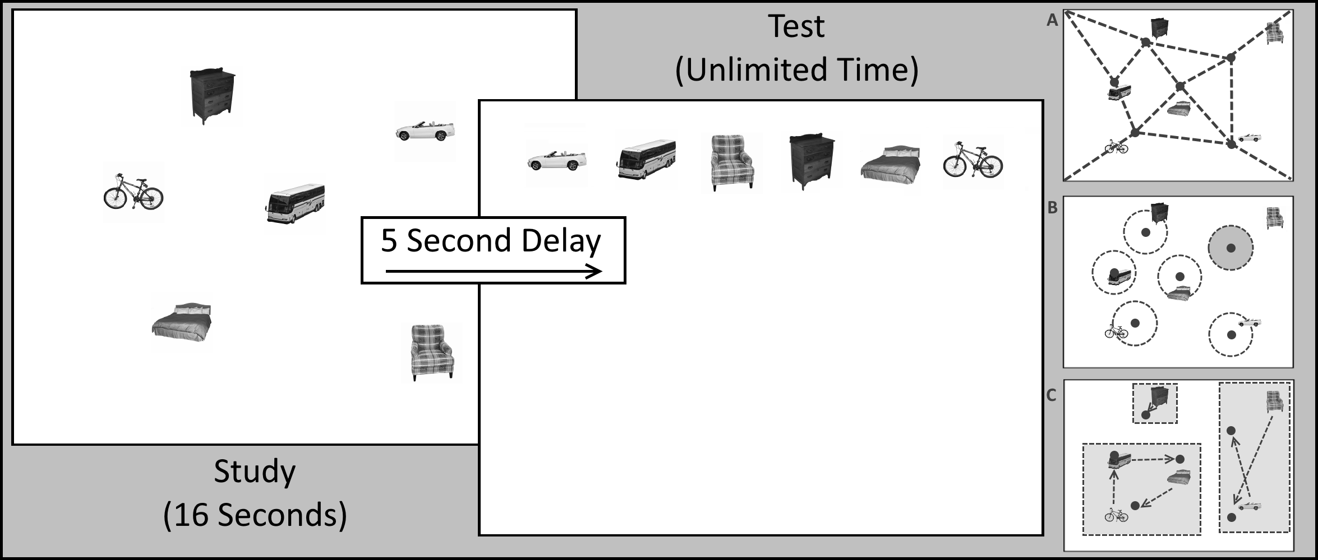

Example Reconstruction Task: a finite, continuous, 2D, Euclidean, spatial, connected domain populated with 6, precisely located, finite, randomly distributed pictures of real-world objects which will not overlap/appear on top of one another and are sampled from a finite set of possible objects. Note that the study portion is timed, there is a short delay, then the test has unlimited time. These are constraints on sampling the environment and maintaining memory more than the information contained within the configuration.

#### Relational Invariance under Transformations

First, for location information, if the intent is to reconstruct an original configuration of these items, a precise reconstruction will require all 12 location numbers to be represented. However, for an approximate representation, a much more compressed option may be available. Suppose the positions of each element were encoded into a graph-like representation where the relations between a subset of the items was encoded instead of any explicit location. This is, in fact, a representational framework posited by relational memory theory (Neal J. Cohen & Eichenbaum, 1993). Now, if the graph can be represented more efficiently, only one position need be remembered precisely (i.e. the overall position of the graph within the environment). Moreover, with this representation, the positions can now be transformed in ways which are not obvious given a set of 6 unassociated points. For instance, if the space were to be scaled up or down (as was done in Muller & Kubie, 1987 in rodents), the relative relations would simply be scaled up or down in accordance (and in fact, Muller & Kubie showed that place cell firing in an open field remapped with scaling, maintaining the relative shape of spatial firing). If the space were to be translated (i.e. moved in any direction a fixed distance), the graph itself need not change, only the global position would need to be adjusted. In fact, within a space like the one we’ve defined, scaling and translation are the fundamental transformations which do not require alteration of the graph of relative positions. Interestingly, some theories of temporal memory for order also share this property of scale and translation invariance in time (Howard, Fotedar, Datey, & Hasselmo, 2005; Howard & Kahana, 2002; Howard & Natu, 2005; Shankar & Howard, 2015). Rotation, sheering, or other more complex transformations can potentially result in the relative positions of items being changed, but with scaling and translation, any item to the left of another will remain to the left, and any item on top will remain on top. This idea parallels similar ideas from physics and mathematics, where certain quantities are conserved (or invariant) under certain transformations. Noether’s theorem (Noether, 1971), in fact, specifically states that for any transformation (specifically, those which are differential symmetries of an action), there is some corresponding conservation law (conservation of energy is equivalent to translational symmetry in time, conversation of moment is translational symmetry in space, conservation of angular momentum is rotational symmetry in space, etc.). If we believe memory for the location information which describes a set of points is encoded in such a relational graph, we should similarly believe that the representation should only be conserved under those transformations which have relational invariance (i.e. scaling and translation) but not those which lack such an invariance (i.e. rotation and sheering). Moreover, we might suspect that transformations which conserve parts of the relational information (like reflection, which conserves relations on all but the reflected axis) might have a graded effect on memory for the locations. However, in 1D domains (such as time) a reflection would have a more extreme effect as it is guaranteed to damage the relational information between every item pair that isn’t directly on top of each other.

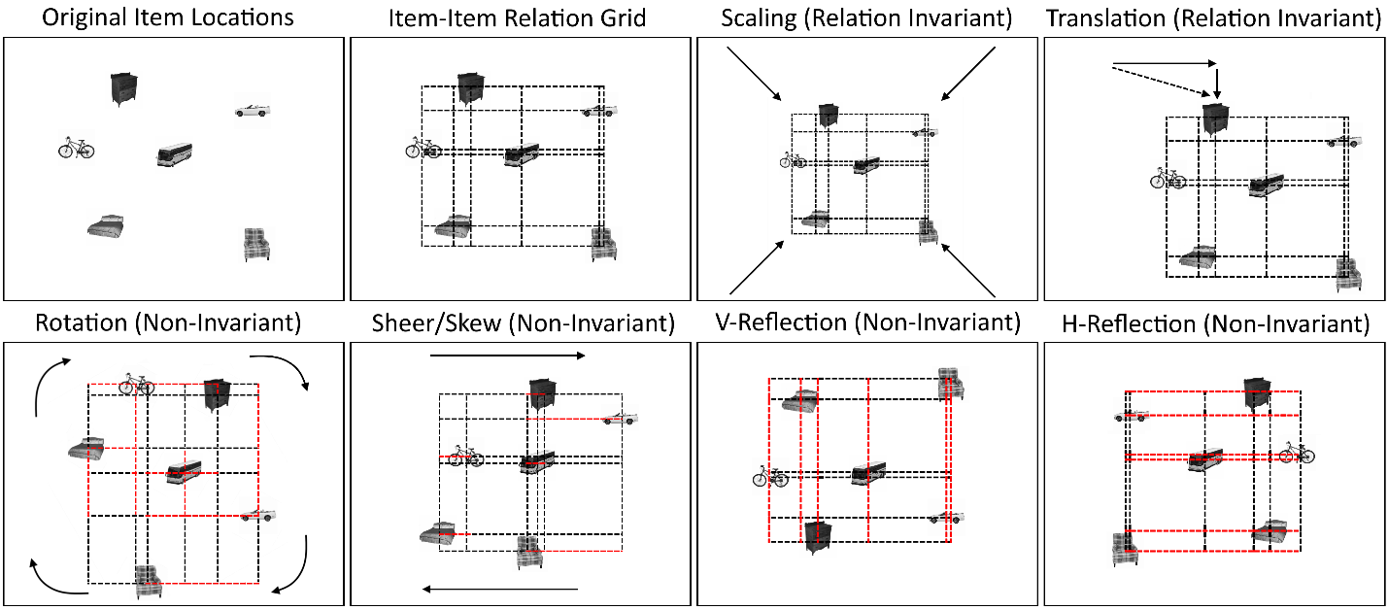

Relational Invariance in Affine Transformation Components in 2D: Note that via an item-item relational grid, we can observe the impact of different transforms on the relations present between items. Scaling and Translation have no impact on the relations between items (though scaling impacts distance between items. On the other hand, Rotation, Sheer/Skew, and Vertical/Horizontal Reflection all can modify relations in some systematic way. However, rotation uniquely can modify both dimensions relations.

#### Precision and Identity Information

Of course, the precision of the memory for the graph position and for the relational information may vary as well, but this can be treated as different types of noise which can be quantified in particular ways. The Precision and Binding Model (Yonelinas, 2013a) suggests that the hippocampus is critical for binding precise, high resolution information, and the associated measures of precision used in testing this model (a variable sized accuracy window) are one example of a quantification method which shows promise in providing more interpretability when working with complex path data (Kolarik et al., 2016, 2017). However, this model addresses precision in continuous domains, not precision for discrete information, and it does not address the specifics of how different binding configurations might influence memory. Moreover, because the theory addresses behavior only in a Virtual Morris Water Maze with a platform as the target entity, there is no identity information and no item-item relational information (item-environment relational information is present in the form of platform-landmark relations). Relational memory theory (Neal J. Cohen & Eichenbaum, 1993), on the other hand, very directly addresses how memory for arbitrary relations might form a flexible representation (in the graph-like manner discussed previously). However, even once we accept that a graph-like representation is at the core of memory for reconstruction, the problem is still far from solved. We don’t know, for instance, if a subset of the items are being represented relationally, bound to each other, while a single item is being bound to some aspect of the environment in exclusion of the other items. Additionally, the presence of higher-order organizational information (such as contextual information) might bias the reconstruction in ways which are measurable in the change of position of the groups of entities which share that higher-order property. The exact definition of context, however, is a topic of heavy debate and will not be resolved in this work.

Now, for identity information, we also have several possibilities. If the identity information is being convolved with some aspect of the spatial information, we would expect it to be subject to the same transformation and invariance rules outlined in the previous paragraph. If, however, the items are being bound to particular locations (as was suggested in Watson, Voss, Warren, Tranel, & Cohen, 2013), these bindings might be subject to their own invariance rules. This situation is more likely if the items are arbitrary, i.e. they just as easily could have been any item. Arbitrary items cannot be as easily convolved with location, as no expectancy can be formed about what item should be associated with a given location (thus, arbitrary). In reality, arbitrary items may still end up with alternative associations by chance (for instance, if an image of a plane happens to appear over an image of a tree, this obviously has a location-identity association which is non-arbitrary as planes tend to fly over trees, but it may have occurred by chance), but if the items are arbitrary, we can imagine them, in some way, as a disjoint domain of their own which must be bound to the continuous, connected domain of space. This binding may not be damaged by transformation of the space as it is being done via creating arbitrary relations from single points to identities. The various identities, however, could end up confused in some way if that information was not remembered but the location information was. In this way, particular identities might be assigned to the wrong location, or identities might switch places. If the relations are arbitrary, these errors should be thought of as distinct from the sorts which might result from some failure to remember location.

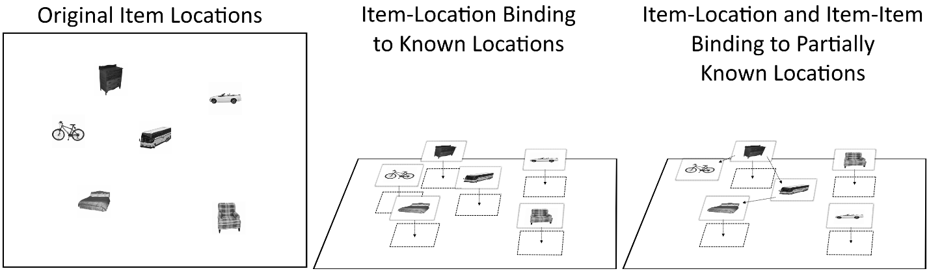

Examples of different identity binding methods. Item-Location Bindings to Known Locations assumes that item identities are being associated to particular locations and the locations are being remembered independently. Item-Location and Item-Item Binding to Partially Known Locations shows how, even in the absence of perfect location information, item-item relations can allow imprecise reconstruction of locations. Similarly, item-location binding can still be present, but identity can be misassigned even with perfect memory for location (i.e. the chair and the car are switched). Although we cannot easily know the particular representation being used by an individual on a particular trial, we can observe when these various errors occur and narrow down the possible representations and the information which is lacking.

#### Sampling and Encoding During Study

Finally, the discussion up until now has been exclusive to the representational and retrieval portion of memory, but it largely neglects the encoding aspect of reconstruction. When performing a reconstruction task, individuals are given some amount of time to study the information. During this time, there are numerous behaviors which might be performed in order to attempt to gather the information. The structure of human sensory systems is such that we generally sample specific aspects of information one-at-a-time, rather than assimilating the whole environment simultaneously (see Kveraga & Bar, 2015 for a thorough treatment of the topic). This sampling behavior is of particular interest as it is often measurable. If the information being studies is all visual (such as a computer screen task), the eyes will be the only sampling medium and, as such, the movement of the eyes in some way determines the information which can be encoded. Eye movements have been successfully used to identify critical differences between viewing patterns in hippocampal damaged individuals and comparison participants due to memory (Neal J. Cohen & Banich, 2003; Deborah E. Hannula & Ranganath, 2009). In Virtual Reality or Real-World environments, navigation (the combination of body-movement and eye-movement) provides a more flexible form of sampling (and, in fact, eye movements can be a subset of this sampling as the technology to sample eye movement at the same time as head movement and environment position has been available for nearly 20 years; Duchowski et al., 2000). In either case, sampling comes down to a stream of information which is received by the system whose contents can be guided by in-the-moment demands; in fact the Covert, Rapid, Action-Memory Simulation (CRAMS) model specifically addresses this sort of rapid, in the moment, memory guided decision making, suggesting that prefrontal-hippocampal interactions provide rapid simulations of potential outcomes of decisions in order to guide behavior (Wang et al., 2015). If the task at hand has few demands, very little sampling will be required, however, in a demanding task, extensive sampling may be required to acquire the necessary information. Task are sometimes designed to require participants to sample particular aspects of an environment (via masking all but some small region of the environment, a la Yee, 2012, or by forcing the participant to acknowledge sampling of particular aspects of the environment before proceeding, for example), and these demands may also bias behavior in particular ways. Sampling is a complicated topic, and as such, it will only be examined in relation to the test performance and not in a more holistic, information rich manner.

## Overview of Chapters

The remainder of this document will discuss algorithmic and mathematical formulations of these ideas for the aforementioned example of 2D space and show that hippocampal damage does uniquely impair some, but not all, measures of performance in reconstruction (Chapter 1). Later sections will extend these methods to a temporal domain and show how, despite its differences, temporal memory representations may be treated in much the same way as spatial memory representations (Chapter 2). Temporal and spatial domains may share many similarities, but errors in each may be distinct in other ways which can be seen in reconstruction performance. In particular, contextual information may have a similar influence on memory in both space and time, when it comes to precise remembering of location information, but relational information may be in some way different in these two domains. Finally, we will examine aspects of sampling of a domain which might influence the ability to remember and reconstruct information (Chapter 3).

#### Reconstructing Relational Information

In the first Chapter, a computational framework based on the theories outlined so far in the introduction is established which attempts to approach the task of inferring information about spatial reconstruction performance in hippocampal damaged patients from a principled perspective, making as few assumptions as possible and carefully defining different *types* of spatial relational information which are quantifiable in a reconstruction. Previous work has identified misplacement (i.e. the sum of Euclidean distance of the reconstructed locations of items to their target locations) as an error which shows greater magnitude in hippocampal damaged patients than comparison participants (Huttenlocher & Presson, 1979), and more recent work has hypothesized that some of this may be due to swapping of item identities between otherwise remembered locations (Watson et al., 2013). The work here expands on these ideas with a far more precise mathematical formulation of errors involving misassignments of items, global transformations (i.e. translation, scaling, and rotation), and swaps/cycles of items which are misassigned as a group. 3 hippocampal damaged patients are evaluated in a computer-based spatial reconstruction task with 6 unique items and 32 trials. 9 age, sex, and education matched comparison participants perform the same task. In agreement with previous theories of relational memory and hippocampal damage <cite>, single-item misassignments (i.e. placing of an item in another item’s location without any presumption about where the item which should’ve occupied that location was placed) are significantly more common in hippocampal damaged individuals than comparisons. However, patients and comparisons do not show a difference in the number of overall locations which are correctly reconstructed with some item (though not necessarily the correct item identity). This suggests that hippocampal patients are able to maintain certain relational information (i.e. general studied locations), potentially via an alternate representation that leverages other brain regions and/or memory systems.

Furthermore, despite previously identified differences in swapping between patient and comparison participants, with these more sensitive measures, we show that this difference is only present at low set-sizes (i.e. few items, <=4, in the reconstruction). At 5 items, comparison participants begin to commit identity-location spatial relational errors and, at this point, we find that no difference is present between patients and comparisons in the number of compound errors (swaps and cycles of items). Additionally, although identity information does account for the majority of the difference between patient and comparison participants, a significant difference remains in their misplacement even after all corrections are made. This “local” misplacement may represent a deficit in precision as described by others (Kolarik et al., 2016, 2017; Yonelinas, 2013b).

This work serves two primary purposes: first, the paper establishes a methodological framework for making inferences about spatial reconstruction performance (and, in general, reconstruction performance in any domain) which makes minimal assumptions and approaches the issue from a principled perspective. Second, the work shows that not only are previous theoretical accounts of relational memory and the hippocampus consistent with this work, but that, critically, it is the arbitrary identity-location information (i.e. the information which “could have just as easily been anything”) which is impaired in hippocampal damaged patients, not the overall location information. This work speculates as to how such information might be maintained or represented, but future studies which are not part of this work will be necessary to clarify how some relational information might still be maintained via alternate mechanisms.

#### Memory during Time Travel: Spatiotemporal Navigation, Contextual Boundaries, and Relational Memory Errors in Virtual Reality

Beyond just the spatial domain, episodic memory (which is critically supported by the hippocampus; Tulving, 2002a) involves the temporal domain as well. There is an extensive literature studying the temporal domain showing that humans naturally segment events into discrete regions in time (Zacks et al., 2007a), that contextual boundaries impact perceived distances across time (DuBrow & Davachi, 2013), that order memory is impacted by recency, contiguity, and primacy effects (Howard, Shankar, Aue, & Criss, 2015), and an enormous litany of other discoveries, all which make the same crucial assumption – that time need always be sampled differently than space, i.e. always forward. The work presented in this section shows that this assumption is not necessary and space and time can be put on a more equal footing, allowing free exploration of both domains simultaneously (known as a Spatiotemporal Navigation Task) in Virtual Reality (VR). Virtual Reality allows increased measurement and control capabilities over other methods, increasing a sense of presence, and providing greater ecological validity than more traditional methods (Kuliga, Thrash, Dalton, & Hölscher, 2015; Schultheis, Himelstein, & Rizzo, 2002). Many of the same effects seen in more traditional tasks can be seen in this spatiotemporal navigation task (context boundary effects – in which items which share context are remembered as closer together and items across contexts further apart; misassignments – where one event is placed in another event’s location; overall misplacement improvement – i.e. the sum of the Euclidean distances of all events to their targets). While many of these effects are similar to previous tasks, despite the present study allowing for the ability to traverse the timeline freely, some unique differences can be found between space and time when comparing relational information in each domain.

Leveraging the methodological work from Chapter 1, Chapter 2 shows that misassignments in time (i.e. placing an event in another event’s temporal location) is far more likely than misassignment in space (i.e. placing an event in another event’s spatial location) in healthy young adults even with the ability to freely explore both domains. This difference is persistent across trials, with spatial misassignment dropping to near perfect accuracy by the last trial while temporal misassignment remains significantly higher. However, a significant linear trend is present in the temporal misassignment across trial suggesting it might eventually plateau if more trials were utilized. This result is interesting in light of work by Howard Eichenbaum and colleagues showing the existence of time cells in the hippocampus which fire in relation to specific points in time (Eichenbaum, 2014; B. Kraus et al., 2013). It also raises questions of if these time cells are firing in accordance with an allocentric perspective on time (similarly to place cells) or an egocentric perspective (i.e. based on the subjective moment in time regardless of where in the series of events the individual is present). Based on what we know of other selective cells in the hippocampus (i.e. orientation selective), it’s reasonable to assume that time cells are in reference to allocentric time, however without the manipulation allowing for allocentric and egocentric perspectives on a timeline, it is difficult to dissociate the two. This task presents such a manipulation which might one day lead to a better understanding of these temporal representations.

This task does not simply address spatial and temporal reconstruction in isolation; it also contains temporal contextual information in the form of changing background colors in the environment at different moments in time. Using these temporal contexts, temporal context boundary effects can be assessed. Although these effects have been looked at for temporal order memory in previous experiments (DuBrow & Davachi, 2013; Ezzyat & Davachi, 2014), those experiments never allowed the participant to freely transition between contexts at will, to (re)explore contexts as much as they would like, or retested on the same information several times (to assess improvements to contextual vs. overall memory). In this task, participants repeated the same event sequence 4 times, and showed improvements to their overall memory on each subsequent trial. However, despite improvements in performance across nearly every other metric, temporal context boundary effects did not diminish across trials. This strongly suggests that this “error” in placement is, in fact, a bias created by an organizational principle which uses context to separate groups of events from one another. This suggestion is consistent with other computational models of the impact of temporal context on memory (Howard et al., 2014); however, these models do not generally allow for the assumption of free traversal of time.

Interestingly, this contextual bias does not just impact memory for the relative distance between events, but contextual information also biases relational information in time (i.e. temporal misassignments, from earlier in this section). Across all trials, a significantly higher number of misassignments are to same-context locations that should occur by chance. Moreover, this effect actually increases across trials as the impact of context on distance judgements holds steady and the overall number of misassignments decreases, suggesting that this bias is not easily corrected with restudy and reflects an organizational principle which causes within-context items to be associated to each other but not necessarily with the same precision on an individual-item level. Interestingly, this finding (i.e. that contextual boundaries might make memory for the order of within-context items worse) is consistent with one account of contextual boundaries (Davachi?) but not others (Zachs).

Together, these methods serve as a first step towards a more comprehensive understanding of episodic memory and relational memory in domains other than space, showing that, when we put space and time on a more equal footing, we can study both domains with more flexibility and fidelity to illuminate critical elements of the organization of memory.

#### Spatiotemporal Navigation, Sampling, and Information Encoding in Virtual Reality

Previous sections have highlighted primarily test results, while leaving study-time behavior largely unaddressed. This section proposes various measures of study-time performance in the most complex case of the tasks discussed in this work, the spatiotemporal navigation task, and discusses some preliminary data and hypotheses related to this work. Previous work on eye tracking in the iPosition task has revealed a variety of visual sampling phenomena which are predictive of aspects of memory and reconstruction (Neal J. Cohen & Banich, 2003). However, sampling in a 2D environment via eye movement is somewhat different from a computational perspective than navigation within a 4D environment. Basic navigation metrics such as the distance travelled in space and time have been evaluated, showing that performance on these metrics improves across trials in the spatiotemporal navigation task. Additional metrics from other work in spatial navigation (such as the Fractal Dimension measure; Daugherty et al., 2015) are planned to determine if coarse measures of study-time exploration can predict aspects of overall memory, relational memory, and contextual biases at test. Additionally, an analysis of the order of exploration versus order of reconstruction and associated accuracies (more akin to the Recency and Contiguity effects explored in traditional temporal free recall tasks) is planned.

The data from the Spatiotemporal Navigation Task are incredibly detailed and rich, and, as such, there are a huge variety of applicable analyses. Many of these have already been planned (as mentioned above) from the inception of the task, however, there are certainly more which are possible. Suggestions in regard to further analyses which might serve to elucidate aspects of exploration and navigation which impact future reconstruction are welcome and encouraged.

# Reconstructing Relational Information

## Introduction

Relational memory is critically supported by the hippocampus (Cohen & Eichenbaum, 1993; Eichenbaum & Cohen, 2001; Konkel & Cohen, 2009; Konkel, Warren, Duff, Tranel, & Cohen, 2008). For example, memory for relationships of items to spatial locations is highly sensitive to hippocampal damage in humans (Hartley et al., 2007; R. J. Allen, Vargha-Khadem, & Baddeley, 2014; Smith & Milner, 1981a; Watson, Voss, Warren, Tranel, & Cohen, 2013). Moreover, it has been shown previously that the hippocampus is necessary for all “manner” of relational memory (Konkel et al., 2008); that is, it is critical for binding information regardless of the informational domain, be it spatial, temporal, sequential, associative, etc. However, while the hippocampus can be involved regardless of the domain of information, there are many possible relations between the constituent elements within a given domain, such as item identities (i.e. labels that distinguish items from one another, such as names), locations (i.e. positions in the domain in which an item was present during study), and environmental elements (i.e. the boundary of the environment or landmarks). It is possible that not all of the relational information among these elements critically relies on the hippocampus, and that some *types* of relational information may not be impaired by hippocampal damage.

Importantly, we distinguish between a *manner* of relation and *type* of relation. Hippocampal involvement in all *manner* of relation means, more generally, that the hippocampus can be involved regardless of the informational domains (i.e. spatial, temporal, social, associative, etc.). However, within a given domain, particular *types* of relational information exist (and are enumerated here) which may not all be equivalent in terms of hippocampal involvement. It is possible that when comparing *types* of relations in two different domains, seemingly similar relations may have distinct representations with different amounts of reliance on specific memory systems. For instance, item-item relations within a spatial domain containing several items can be used to derive information about item locations even with an imperfect representation of each individual relation (this point will be elaborated upon later), while item-item relations in an arbitrary word pair cannot be easily used to derive additional information about other arbitrary word pairs. Similarly, item-environment relations in some spatial-relational tasks may or may not be informationally equivalent to item-environment relations in others (such as studying the location of a single item in a scene vs. the locations of many items within an empty environment). A primary reason for this difficulty is in the diversity of uses of terms like ‘item’ and ‘environment’ across different tasks.

It is the aim of this work to precisely define *types* of relations within the spatial domain in such a way as to determine if memory for specific *types* of spatial relations are impaired (or not) by damage to the hippocampus. To this end, we propose a framework for systematically classifying *types* of relations in a spatial memory task. This framework allows us to: 1) distinguish multiple types of first-order (i.e. pairwise or one-to-one) and higher-order (i.e. group-wise or many-to-many) spatial relations, and 2) determine if these various types of spatial relations are differentially impaired by hippocampal damage by inferring the presence or absence of relational information via observations of different types of errors in a reconstruction.

Here we take advantage of the rich data generated by spatial reconstruction (SR) paradigms, in which multiple items are studied in various spatial locations before participants are asked to reconstruct (i.e. freely place) each item in its remembered location. There is a long tradition of using SR paradigms to study spatial memory (Huttenlocher & Presson, 1979) and its susceptibility to hippocampal damage (Jeneson, Mauldin, & Squire, 2010; Smith & Milner, 1981; Watson et al., 2013). These experiments have historically used a general quantification of “misplacement error” in space by calculating the sum of the Euclidean distance between each placed item and its studied location. The typical finding of these experiments is that individuals with hippocampal damage show increased overall misplacement relative to comparison participants.

One critique of the use of misplacement as the sole metric of performance on SR tasks has been that it provides relatively little information about the nature of spatial memory deficits following hippocampal damage (Watson et al, 2013). In other spatial paradigms, such as the virtual Morris Water Maze (vMWM), some theories of hippocampal function such as the Precision and Binding Model (PBM; Yonelinas, 2013) would predict the increased misplacement seen in SR tasks, with PBM, in particular, predicting poorer precision of spatial memory in hippocampal damaged patients (Kolarik et al., 2016, 2017). This could be consistent with the explanation that high levels of misplacement could theoretically reflect an inability to remember coordinates on a “grid-like” mental representation of the display, with patients showing a deficit in the resolution of the grid. Alternatively, high misplacement could reflect a deficit in representing inter-object configural or relational information (among other possibilities, discussed below). Due to this resolution issue in using misplacement as a primary metric of performance, there have been recent attempts to develop additional metrics of spatial reconstruction performance that help to disentangle these possibilities (Jeneson et al., 2010; Watson et al., 2013). In particular, Watson et al., 2013 focused on a very specific type of spatial relational error termed a “swap” error. “Swap” errors are errors in which the relative position on each x and y axis for a pair of items is flipped. Such errors appear to be strongly influenced by hippocampal damage. In fact, patients with hippocampal lesions even make “swap” errors in set sizes as small as two items and at surprisingly short time scales (Watson et al., 2013).

These data suggest that when the hippocampus is impaired, relational binding errors occur regardless of the number of items to be remembered (e.g., in a set size invariant manner). Moreover, swap errors in Watson et al (2013) were found to be a significant contributor to the overall differences in misplacement rates between patients and healthy comparison participants. However, there are many additional potential relation-based explanations for increased misplacement in hippocampal patients. Patients could be making global errors of some sort (i.e. moving all items down, squishing items together, or rotating all the items), local or “noisy” errors (i.e. placing items pseudo-randomly based on a heuristic or limited memory for locations), or relational errors (i.e. placing items in the wrong location given their identity, but that location would have been valid for a different item). Thus, in the present study, rather than focus on one type of spatial relational error (e.g. swaps), we sought to identify the multiple types of relations in space, to organize them in a systematic framework, and to determine if all, or only some, types of relations are impacted by hippocampal damage.

At the core of our proposed framework is the classification of three primary types of first-order spatial relations: item-environment relations (e.g., one item is in the upper left corner of the display), item-item relations (e.g., one item is below and to the left of another item), and identity-location relations (e.g., item A belongs in location A). Note that terminologically, the use of the word “item” here is specific to location information (with identity information being separated out as identity-location information). An analogy to help clarify the meaning of these different relations can be found in navigating a shopping mall. While navigating, it may be important to remember the locations of stores. This would require you to remember location information about where the stores of interest are in relation to the shopping mall layout (i.e. item-environment relations) or perhaps the locations relative to other stores (i.e. item-item relations) as well as which store is in which particular location (i.e. identity-location relations). The hippocampus has been implicated for decades in item-environment relations. Indeed, animal models demonstrate hippocampal place cell firing tied to the distance and direction of item cues in an environment (Gothard, Skaggs, & McNaughton, 1996; Gothard, Skaggs, Moore, & McNaughton, 1996; John O’Keefe & Burgess, 1996). While humans with hippocampal damage are able to retain some item-location information via maintenance in working memory, this maintenance is transient (R. J. Allen et al., 2014; Libby, Hannula, & Ranganath, 2014). In both humans and animals, arbitrary item-item association has been extensively studied. Memory for item-item relations is impaired following selective damage to the medial temporal lobe in rodents (Bunsey & Eichenbaum, 1993), monkeys (Murray, Gaffan, & Mishkin, 1993), and humans (Giovanello, Verfaellie, & Keane, 2003). Furthermore, humans with hippocampal damage show item-item impairments for all manner of relations (e.g. spatial, temporal, associative, etc.; Konkel et al., 2008).

In addition to these first order relations, we examine higher-order, compound relations (e.g., item A, B, and C form a group), which can contribute to compound spatial relational memory errors (e.g. the group is translated to the left, all of the items are squished towards the group’s center, or two items swap locations). Compound relational errors can be seen in two forms in our analysis. Firstly, swaps of items (i.e. when two items are placed in each other’s location) and cycles of items (i.e. when more than two items are placed in each other’s locations) are forms of compound error primarily involving multiple identity-location errors. Secondly, various transformation errors (translation, scaling, and rotation) are forms of compound errors involving multiple item-item and/or item-environment errors.

In addition to first-order (i.e. pairwise) and higher-order (i.e. compound) relations, we can begin to consider the question of how general, Gestalten shape information, i.e. configural features which constitute parts of a unified whole, may be used independently of the hippocampus to maintain more global spatial information. While the current data cannot provide a definitive response to this proposal, the relevant data are suggestive and considered.

Finally, given the evidence that hippocampal damage impairs reconstruction performance even at very small set sizes (Watson et al., 2013), the implication of varying set size on memory for these different types of spatial relational information was considered. To this end, we take advantage of an existing dataset (Watson et al., 2013) that recorded SR task performance from hippocampal patients across set sizes (i.e., from 2 items to 5 items) and reanalyze those data using the current analysis framework. We first evaluate the extent to which hippocampal patients and comparison participants committed relational memory errors of particular types even at small set sizes (e.g., 2 items). Second, we determine whether those error types change or remain consistent as set size increased.

In summary, in the work presented here, we investigate the types of relations that are sensitive to hippocampal damage from a first principles approach by breaking down reconstruction errors in an SR task into multiple error types, which can then be evaluated simultaneously. We consider three types of first-order relations (i.e., item-environment, item-item, and identity-location relations) as well as two types of higher-order compound relations (i.e., swaps and cycles). We evaluate the degree to which the overall difference in misplacement between hippocampal patients and matched comparisons can be explained by these distinct error types. Finally, we discuss the implications of these findings for theories of hippocampal function.

## Materials and Methods

### Participants

Behavioral data were collected from 3 patients with hippocampal damaged and profound declarative memory impairment or amnesia (see Table 1 for details) and 9 healthy comparison participants. Three of the healthy comparison participants were matched to each hippocampal patient for sex, age (+/- 5 years), and education (+/- 2 years).

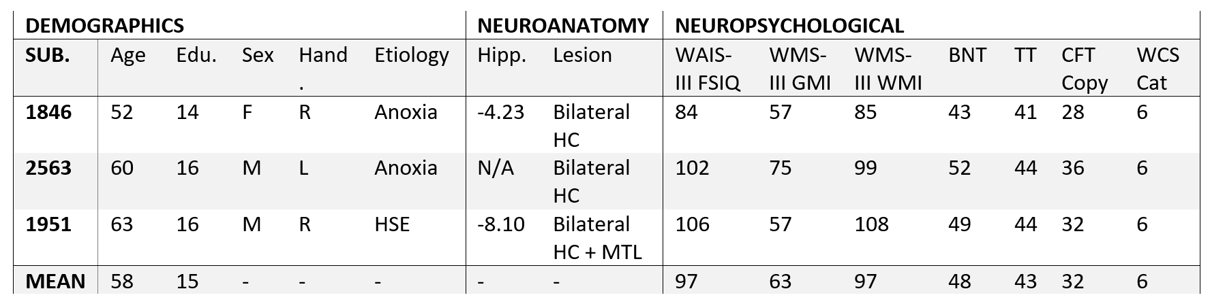  
“**Table 1**: Demographic, neuroanatomical, and neuropsychological characteristics of participants with hippocampal amnesia. Hand. = Handedness. Ed. = years of education. HSE = Herpes Simplex Encephalitis. HC = hippocampus. + MTL = damage extending into the greater medial temporal lobes. HC Volume = hippocampal volumetric z-scores as measured through high resolution volumetric MRI and compared to a matched healthy comparison group (J. S. Allen, Tranel, Bruss, & Damasio, 2006; Buchanan, Tranel, & Adolphs, 2005). WAIS-III FSIQ = Wechsler Adult Intelligence Scale–III Full Scale Intelligence Quotient. WMS-III GMI = Wechsler Memory Scale–III General Memory Index. BNT = Boston Naming Test. TT = Token Test. CFT = Complex Figure Test; WCT = Wisconsin Card Sorting Task; Cat = Number of categories achieved out of six.”

Two patients experienced anoxic/hypoxic episodes (1846, 2563) resulting in bilateral hippocampal damage and the third patient contracted herpes simplex encephalitis (1951) leading to more extensive bilateral MTL damage affecting the hippocampus, amygdala, and surrounding cortices (Figure 1). Structural MRI examinations completed on 2 of the 3 patients confirmed bilateral hippocampal damage and volumetric analyses revealed significantly reduced hippocampal volumes. Participant 2563 wears a pacemaker and was unable to undergo MRI examination and thus their damage was confirmed by computerized tomography; damage was confined to the hippocampus.

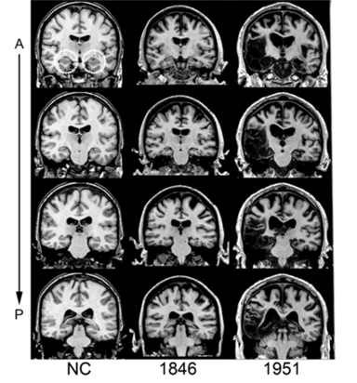

**Figure 1**: Magnetic resonance scans of hippocampal patients. Images are coronal slices through four points along the hippocampus from T1-weighed scans. Volume changes can be noted in the hippocampal region for patient 1846, and significant bilateral MTL damage including the hippocampus can be noted in patient 1951. A = anterior, P = posterior, NC = healthy comparison brain.”

Neuropsychological examination confirmed severe declarative memory impairment in all hippocampal patients (M =63; Wechsler Memory Scale-III General Memory Index, more than 2 SDs below population norms) in the context of within normal performance of standardized measures of intelligence, language, visual perception, working memory, and executive functioning (see Table 1).

### Experimental Paradigm

Participants completed a computerized spatial reconstruction task (Monti et al., 2015; see top of Fig. 2). Participants studied 6 items (gray scale, nameable objects; Brodeur, Guérard, & Bouras, 2014) per trial, arranged pseudo-randomly in an pixel area within a pixel computer screen across 32 total trials. During the study phase, participants viewed the 6 items for 16 seconds, followed by a 5 second delay (blank screen). At test, which began immediately after the delay, items were randomly placed in a line at the top of the screen, and participants used a mouse to drag each item to its remembered location on the screen. Participants had unlimited time to reconstruct the studied display. When they were finished, participants pressed space bar to start the next study trial. Participants’ eye movements were recorded throughout the experiment. Eye tracking data are not reported here and will be reported elsewhere (Lucas, Duff, & Cohen, in preparation).

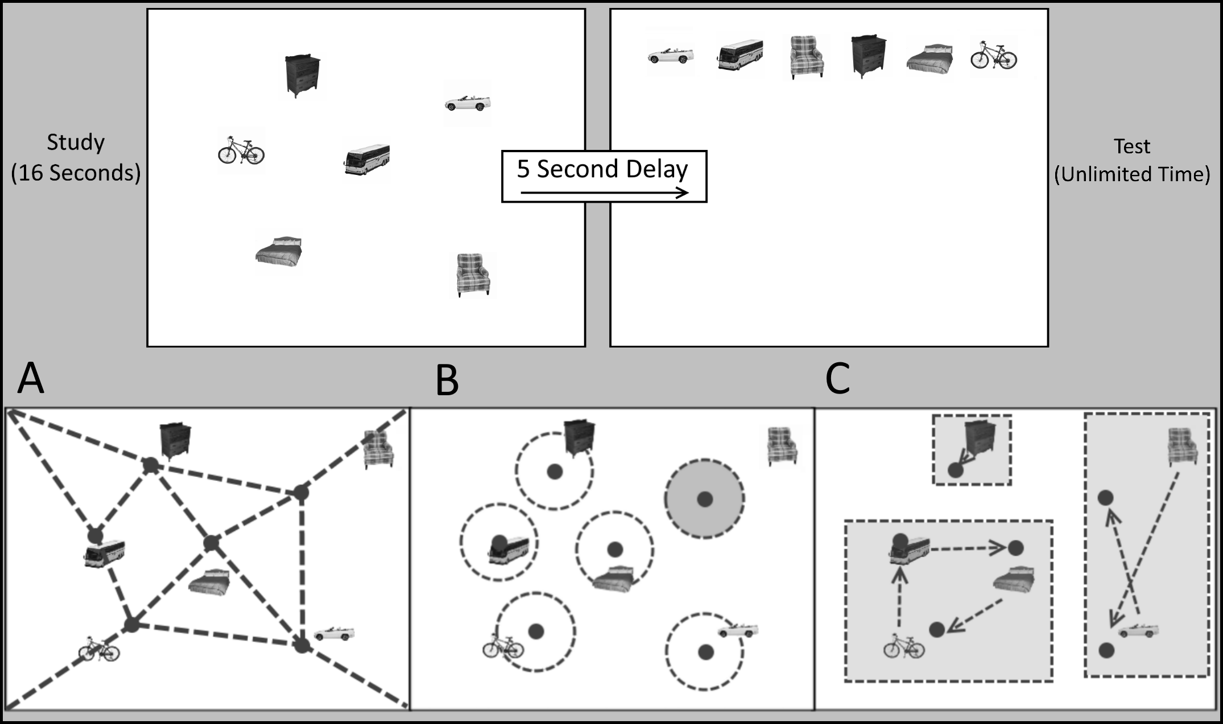  
"**Figure 2**: A sample trial from the spatial reconstruction task; A, B, and C show different interpretations of the same reconstruction where the objects are in the reconstructed locations and the dots are the target locations from the study phase. (A) shows item-item and item-environment relations (dotted lines), which might be used to determine the locations of the dots. (B) shows reconstructed item to target location relations where gray shaded circles indicate a failure in placement of items to those locations (note that identity is ignored as, for example, the bus is not in its target location). (C) shows compound relations where some items roughly swap locations (although not necessarily precisely, in this case being a "partial swap"), some show cycle relationships (i.e. Bus🡪Bed🡪Bicycle🡪Bus), and some show single-item placement in the correct target location."

To determine if item-environment, item-item, identity-location, and compound relations showed selective differences in performance between patients and comparison participants, a new set of tools for analyzing spatial reconstruction data were created. These methodologies were designed with the intention of making as few assumptions as possible about the nature of the reconstruction to separate the types of errors via more mathematically rigorous and interpretable metrics. This approach applies Point Set Registration methods (see Besi & Mckay, 1992 for an introduction to the topic), in which a set of points (often derived from key points in an image) are assigned to an independent set of points (often from a reference image) based on an inferred relationship between the two sets. The SR paradigm is analogous to the Point Set Registration process of understanding the relationship between reconstructed points and their target (i.e., studied) counterparts, with two primary differences. Firstly, in the case of Point Set Registration, it is often not guaranteed that every point in the data set will correspond one-to-one with a point in the target. In the case of the SR task, we have a much stronger reason to assume that such a one-to-one correspondence should exist (though it may be interesting to consider the sorts of memory errors that might cause this assumption to be violated). Secondly, in Point Set Registration, it is often the case that there are many more points from which to define a model than exist in the SR task. For this second reason, especially, it is important that we proceed with caution in what models we apply to our data to avoid overfitting to a small set of points.

The model for the comparison of the reconstructed and target (i.e., studied) points can be thought of as having four primary components: identity remapping (wherein the identity of each item is removed and the set of placed item locations is mapped onto the target locations in a way which minimizes error), global error correction (wherein global translation, scaling, and rotation errors are subtracted from the placed item locations), location placement evaluation (wherein a binary determination of accuracy is made for each location), and compound error evaluation (wherein “swaps,” in which two items are misassigned to each other’s locations, and “cycles,” in which more than two items are misassigned to each other’s locations, are identified).

#### Identity Remapping

For this first step, identity remapping, a one-to-one mapping between the reconstructed points and targets must be created. This mapping can be determined by a variety of methods, each with their own advantages and disadvantages (Burkard, Dell’Amico, & Martello, 2012); however, for the sake of simplicity and interpretability, it is often preferable to find the mapping which globally minimizes the overall error in the reconstruction (effectively eliminating any effects of item identity-location misassociation in the reconstruction). This can be solved using the following Assignment Problem (H. W. Kuhn, 1956; Harold W. Kuhn, 2010; Munkres, 1957) equation:

where is the cost matrix associating each vertex in a graph and is the binary assignment of an undirected edge to the graph. Using the above equation, we find the set of associations (which we will call “the map”) which results in the smallest numerical value, forming a minimal one-to-one mapping of the placed item location to a target (studied) location.

#### Global Error Transformations

Once a one-to-one mapping has been found, the next primary component to be determined is the global error transformation which finds shared error across all the items. This transform could be any function, and with enough parameters, the items could be mapped perfectly onto their assigned target locations. However, because our intention is to differentiate between global relational errors and item-level errors, a simplified transformation is used such that only translation, scaling, and rotational errors are included in the model. Together, these transformation components describe a 4 parameter system (x translation, y translation, scale, and rotation), which can be used to model global error across all items in a trial (cf. Similarity Transform; Cederberg, 2001). One could speculate as to what might cause these different types of errors (i.e. translation being a misrepresentation of the entire stimulus space in the environment with an offset, scaling being a squishing or stretching of the stimulus space, and rotation being a misrepresentation of the directions in the environment). Regardless, by identifying this global error, we can subtract out its effects from each item’s location so as to get a more precise measure of individual item accuracy independent of shared, systematic, spatial errors. The similarity transform can be more precisely stated as a solution to the equation:

where is the ratio of similarity (or scaling factor), is an orthogonal matrix and is a translation vector. can be decomposed into a single value which represents the magnitude of rotation around the point set center. This transformation can be computed using Umeyama’s algorithm (Umeyama, 1991) which uses Singular Value Decomposition (Cline & Dhillon, 2006; Golub & Kahan, 1965) to obtain a transformation matrix. It is useful to note that it is not always possible to find a transformation given a set of points if they do not actually share any global error of the types we’ve specified (i.e. translation, scaling, and rotation). In our model, we allow rotation to fail independently of translation and scaling, as it is more difficult to find rotational components in small data sets. If all attempts to find a transformation fail, no global adjustments are made and the transformation data from those trials are excluded from the analysis. Singular Value Decomposition computes the transformation matrix by solving the following equation:

where is the dot product of the reconstructed and target point locations divided by the number of points, and are unitary matrices, and is a diagonal matrix of non-negative, real numbers. Umeyama’s algorithm allows the decomposition of the matrix into the translation, scaling, and rotation components.

#### Location Placement Evaluation

Now that associative and global errors have been subtracted from the point locations, a measure of reconstructed-to-target location placement accuracy can be evaluated in a manner that is not influenced by incorrect item-identity choices or global rearrangement. Previous studies have attempted to include accurate placement as an aspect of the analysis using an arbitrarily chosen distance value (Jeneson et al., 2010). However, an inflexible threshold imposes a very strict, nonlinear boundary on our evaluation of accuracy, which is difficult to handle without training participants to operate within this constraint (potentially influencing behavior in unintentional ways). It would be preferable for such a boundary decision to be made flexibly, based on the variability in local misplacement (i.e. misplacement that is not shared amongst the items nor due to item identity errors). To accomplish this goal, we determine accuracy based on the data by creating a statistical distribution of the misplacement after correcting for item-identity and global error and use the confidence intervals for the distribution (in this case, 95% confidence intervals) as the accuracy threshold. This distribution could be formed on a trial-by-trial basis, but it is more stable to compute it across all trials for an individual as there are more sample points (192 points instead of 6). This trade-off means that the threshold will be slightly stricter than the data would suggest for earlier trials and slightly less strict for later trials:

This choice trades a rigid, predetermined threshold condition for a new assumption: that the participant placement of items will generally be in the studied locations (to a degree specified by the confidence interval width). This assumption may not be correct for patients with hippocampal damage as overall misplacement for patients is greater than for matched comparisons (Huttenlocher & Presson, 1979; Jeneson et al., 2010; Smith & Milner, 1981a). Therefore, we opt to use the accuracy thresholds computed from the comparisons as the measure of accuracy for the patients. This choice allows our definition of placement accuracy to be unified between the groups, with the matched comparisons determining their associated patient’s placement accuracy threshold. This adjustment is necessary in deciding a threshold for patients because we are forming a statistical distribution based on individual item misplacement which incorporates all the individual item variability. This item variability is not necessarily matched between patients and comparisons given that the comparisons generally perform better. Thus, we use the stricter criteria, the comparison thresholds, for placement accuracy in patients.

#### Compound Identity Error Evaluation

Finally, once all item-location assignment and global errors have been subtracted from the data and placement location accuracies have been determined, item-to-location mapping can be examined for both accurate locations and inaccurate locations. Using the mapping from the first step of the analysis and the accuracy from the previous step, we can also find if there are any accurate or partially accurate location-cycles of items where items were potentially assigned to the wrong location (i.e. within the threshold we have defined for our binary location accuracy judgement but with a center on a different item’s studied location). The cycles are computed via a graph-theoretical connected-components analysis where closed loops in the graph of associations are treated as individual components (Hopcroft & Tarjan, 1973). If an item exists in a single-component system, it is assigned correctly with its target (studied) location. Otherwise, the items in the component system form a cycle, where the simplest cycle would be a 2-cycle, which can also be thought of as a swap, and higher order cycles can also be found (up to a 6-cycle, as 6 items are being tested). In the general case, an N-cycle is possible where N is the number of items under test. Note, this “swap” is computed differently than our previous version of “swaps” (Watson et al., 2013), as the metric described here includes location accuracy (with item identity ignored) as part of the requirement for being called a “swap”. We believe that this new metric is more consistent with the general item-location misbinding interpretation of a “swap” error. These error types are collectively called compound errors.

In summary, this process produces a set of nine output metrics. The 1&2) translation (x and y), 3) scaling, and 4) rotation magnitudes from the transformation step, 5) the number of items within the location accuracy threshold after removing both the item identities and the number of compound errors of various types. For consistency with our previous work, we will consider 6) 2-cycles, aka swaps, in isolation of 7) >2-cycles in statistical analysis. Further, any system with one or more inaccurate items is treated as a 8&9) “partial” cycle (or swap), versus those in which all locations contain an accurately placed item.

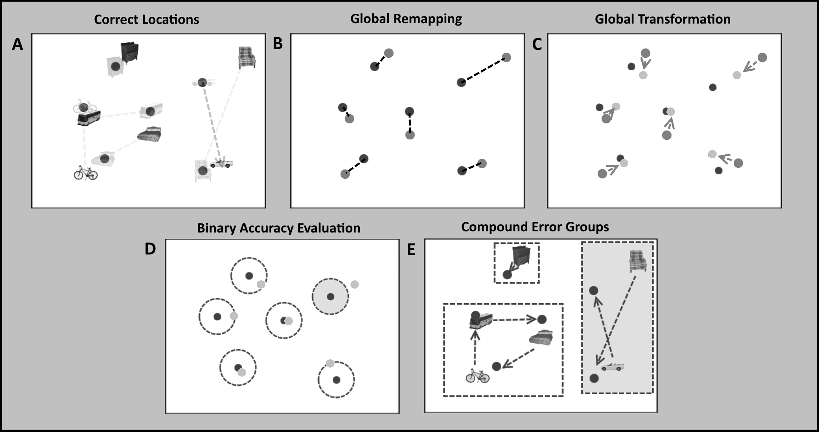

“**Figure 3**: The analysis procedure as defined in the above sections. (A) shows the correct locations (dots with shadowed identities) and the reconstructed locations (items) along with shadowded dotted lines showing the original misplacement. Note that large amounts of misplacement error is accumulated via improper assignment of identities to locations. (B) shows the global remapping (dark dots are targets and light dots are reconstructed points) wherein identity is stripped away and a minimal one-to-one mapping is formed. (C) shows the global transformation (in this case a slight rotation and scaling error) where dark dots are targets, medium dots are reconstructed points, and light dots are post-transformation reconstructed points (i.e. points where the global error have been subtracted from the reconstructed points). (D) shows the binary accuracy evaluation on the post-transformed points (where the dark shaded circle signifies an inaccurate item). (E) shows the compound errors identified and labelled according to the previous steps (where shaded regions are considered “partial” groups where at least one item was inaccurately placed).”

### Gestalten Shape-Like Information

There are many ways to define “shape”, and this proposal evaluates only one such definition. Shape is defined here via the location vertices and their relative positions, such that the shape is altered with item placements in non-studied locations and unaltered with transformations such as translation and scaling. Under this definition of shape, shape can be thought of as the highest order of compound identity-location and item-item relational information which includes all pairwise relations amongst items without regard for item-environment relations. One way to dissociate identity-location and item-item relations is to strip away the identity information and treat all items as if they were anonymous (i.e. unlabeled) in order to determine if the placement locations match up with any studied locations (see Identity Remapping above for details). The current study takes steps to evaluate and dissociate the degree to which shape-like information may be maintained by hippocampal patients by comparing the number of correct location placements (disregarding item identity) and the magnitude of different types of global errors (i.e. error which is shared between multiple items in the reconstruction), such as translation (i.e. a fixed offset in x and/or y of all items), scaling (i.e. all items being closer to or farther from a central point without a change in angle between any item pair), and rotation (i.e. all items rotated some distance around a central point) between the groups which might suggest differences in shape memory.

### Statistical Analysis

All t-tests shown were conducted via Welch’s *t*-test for unequal variance and unequal sample size (two-tailed) unless otherwise indicated. An alpha level of 0.05 was used to determine significance. This means that the degrees of freedom for each *t*-test is the adjusted degrees of freedom given by the Welch-Setterthwaite equation which corrects for unequal sample size and variance. Repeated measures ANOVA were used when comparing metric performances and set size data. All ANOVA used Huynh-Feldt correction for non-sphericity.

### Reanalysis of Watson et al. (2013) Set Size Data

Previous work from our group showed that hippocampal patients committed swap-like relational memory errors even at set sizes as small as 2 items, whereas such errors were virtually non-existent in comparison participants even at size sizes of 5. These data suggest that hippocampal damage leads to a pervasive inability to retain relational information even in the most restrictive circumstances. To investigate whether all types of relations are set size invariant, we conducted a reanalysis of a previously acquired data set (Watson et al., 2013) to determine if the patterns seen in the new data set hold in the previous one. The data contained four patients and four matched comparisons. Because that data set contained variations in set size, a repeated measures ANOVA was run to determine if the average error magnitudes across set sizes differed for each type of error. There was an overlap of one patient in both studies, 1846, though the data were collected approximately 4 years apart.

## Results

### Differences in Misplacement Accounted for by Global Errors

Consistent with previous work (Jeneson et al., 2010; M. Lou Smith & Milner, 1981; Watson et al., 2013), the hippocampal patients show significantly more overall misplacement (difference between means is 109.2 pixels; ) than the comparison participants (Fig. 4 “Original”). However, our new analysis framework allows us to determine the degree to which this misplacement difference can be accounted for by the different types of spatial relational errors. The first step in our analysis process was to remap the item-location relations to quantify the misplacement accounted for by identity-location errors. This quantity is the sum of all of the misplacement accounted for by each identity-location error (Fig. 4 “Post-Remapped”) and, indeed, performing this procedure removes the majority of the difference in misplacement between the two groups (difference between means is 26.6 pixels; ). This procedure also shows a significant difference in the magnitude of the reduction of overall misplacement between patients and comparison participants () as would be expected given the relative magnitudes of the original misplacement. Note that the reduction in misplacement from remapping accounts for over 75% of the difference between the groups. In other words, the majority of the difference in performance between patients and comparison is due to identity-location errors.

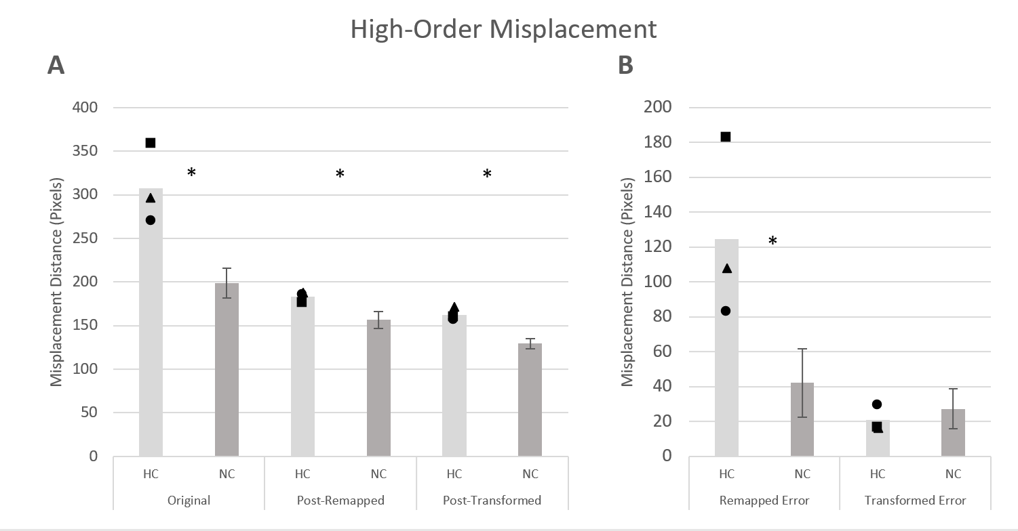

“**Figure 4**: Comparisons of Patient (HC) vs Comparison Participant (NC) groups for A) Misplacement Across Analysis Steps, i.e. misplacement magnitudes at each step of analysis and B) Reduction in Misplacement by High-Order Error Type, i.e. differences in misplacement accounted for by each step (i.e. the subtraction of A). For Patients, individual symbols are shown such that: Square is 1951, Triangle is 1846, and Circle is 2563. (\* means p<0.05)”

Regarding the transformation misplacement (Fig. 4 “Post-Transformed”), a repeated measures ANOVA was performed (Huynh -Feldt corrected) with group by misplacement (original, post-remapped, and post-transformed). A main effect of both group (F(1, 10) = 8.097, p=0.02) and misplacement (F(1.34, 13.41)=45.392, p<0.001) was found, as well as an interaction between group and misplacement (F(1.34, 13.41) = 7.536, p = 0.01). Follow up t-tests confirmed both patients and comparison participants show a significant reduction in their misplacement via the transformation procedure ( and respectively). However, the patients and comparison participants show no difference in the amount of misplacement accounted for by the global error amongst their items (). When the different transformation components (translation, scaling, and rotation; Fig 5c) are observed independently, we see that only rotation has a significantly different magnitude, with patients having larger magnitude rotation errors than comparisons ().

Once all global transformation procedures are performed, patients and comparisons still show differences in the remaining misplacement (difference between means is 33.0 pixels; ). This misplacement is “local” misplacement, which is not shared by all items nor accounted for by identity-location errors. Note that because there is no significant difference between patients and comparisons in the amount of global misplacement error, the final difference between the groups is still significant.

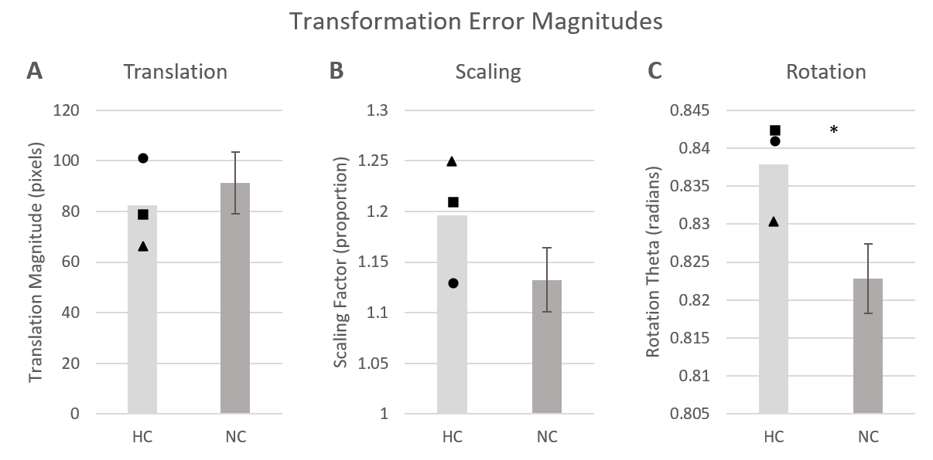

“**Figure 5**: Comparisons of Patient (HC) vs Comparison Participant (NC) in the magnitude of the three types of global transformation error; A) the Translation magnitude, B) the Scaling magnitude (where 1 means no scaling, <1 means shrinking, and >1 means stretching), and C) the Rotation angle (in radians). For Patients, individual symbols are shown such that: Square is 1951, Triangle is 1846, and Circle is 2563. (\* means p<0.05)”

### First-Order and Higher-Order Relational Errors

When we evaluated the location placement accuracy of identities to their assigned locations, there were three primary first-order comparisons of interest. The first two comparisons addressed the question of whether patients could remember identity-location information as often as comparisons, evaluated by: 1) the number of correct placements and 2) the number of items placed in another item’s location. The third comparison of interest addressed the question of whether the patients could remember just the location information as often as comparisons regardless of identity, which was evaluated by examining the number of items placed in any valid location (note that this is just the sum of 1 and 2). To examine group differences in these quantities (particularly 2 and 3), we performed a between groups repeated measure ANOVA on the identity-location errors (i.e. 2, above) and the total number of items placed in any valid location (i.e. 3, above, the sum of the identity-location errors and the correctly placed items). We found a significant interaction of group and these two quantities (F(1, 10) = 17.127, p=0.002). Follow up Welch’s t-tests showed that hippocampal patients made fewer accurate placements of the correct identity to the correct studied location (e.g., successful identity-location binding) than comparison participants (t(5.21)=5.45,p=0.003;Fig 6). Importantly, however, patients had more placements of items in another item’s studied location (i.e. correct item-location relations with incorrect identity-location relation) than comparison participants (t(5.06)=2.83,p=0.04); Fig 6.), even after subtracting the global errors. When we looked at memory for locations (regardless of identity; i.e. items placed in any valid location), we found no significant difference between patients and comparisons (t(4.71)=0.71,p=0.51)).

In regard to compound errors (i.e. swaps or cycles), we saw no difference between patients and comparison participants (t(9.96)=0.39,p=0.71 for swaps and t(7.11)=1.75,p=0.12 for cycles, respectively) despite large differences in individual identity-location assignment.

The fact that patients and healthy comparison participants had similar memory for locations (ignoring identity assignment) serves as the first piece of evidence suggesting the possibility that some shape-like information (albeit only in the form of a set of vertices) may be used by patients to reconstruct spatial location. In any case, it is clear that some aspects of relational information in the reconstruction (i.e. some combination of item-environment or item-item relations) was not impaired in hippocampal damaged patients.

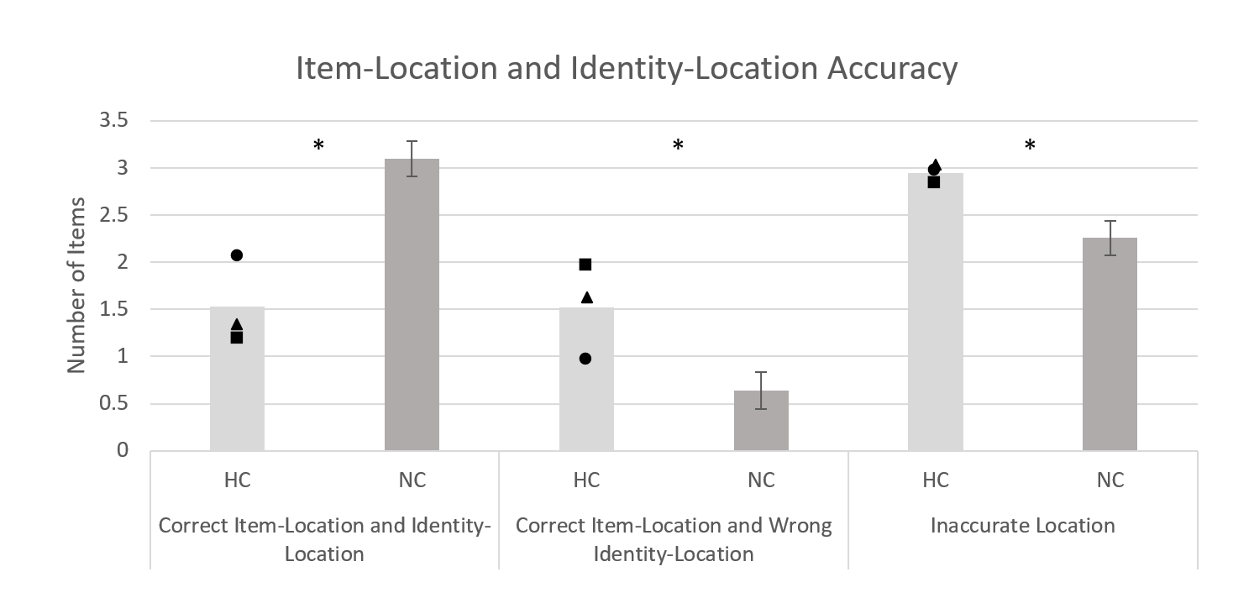

“**Figure 6**: Comparisons of Patient (HC) vs Comparison Participant (NC) in the number of items in which item-location and identity-location was correct and incorrect. Note that items which were not placed in any studied location are collapsed together as ‘Inaccurate Location’. For Patients, individual symbols are shown such that: Square is 1951, Triangle is 1846, and Circle is 2563. (\* means p<0.05)”

### Differences in Accuracy of Item-Location Associations across Set Sizes

As our previous work showed that patients committed relational memory errors even at very low item set sizes, it is useful to ask if, given our new framework for analyzing various types of relational information, we see the same pattern of impairment across all set sizes. We took advantage of our previous data set from Watson et al 2013 to determine if the number of studied items impacts the different types of spatial-relational errors discussed here. In a 2 x 4 ANOVA with factors group (patients and comparisons) and set size (2, 3, 4, 5), hippocampal patients showed no main effect of set size () on accuracy of placing items in their target locations, placing roughly only a single item in its correct location (identity-location relation) regardless of set size (2 to 5). However, the main effect of set size was significant for comparisons (). Importantly, as reported previously (Watson et al., 2013), only patients committed identity-location errors at small set sizes; comparisons did not. Furthermore, when considering performance at set size 5, in which both groups made identity-location errors, there were no significant group differences for other types of compound relational errors, namely swaps and cycles; swaps () and cycles (). Taken together, these data show that across set sizes, patients show specific impairment to identity-location information without showing any significant compound relational error differences once the set size is sufficiently high for comparisons to begin making identity-location errors.

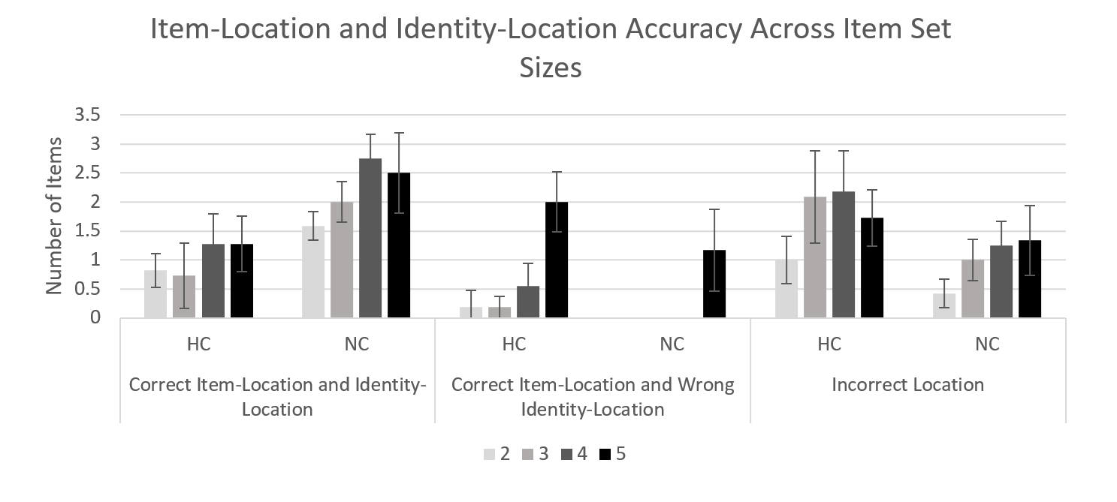

“**Figure 7**: Comparisons of Patient (HC) vs Comparison Participant (NC) Item-location and identity-location accuracy across set sizes for patients vs comparisons. Note that items which were not placed in any studied location are collapsed together as ‘Inaccurate Location’.”

## Discussion

The present study investigated the impact of hippocampal damage on various types of relations in a spatial memory task. While the role of hippocampus in spatial memory has an extensive history (Hayes, Ryan, Schnyer, & Nadel, 2004; John O’Keefe & Nadel, 1978; L. Ryan, Lin, Ketcham, & Nadel, 2009), the present data demonstrated that patients with hippocampal damage are not impaired relative to healthy comparison participants on *all* *types* of spatial errors; rather they demonstrate particular deficits in identity-location relational memory.

There are many reasons why identity-location relationships, specifically, might be impaired with hippocampal damage. Consider a case where a single item is presented in a bounded spatial environment. Only one type of relational information, namely the item-environment relations, is necessary to remember where that item belongs. Remembering the identity of that item is not necessary to complete the task. However, if a second item is added to the display, each item has an item-environment relationship, but also item-item relations and identity-location relations. It is, of course, not necessary to encode all three relation types to represent the display because some relations provide redundant information (i.e. the item-item relations contain information which is redundant with the item-environment relations). However, for an accurate representation, the identity-location relationship is not redundant with other types of relations and must always be considered. Identity-location relations are entirely arbitrary (in the SR task) and the critical component for successful memory performance; perhaps unsurprisingly then, arbitrary identity-location relationships are the type of relations that are most hippocampally dependent in a spatial memory task. As mentioned previously, it is important to note that item-item and item-environment information in this task and framework are not necessarily equivalent to seemingly similar relations in other domains (i.e. item-item where both are words or item-environment where it is the mapping of an object *including its identity* to a spatial location); this is due primarily to the specificity with which we have defined these terms (i.e. ‘items,’ in this case, have had their identity information removed and specifically reference spatial-only information).

The assertion that the *arbitrary* type of relational information in this task is the type showing impairment is consistent with previous findings showing hippocampal damage impairs memory for *arbitrary* relations between words (Giovanello et al., 2003), spatial locations in a scene (D. E. Hannula et al., 2006), and temporal relations, and, indeed, all manner of relations regardless of the informational domain (Konkel et al., 2008). The data bear out this conclusion by showing that if we remove the identity information from the patient data, we see the difference between the groups in overall misplacement reduced by over 75%. Furthermore, when stripped of identity information, patients and healthy comparison participants do not differ on the number of correctly chosen locations. This shows that although patients show impaired memory for arbitrary relations in all stimulus domains, including spatial relations, they are not impaired on all *types* of spatial relations (i.e. they are able to reconstruct some item-environment and item-item relations). Patients with hippocampal damage show a deficit in reconstructing the *specific* item identity to its *specific* studied location.

The present data also demonstrated that hippocampal patients and comparison participants do not differ in compound spatial relational memory errors (e.g., translation, scaling, swapping, and cycles). And while rotation errors showed a statistical difference in magnitude between patients and comparison participants, the magnitude was quite small (0.86 degrees), accounting for very little overall misplacement difference between the groups. Moreover, because the very first step in the analysis is to remove identity information, the total amount of possible rotation is artificially restricted to no more than the half of the maximum angle between two items from the rotation center, making it more complicated to interpret global error type than scaling and translation that have no such restrictions. It is, of course, possible that the significant difference in rotation errors is due to additional memory deficits. Unlike scaling and translation, in which pairwise spatial relations are invariant (i.e. if item A is above and to the right of item B and a translation or scaling transform is performed, item A will always still be above and to the right of item B), pairwise spatial relations are not invariant under rotation. This could point to further, more subtle deficits in particular types of relations, but further investigation into this error type is needed.

It is interesting to note that some misplacement remains as local, “noisy” misplacement after the removal of identity and global errors, and this local misplacement was significantly greater in patients than comparison participants. This is consistent with other accounts of spatial memory and the hippocampus such as the Precision and Binding Model (Yonelinas, 2013a) which posits that the hippocampus is critical for “high-resolution” binding in space, predicting that hippocampal patients should have poorer spatial memory precision. These accounts may not generalize to all domains of information, however, as some evidence shows hippocampal damage relating to impairment in the quantity of information which can be remembered, rather than the quality (or precision) of the information when testing hippocampal patients on color information (Warren et al., 2015).

In regard to compound relations involving identity-location information (e.g., swaps and cycles), it has been proposed previously that a lack of memory for identity-identity and identity-location relations in hippocampal patients may result in more identity-identity swapping (Watson et al., 2013). However, the present data demonstrated no group difference in swaps or cycles after accounting for overall location accuracy. The reason for this discrepancy is likely a combination of: 1) a difference in mathematical formulation of swapping (i.e. not using accuracy as a prerequisite for a successful swap results in an over estimate of the number of swaps) and 2) the inability of hippocampal patients to represent a sufficient amount of relational information to commit compound-relational error such swaps (which requires memory for two locations and their positions relative to one another and/or the environment but no information about item-location relations) more than by chance. Specifically, on the second point, if hippocampal patients are not maintaining identity-location information, their ability to have group-wise reassignment errors will be limited because they do not have specific knowledge of the constituents of the group. These compound swap/cycle errors do occur in both patients and controls (although patients uniquely commit them at very small set sizes), but once the set size is sufficiently high (i.e. once the comparison group actually makes identity-location errors) the groups do not differ in the frequency of their occurrence. Said differently, just as identity-location errors seem to account for a substantial proportion of patients’ overall misplacement errors, the disproportionate occurrence of swap and cycle errors at small set sizes in patients can also be attributed to their overall deficit in identity-location binding.

What causes this sudden increase in identity-location errors in comparison participants at higher set sizes? One possibility requires consideration of accurate identity-location placements in isolation of other metrics. Across all set sizes, hippocampal patients make approximately one accurate identity-location placement. This accuracy could be due, in part, to a maintenance of a single identity-location relation in working memory across the relatively short time span between study and test. Comparison participants, on the other hand, make accurate identity-location placements proportional to the set size.

When we consider how hippocampal patients may be able to maintain item-environment and item-item spatial relational information, it is interesting to consider alternate representations which may be able to maintain those relations. Previous work suggests that hippocampal damage may not impair shape information in SR task performance, as hippocampal patients may be able to represent shapes via an alternative, “unitized” representation, which can be formed via Gestalten perceptual features, i.e. configural features which constitute parts of a unified whole, rather than relations (Corsi, 1972; Kessels et al., 2000; Uttal & Chiong, 2004). The present data provide a suggestive look at this assertion from a purely vertex-oriented definition of shape, as the patients and comparisons did not differ in the number of locations (i.e. vertices) in which they accurately placed an item (independent of item identity), nor did they differ in the amount of global misplacement (i.e. misplacement that is systematically shared by all items) of the entire item set. This suggests that, at least in this highly restrictive definition of shape being defined via vertices, a similar amount of shape-like information is present in both comparison participants’ and hippocampal patients’ reconstructions. That said, using global misplacement transformations as a measure of shape is not necessarily the optimal method for investigating this issue, even with shape being defined solely via vertices. Topological Data Analysis techniques may prove to be a better analysis framework for determining the degree to which high-level relational information is preserved in a reconstruction (Carlsson, 2009; Ghrist, 2007). In Topological Data Analysis (TDA), large groups of vertex relations can be evaluated and compared directly with minimal assumptions by forming a more mathematically rigorous definition of the high-order structure of these relations. A similar technique to TDA has been used previously in spatial memory by Kolarik et al. in analysis of data from hippocampal damaged patients using a virtual Morris Water Maze (Kolarik et al., 2016, 2017). It is unclear, however, if this technique scales well to a very small number of points, and, as such, these analyses are not included in this work; future investigations better suited to the technique should be considered.

There are alternate explanations for the ability to maintain item-environment and item-item spatial relations other than maintenance of shape-like information. It is possible individual relational information *is* being stored separately via a different brain region(s). For example, the parahippocampal place area has been shown to be involved in processing geometric information about scenes (Epstein, 2014), and the occipital place area has been related to processing of boundary relations between items and visible scene boundaries (Julian et al., 2016). If shape information were being used, regions such as the inferior temporal cortex could be involved in providing preprocessed representations of shape via shape selective neurons identified in this region (Perrett & Oram, 1993). Alternatively, some heuristic approach to reconstruction could be used which takes advantage of hidden constraints in the task (i.e. it is unlikely for two items to appear on top of each other, which constrains the possible reconstructions). Should the hypothesis that shape-like information is being used to maintain these relations be investigated, different experimental paradigms could be used in which various levels of complexity of shape-like information are superimposed on a point set and presented to participants to be learned then reconstructed. In particular, edges between the locations could be drawn to avoid the need to infer some item-item relations which may contribute to a shape-like representation. We would predict that patients would perform similarly to comparisons for simple shapes and show deficits primarily in identity information for the vertices. Patients may also show performance deficits for more complex shapes, which are not as easily unitized (thus preventing a non-hippocampal representation from being as helpful).

Taken together, the evidence presented here defines the various *types* of relations present in a spatial-relational paradigm by applying a systematic framework that allows a more thorough investigation of the role of hippocampus in spatial-relational memory. Consistent with previous theories of the role of hippocampus in relational memory via the arbitrary binding of information (Neal J. Cohen & Eichenbaum, 1993; Eichenbaum & Cohen, 2001), patients with hippocampal damage demonstrated specific deficits in arbitrary binding of identity-location relational information. Patients do not show a deficit in compound relational errors or location accuracy, suggesting that some types of relational information (in fact, the non-*arbitrary* relational information; i.e. information which has alternative derivations or redundancy) can be maintained by memory systems which are not hippocampally dependent. These results further clarify the role of the hippocampus in relational memory theory to be specifically in maintaining *arbitrary* relations which cannot be derived from other information which might be remembered by the participant. We have also proposed several possible alternate means through which other, non-arbitrary information may be maintained (such as a shape-like representation), which can be investigated in future research. We would predict, however, that because one benefit of representing arbitrary relations is in the ability to flexibly use those relations with changing task demands, whatever alternative means is being used to maintain these relations may not permit the same amount of flexibility.

SR tasks have proven enormously informative in that they provide sensitive measures of relational memory abilities that have been tied not only to hippocampal damage, but to more subtle hippocampal deficits such as subjective memory complaints (Lucas et al., 2016), spatial pattern separation (Clark et al., 2017), and medial temporal lobe viscoelasticity (Schwarb et al., 2017b, 2016). Precision and specificity of the metrics and the ability to distinguish between several different types of spatial relational errors will undoubtedly serve these lines of investigation well as it will allow a far more resolute picture of the specific impairments that may be tied to particular behavioral, functional, and structural phenotypes.

# Memory during Time Travel: Spatiotemporal Navigation, Contextual Boundaries, and Relational Memory Errors in Virtual Reality

# Introduction

*Episodic memory* involves memory for events, i.e. things which happen in time and space, organized according to relational and contextual information, and is often referred to as the “ability to jump back in time and relive events from the past” (DuBrow & Davachi, 2013; Tulving, 2002). In humans, the *hippocampus* has been shown to be a critical brain region for episodic memory such that hippocampal damage in humans causes pervasive *amnesia* (for review, see Cohen & Eichenbaum, 1993). There has been considerable historical success in studying hippocampal function in the spatial domain, with early experiments identifying “place cells” in the hippocampus of rodents which fire in association with the location of an animal in a spatial environment (O’Keefe & Nadel, 1978). The temporal organization of memory has also received considerable attention, including the recent identification of “time cells” in the hippocampus which fire selectively for moments in time (Eichenbaum, 2014). However, experiences are not restricted to space or time in exclusion of each other, but consistently involve a mix of both. Despite this, most studies do not simultaneously examine behavior in both space and time, possibly because space, as an explorable domain that can be selectively sampled, and time, as unidirectional flow of experience that cannot be selectively sampled, seem to be too distinct for direct comparison. This work takes the first step towards resolving this asymmetry by allowing both space and time to be explored by participants using *Virtual Reality* (VR), a technology which allows for increased measurement and control fidelity as well as increased ecological validity when compared to other methods (Schultheis, Himelstein, & Rizzo, 2002). This approach provides a new framework to investigate and understand the nature of episodic memory, extending beyond the limitations of typical experimental environments.

*Relational memory theory* explores the relationship between different domains of information (such as, but not limited to, space and time) and their representation in the hippocampus. (Cohen & Eichenbaum, 1993; Eichenbaum & Cohen, 2001; Konkel & Cohen, 2009; Konkel, Warren, Duff, Tranel, & Cohen, 2008). According to relational memory theory, the hippocampal region critically supports episodic memory via relational memory, i.e. the learning of arbitrary relational information regardless of the domain (Konkel et al., 2008) – a function which is pervasively impaired in hippocampal damaged patients. To evaluate relational memory in humans, *spatial reconstruction* (SR) tasks have proven particularly effective in examining relational memory errors in space. This task can be used to infer an individual’s success in forming arbitrary associations between items and locations in space (Huttenlocher & Presson, 1979),and to determine the susceptibility of making relational memory errors due to hippocampal damage (Jeneson, Mauldin, & Squire, 2010; Smith & Milner, 1981; Watson et al., 2013). In an SR task, participants are asked to study the locations of items in space and, after a short delay during which the items are removed from the environment, place the items back where they were studied (i.e. reconstruct the study configuration). Hippocampal damage specifically impairs arbitrary identity-location binding, i.e. binding of the identity information for a specific item (i.e. the item was a boat, plane, boxing gloves, or flower) to a specific location (Horecka et al., 2017, under review). In healthy individuals, identity-location binding errors and compound memory errors (i.e. those in which groups of items are misbound to each other’s locations) can occur when the number of to-be-remembered items increases beyond approximately 4-5 items (Watson et al., 2013). SR tasks have been used successfully in examining the relationship between relational memory and subjective memory impairment (Lucas et al., 2016), medial temporal lobe viscoelasticity (Schwarb et al., 2017; Schwarb, Johnson, McGarry, & Cohen, 2016), and spatial pattern separation (Clark et al., 2017), however, time has always been intentionally isolated into other tasks. In this work, we present the first *spatiotemporal reconstruction (STR) task* in which the locations of events in both space and time are studied and reconstructed.

There is substantial evidence that the hippocampus is critical for organizing information about the temporal order of events, and that in humans, hippocampal damage results in deficits in temporal-order memory for those events (Dede, Frascino, Wixted, & Squire, 2016). Additionally, functional imaging studies have shown hippocampal activation during encoding and retrieval of event order information (see Eichenbaum, 2014 for a review). In rodents, hippocampal lesions also impair temporal-order memory for non-spatial stimuli without impairing memory for the specific stimuli (Fortin, Agster, & Eichenbaum, 2002; Kesner, Gilbert, & Barua, 2002). However, in all of these examples, event series have been viewed unidirectionally, critically restricting the directionality of temporal relations and information. Although physical space-time may have the restriction of direction-of-flow in time, this restriction can be, at least in part, artificially overcome in simulation.

Additionally, there is extensive evidence that contextual information influences temporal order memory in online processing of sequences (Ezzyat & Davachi, 2014). For example, Zacks et al. have suggested that an *event model* which is updated according to event *boundaries* can describe processing of events in time (Zacks, Speer, Swallow, Braver, & Reynolds, 2007). In humans, *context boundary effects* (i.e., distance judgements of item pairs within vs across context boundaries are biased such that items which are separated by a context boundary are judged as further apart than those which are within a context) have been demonstrated (DuBrow & Davachi, 2013) and the hippocampus has been implicated in representing temporal order and distance in the presence of changes in context (Davachi & DuBrow, 2015). Taken together, these studies highlight the importance of context in episodic memory representations; importantly, however, this evidence was bound to a unidirectional timeline of events and often discretized such that time is not allowed to flow normally in a continuum (with the exception of the Zacks work), but is instead broken up into discrete events. It is unclear if, given the ability to freely explore a series of events organized by context in a continuous timeline, these same effects would persist. In particular, the ability to cross contextual boundaries in both directions as often as desired (a feature of real-world navigation which is far more common than the restriction that each boundary may only be experience once and in the same direction) has never been explored.

In this work, we introduce a powerful *spatiotemporal navigation task* for examining relational memory errors and the impact of context on memory for event locations in space *and* time by allowing participants to freely explore an environment in both space and time using Virtual Reality. Critically, we provide participants with the ability to “time travel” (i.e. decide the direction of the flow of time), placing the ability to explore space and time on more equal footing so that errors in either domain can be examined simultaneously. This “time travel” ability is necessary to allow spatiotemporal reconstruction where participants can visit events in time as freely as they can the spatial locations of events. To our knowledge, this is the first *spatiotemporal navigation task*.

# Methods

Participants

43 participants (ages 18-24; mean 20.0 years; 23 males; 13.8 mean years of education) from the University of Illinois Urbana-Champaign participated in the study. In addition to the 43 participants being analyzed, 4 participants were excluded due to not completing the task within the allotted 2.5 hours. All participants signed informed consent prior to participation, approved by the University of Illinois Urbana-Champaign Institutional Review Board and were paid $8 per hour of their time.

Design and Procedures

In this task, participants were placed in a virtual environment measuring 40 meters by 40 meters, bounded by walls on the exterior (see **Figure 1A)**. The environment resembles a small park with trees, rocks and plants. Participants used the Oculus Rift DK2 and a wireless Xbox controller to interact with the environment. Auditory cues were presented via a pair of over-ear, stereo headphones. Participants were given a single practice trial to learn the simulation mechanics as well as to gain competency in using the virtual reality hardware. Practice was not timed and participants were allowed as much time as they desired to become comfortable. The stimuli during practice were white boxes (0.5m x 0.5m x 0.5m) floating 0.25m above the ground with gray dots on each face. Five items were used in practice. In order to encourage exploration the environment, an invisibility bubble 10m in diameter was placed around the participant such that any items beyond that distance away from the participant were not visible. A ring was visible on the ground to indicate to the participant the distance at which items were visible. In addition, some items were always present throughout the trial, while others underwent events (i.e., entered the display or were removed from the display) at specific time points during the simulation timeline (see **Figure 1** for a description). Thus, there were three event types 1) items flew into the sky and left the environment at specific times (an “up” event, i.e. disappearing), 2) items fell from the sky and land in the environment at specific times (a “down” event, i.e. appearing), and 3) items were stationary and thus always present in the environment. During practice, there were two up events, two down events, and one stationary item. An auditory cue was given every time an event occurred regardless of whether or not the item was in view. Item positions were determined via random number generator; however, they were constrained in time to balance for within vs. across context boundary distance.

Temporal context information was provided in the form of the simulation boundary walls changing colors at evenly spaced intervals throughout the simulation. Thus, context boundaries were defined as shifts from one color to the next. The colors yellow, red, green, and blue were used for the contextual information, which changed every 7.5 seconds during practice such that all contexts appeared within 30 seconds. The order of the temporal contexts was counterbalanced across participants with half receiving yellow, red, green, and blue and the other half receiving blue, green, red, and yellow.

**A**

**B**

**C**

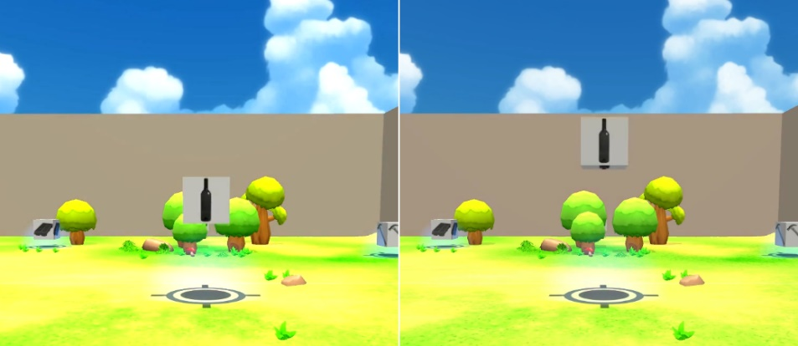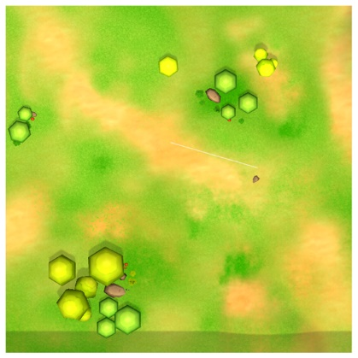

**Figure 1**: The two types of events an item can undergo in time and a visualization of the environment. A) shows a “down” event, in which the item falls from the sky, B) shows an “up” event, in which the item flies into the sky, and C) shows the environment from a top-down view. Note that these two types of events are time-symmetric, in that they look identical when viewed from opposing directions (forward or backward) in time.

Participants could both walk around the environment (and turn their head to look in any desired direction). Temporal navigation was controlled via button press that could reverse the flow of time, at the same speed as the forward flow of time. To provide additional temporal information, ambient music was played for the entire timeline of the task, meaning reversing the flow of time reversed the music as well. Participants’ looking direction and location in space and time were logged at every time point in the simulation (~16ms intervals). If the participant reached the beginning or end of the simulation’s time course, time was paused but the participant was still allowed to freely move about the spatial axes in the environment. Participants were instructed to find the locations of each item in space and time, specifically when their events happened. To signify they had found the item at its event, there was a 0.5 second window during which participants could see the item’s event (if close enough) and press a button on the controller to acknowledge they witnessed the event. When the participants successfully click on the item during its event, the item would change to the background color during its event (with stationary items staying grayscale when clicked). Participants were given unlimited time to explore the environment, find each item, and acknowledge they had viewed each event.

After the practice trial, there were four experimental trials each with a study and test phase. Experimental study trials were identical to the practice trial with three exceptions. First, the number of items was increased to ten. Therefor there were four up events, four down events, and two stationary items. Second, the gray dots on the sides of each white box were replaced with namable object images (see **Figure 1B&C** for example). Third, the context changed every 15 seconds such that all contexts appeared within 60 seconds. Each context had two item events during its duration. Finally, the 4 study-test trials all used the same spatiotemporal item configuration, allowing learning across trials to be assessed.

During test, participants were asked to reconstruct each item in its spatiotemporal location as well as to determine which event type (up, down, stationary) the item underwent. To do this, participants were given an inventory of the items (an overlay on the screen) allowing them to freely select any item and its event type. As with study, participants could navigate space in on the x/y plane, and could navigate time via the reverse-time button. Context continued to change as it did during the study phase. Participants were given unlimited time to perform the reconstruction.

Analysis Metrics

Four primary analysis methods were used to evaluate reconstruction performance. First, a naïve misplacement distance error was computed across trials to confirm that participants were improving in all primary sources of information (spatial, temporal, and event type). Misplacement along continuous variables (space and time) was computed via the sum of the Euclidean distance between all placed items and their expected locations. The number of correct event types was determined by a simple comparison of the chosen event type to the expected (studied) event type for each item (i.e. summing the number they got wrong). Additionally, the participant navigation distance in space and time (separately) was observed across trials, during study to confirm that the study-time behavior was also improving. This spatial and temporal navigation distance was computed via the Euclidean distance between all points traversed by the participant in space (i.e. spatial distance in meters) and in time (i.e. temporal distance in seconds).

Second, an evaluation of relational memory efficacy was performed identity-location misassignment in space and in time (Horecka et al., 2017, under review). Identity-location accuracy was evaluated by first stripping away the identity of the items and determining if each was placed in any item’s location based on a 95% within-participant confidence interval of their misplacement. Then, identities were restored to determine if items were placed in their correctly associated locations (or in another item’s location). Identity-location misassignments are the number of instances in which an item was misassigned to another item’s location within a distance which was deemed “accurate” (see Horecka et al., 2017 for details). Identity-location misassignment has previously been identified as critically dependent on the hippocampus (CITE). In order to isolate spatial and temporal information, two separate analyses were performed using these measures. The 1D temporal axis was analyzed (where location is defined as the position along the 1D axis), and the 2D spatial axes were analyzed (where location is defined in the traditional, spatial way).

Third, the effects of context boundaries on temporal memory distances were evaluated by normalizing the pairwise distance between within and across context items (dividing their reconstructed distance by the expected distance) then mean-centering to make 0 represent a perfect placement (i.e. d>0 represent items placed further than expected, and d<0 represent items placed closer than expected).

Finally, the impact of context on relational memory errors was evaluated by determining the number of identity-location misassignments to another within-context item (i.e. the other item with which it shared a temporal context) or an across-context item. Chance level for within- and across-context misassignments were computed by taking the number of identity-location permutations for within and across context identity-location pairs. The two items which had no temporal context were excluded from this part of the analysis, and, therefore, the chance levels were 8/8*P*2 and 1-8/8*P*2, or 0.143 and 0.857, respectively, where n*P*r represents the number of r-length permutations of n items and the number 8 is due to the 4 contexts containing 2 possible within-context misassignments each (i.e. items a and b within a context can be misassigned a🡪b’s location or b🡪a’s location).

Statistical Analysis

All analyses which compare trial-by-trial performance use repeated measures analysis of variance using SPSS. Where appropriate, Huynh-Feldt correction was applied. Comparisons which involved collapsing performance across trials used either paired-sample, two-tailed t-tests or one-sample, two-tailed t-tests (for comparison to expected chance values). All tests used an alpha value of 0.05 to determine significance.

# Results

Overall Accuracy and Navigation (Misplacement Measures and Navigation Distance)

Three repeated measures ANOVAs (one for each event type) across trials (1-4) revealed that accuracy in both space and time as well as event type improved significantly across trials (see **Figure 2**) for space [F(2.14, 89.79)=25.54, p<0.001], time [F(1.95, 81.94)=78.88, p<0.001], and event type [F(2.56, 107.47)=49.64, p<0.001]. Indeed, participants showed significant improvement trial over trial for all measures [STATS, e.g. t’s > X.XX, p’s < 0.xx], except for the final trial for space [F(1, 42)=2.28, p=0.14)]. Additionally, memory for event type improved significantly across trials (F(1, 42)=5.53, p=0.02 between trials 3 and 4). Finally, the amount of distance travelled in space and time also improves across trials [STATS], showing improved navigation efficacy in addition to test-time memory performance.

**Figure 2**: Overall errors along each of the three major information types in the task and navigation distances in space and time. Space misplacement and time misplacement are continuous variables computed via the sum of the Euclidean distance of all items in a trial to their expected locations in space and time. The number of incorrect event types is just a count of the number of items which were assigned the studied event type. Note that participants improved in all metrics between trials 1 and 4, showing the task was generally well understood. Moreover, navigation performance improved across trials in both space and time showing the improvement was not just in memory during test but also study performance.

Relational Memory Errors

Relational memory errors (identity-location misassignments) were evaluated in space and time separately (see **Figure 3**), showing that significantly more relational errors were committed in time than in space (F(1, 42)= 21.32 p<0.001) even across trials (F(2.56, 107.43,)=13.13, p<0.001 for space and F(3, 126)=11.97, p<0.001 for time). In space, the number of relational errors begin to stabilize by trial 2 (F(1, 42)=3.45, p=0.07 between trials 2 and 3), continuing to trial 4 (F(1, 42)=1.84, p=0.18 between trials 3 and 4).

**Figure 3**: Relational memory errors were evaluated in both space and time independently by measuring the number of items which were assigned to another item’s location (i.e. a misbinding). The number of these errors in time was greater than the number in space. This difference did not change across trials, though both errors decreased as accuracy improved.

Temporal Context Boundary Effects

To evaluate temporal context boundary effects, only items that had been placed in their correct context were considered. A strong temporal context boundary effect (see **Figure 4**) was observed that within-context items were placed closer together than across context items in time (paired sample t-test; t(30)=4.13, p<0.001). This effect was mostly dominated by across-context items being reconstructed as farther apart than they were studied (i.e. a main effect of within vs. across such that the magnitude of the across component is larger than the within component; F(1, 106)=80.84, p< 0.001); however, within-context items were significantly closer together than expected (i.e. the magnitude of the within component is significantly different from 0; t(42)=7.14, p<0.001).

A dimension (space, time) x trail (1-4) repeated measures ANOVA revealed that ……… The context boundary effect did not become significantly weaker trial-over-trial despite increases in both spatial and temporal accuracy (see **Figure 4**; F(2.208, 17.660)=1.155, p=0.342 for within and F(1.731, 13.845)=0.076, p=0.904).

Effect of Context on Relational Memory Errors

**Figure 4**: Context boundary effects (i.e. the misjudgment of distance of within context items as being closer together than expected and across context items as being further apart than expected) can be seen both in within and across context items. These effects are persistent regardless of the trial number.

Finally, when evaluating the identity-location misassignments (i.e. the number of items placed in another item’s location) within vs. across contexts, within-context items were misassigned to each other’s locations far more often than would be expected by chance (t(42)=7.100, p<0.001 for within and t(42)=7.530, p<0.001 for across), suggesting that the contexts biased the relational memory representation, causing confusing between within-context temporal item locations (see **Figure 5**). As a proportion of the relational memory errors which occur across trials, this effect increased trial over trial (F(3, 90)=23.102, p<0.001) until trials 3 to 4 (see **Figure 5**; F(1, 30)=0.281, p=0.60 between trials 3 and 4). Note, this increase in within-context misassignments ran counter to the improvements in overall accuracy and reduced numbers overall relational memory errors, further suggesting the presence of context may bias relational memory representations, resulting in the remaining misassignments being those in which items are assigned to a within context-item location.

Discussion

**Figure 5**: The proportion of items which have been assigned to another item’s location within vs. across context. Although the within context items should be misassigned to each other’s locations by chance at a rate of approximately 14%, we see a substantially higher occurrence of >40%. Interestingly, this effect only gets stronger across trials despite improved accuracy across all non-context based error metrics (including number of misbound items).

In this work, we used a novel spatiotemporal reconstruction task to determine if, when space and time are put on a more equal footing, spatial and temporal relational memory errors would be committed with equal frequency. Furthermore, this work examined if, when a timeline of events can be explored omnidirectionally, the impact of context on distance judgements in time and the subsequent effect on order memory were consistent with previous findings on context boundary effects. This manipulation is critical for theories of the impact of contextual boundaries on memory as individuals can often re-explore across real-world boundaries arbitrarily. We found that, in this task, relational memory errors in time occurred far more frequently than relational memory errors in space. Context boundary effects were found in time such that within context items were judged to be closer together in time than across context items. Finally, we found that relational memory errors in time were influenced by contextual information as items were misassigned to within context locations far more often than expected by chance. Together, this evidence points to a deep interplay between relational and contextual information in both a spatial and temporal domain, and this evidence suggests that temporal representations in memory may be somehow distinct from spatial representations given the huge disparity between memory in each domain even when they are both able to be explored and sampled similarly.

The hippocampus is critical for integrating information into relations representations to aid in flexible memory utilization (Cohen & Eichenbaum, 1993). Its role in episodic memory in humans has been established through work with hippocampal damaged patients who have a pervasive inability to create new episodic memories. Additionally, in humans, some evidence shows the flexibility of the hippocampus’ potential involvement in real-world representations of space and time, even across long distances (Nielson, Smith, Sreekumar, Dennis, & Sederberg, 2015). In rodents, cells which fire in association with space (i.e. place cells), time (i.e., time cells; B. Kraus, Robinson, White, Eichenbaum, & Hasselmo, 2013), and distance (B. J. Kraus et al., 2015) have been identified in the hippocampus and its role in navigation (e.g., Eichenbaum, 2017) has been well established. In line with these observations, some have proposed that space and time make up a scaffolding upon which episodic memories are formed (Ekstrom & Ranganath, 2017). It is not clear, however, if space and time are coded together, as a unified space-time manifold, or if information is bound to each independently of one another. The evidence here cannot completely disentangle these possibilities, however, when using a relational memory error metric which has been shown to be particularly sensitive to hippocampal damage in human patients (Horecka et al. 2017) and the spatiotemporal reconstruction task we present here, we do find differences in space and time relational memory in healthy individuals such that relational memory errors in time are substantially more common than in space. This suggestions that although these domains may be representable as a unified whole, they are not necessarily so in all circumstances. Task demands may play a large role in determining the degree of interplay between spatially bound and temporally bound information; however, the emphasized domain (time, in this case) may not always benefit from being in focus.

There are several explanations for the phenomena we observe here beyond encoding differences between space and time. First, although both space and time could be explored freely in this task, time remained one dimensional while space had two explorable dimensions. The additional dimension adds more information which must be remembered in order to know spatial locations, but it also provides more information which relational representations may bind. Future tasks may attempt to disentangle these possibilities by restricting space to one dimension or expanding time to two dimensions. Additionally, because time can be explored in any order, it is possible that the ability to view events in any order hurts memory for order in a way which increases the chance of misbinding items to other item’s temporal locations. A similar debate has occurred in the rodent literature in spatial navigation such that distinct hippocampal representations for overlapping routes in a maze are not observed when rats are trained to run in either direction of a Y-maze (Lenck-Santini, Save, & Poucet, 2001). This raises an interesting question: can the relative position (i.e. order) of events in time in episodic memory be treated both allocentrically and egocentrically in the same way the spatial position can?

In spatial navigation, Cognitive Map Theory says that allocentric representations depend on the hippocampus (O’Keefe & Nadel, 1978) with alternate strategies such as view-matching being used to overcome deficits in allocentric memory (Banta Lavenex, Colombo, Ribordy Lambert, & Lavenex, 2014). However, it is unclear what a view-matching strategy would be when exploring a temporal axis. Place cell firing is related specific to distal cues and is, therefore, seen as strong evidence for this allocentric perspective. The evidence here hints at the allocentric nature of time cells as well, and perhaps, with the proper observation of time cells in a task which allows the free exploration of a series of events, this hypothesis could be validated.

An additional potential explanation for the asymmetry between spatial and temporal relational memory errors is that the temporal axis in this task uniquely contained contextual information (i.e. the spatial axes did not), which may have caused confusion between within-context items (discussed more in future paragraphs). Tasks in which both spatial and temporal contextual information are present might help to clarify this impact, however, it may not be sufficient to simply include additional types of context to completely disentangle the impacts they have in space and time if spatial and temporal representations are truly distinct.

In addition to the interplay between spatial and temporal memory, this task also allows us to examine the impact of temporal contextual information on memory for a sequence of events. Similar to tasks which exclusively examine order memory, we find context boundary effects such that within context items are placed closer together in time than across context items, even when equidistant. However, this task shows these effects in a continuous timeline of events even when the timeline can be freely explored and the contexts can be restudied freely as often as the participant likes. Moreover, the effect does not diminish when the same short series of events is repeatedly studied. This provides strong evidence that the contextual information is biasing the reconstruction systematically. Critically, of all of the types of errors examined in this task, the context boundary effect is the only error which does not improve with repeated study of the event timeline. Some hierarchical models which attempt to describe how context might be used to organize memory representations suggest that context sits at the top of a hierarchy containing other information such as spatial, valence, and item information (McKenzie et al., 2014). This may explain, in part, why restudy and free exploration don’t improve the context boundary effect as the contextual information is being used as a very high level organizing principle for other, more granular information. This may be consistent with high-level theories of the interplay of multiple brain regions involved in contextual and relational learning such as the Complementary Learning Systems model which would suggest that cortical regions which represent and utilize this higher-order information are potentially slower to update than hippocampally-dependent relational information (McClelland, McNaughton, & O’Reilly, 1995). However, recent updates to this view complicate the issue as the speed of acquisition of information in cortical versus hippocampal systems may not be so clear cut (Kumaran, Hassabis, & McClelland, 2016). Alternative models which posit a rapid interaction between prefrontal and hippocampal regions in service of decision making (Wang, Cohen, & Voss, 2015) might better fit behavior in this task as the utilization of the contextual information is necessarily happening in a continuous, real-time manner. However, it is important to note that real-world contextual information is not nearly as clear and discrete as the artificially imposed contexts in this task, and future work might use contextual boundaries (such as night/day boundaries) which are more consistent with real-life experiences.

Finally, one of the most striking results in this work is the interplay between relational information and contextual information. Specifically, we see that the contextual information is related to poorer performance in order memory even when temporal accuracy improves. This is evaluated by determining the relative proportion of misassignments (i.e. relational memory errors) where an item is placed in another item’s location within vs. across a context boundary. If this error were to occur by chance (via randomly ordering the items), we would expect approximately 14% of misassignments to be to a within-context location. However, we find the error occurs more than twice as often as expected within-context. Moreover, within-context misassignment errors become more common (as a proportion of the total number of misassignments) on repeated study. This result disagrees with previous accounts which show that context boundaries should impair order memory for across context items and enhance memory within contexts (Davachi & DuBrow, 2015), and shows that, at least when a series of events can be freely explored, context can be related to worse order memory for within context items. There are several explanations beyond the organization of memory due to context which could account for this result. Firstly, it could be that the ability to view a timeline of events in any order results in more confusion for within context items as the viewing order of the context can be different on each exploration. However, it is important to note that participants were not required to view the items in a particular order and could have biased their exploration to avoid this issue. Additionally, if this were the case, we might expect more overall misassignment errors, but this would not completely account for why these errors are so much more common within context than expected unless the context was being used to organize the representation on some level. Another explanation might be that with a limited number of items in the context, not enough information is present to form a reliable relational representation. This explanation may be consistent with the interpretation described earlier that spatial relational information, by having an additional axis within which to bind relations, is easier to reconstruct than temporal relational information. In other words, more information may improve relational memory, to a point. This question could be tested by increasing the number of within-context items to see if this improves within-context order memory.

In summary, with the use of Virtual Reality to create a rich task environment, the importance of contextual information in organizing episodic memory representations can be seen with much more fidelity than previous experiments. Furthermore, contextual information is shown to bias relational memory errors, which were far more common in time than space, such that items were more likely to be misassigned to the temporal location of an item with which it shared contextual information that might be otherwise expected. Spatiotemporal navigation, as presented here, can hopefully serve as a first step in furthering our understanding of the flexibility and structure of relational memory representations in space and time and clarify the influence of context on different domains of information without the need to treat time differently than we treat space.

# Spatiotemporal Navigation, Sampling, and Information Encoding in Virtual Reality

## Introduction

Gallistel, (1990) said, “Navigation is the process of determining and maintaining a course or trajectory from one place to another”. This definition captures a surprising amount of cases which would be commonly considered navigation, and it has been echoed in recent reviews of navigation and hippocampal function in various species (Eichenbaum, 2017b). Interestingly, however, the word “place” in this context strongly implies that navigation is generally restricted to space (and is used as the term to describe cells which fire relative to allocentric locations in space, i.e. “place” cells; O’Keefe & Dostrovsky, 1971). Introduced by Tolman, (1948) and elaborated upon in the context of hippocampal function by O’Keefe & Nadel, (1978), Cognitive Map Theory suggests that, at least in space, the hippocampus is responsible for maintaining map-like, allocentric representations, and this theory has been validated to various degrees across many human and rodent lesion studies (Astur, Taylor, Mamelak, Philpott, & Sutherland, 2002; Bartsch et al., 2010; R. G. M. Morris et al., 1982; J. O’Keefe & Dostrovsky, 1971; John O’Keefe, 1991). Tolman himself did not restrict this theory to space; however, later uses of the theory have tended to isolate space in exclusion of any other domains. Despite this isolation of navigation to space, “time” cells in the hippocampus have been identified which fire relative to particular moments in time (B. Kraus et al., 2013), and extensive evidence suggest the hippocampus is involved in mapping far more than just spatial information (Eichenbaum, 2015, 2017d; Konkel et al., 2008). It is, therefore, interesting to expand the definition of navigation to include not just movement from place to place, but also from time to time (or, potentially movement between any discrete locations in any domain). The previous chapter shows how this can be done in time (via having participants Time Travel), and participants successfully reproduce several test phenomena including relational memory errors (see Chapter 1) and Context Boundary Effects (DuBrow & Davachi, 2013), as well as some new phenomena which have not be previously explored; they also successfully, over multiple trials, navigated the environment to improve their memory for a timeline of events (see Chapter 2). One prediction which was made in the previous chapter is that time cells map an allocentric perspective on time, not an egocentric one, despite the fact that time (like space) is consistently experienced egocentrically. Of course, the primary way this hypothesis could be validated is via electrophysiological work with actual time cells, but it is not immediately clear how this task could be run on rodents, so human participants may be required. This puts the direct confirmation of the theory out of the scope of this work. Instead, in this work, I suggest analysis methods which might be applied to the behavioral navigation data collected in the task described in Chapter 2 to gather evidence with respect to this hypothesis. Additionally, I proposed analyses which might clarify aspects of spatiotemporal navigation in general which relate to relational and contextual memory in space and time.

Spatial navigation is a critical capability of all creatures’ survival which are capable of movement (Wolbers & Hegarty, 2010), and it has been extensively studied phenomenologically in humans (Dudchenko, 2010; Huth, 2013; Wolbers & Hegarty, 2010), animals (Poucet, 1993; TRULLIER, WIENER, BERTHOZ, & MEYER, 1997), and even robotic navigation (Franz & Mallot, 2000; Levitt & Lawton, 1990) which has, more recently, become an extremely popular topic in machine learning research (Mirowski et al., 2017). Traditionally, in a laboratory setting, tasks such as the Morris Water Maze (MWM; Morris, 1981) have been used to study both rodent and human (using a virtual Morris Water Maze; vMWM; Moffat & Resnick, 2002) navigation behaviors, showing, in older adults, that smaller hippocampal volumes account for longer distance travelled and time taken in the task (Maguire, Burgess, O’Keefe, & O’Keefe, 1999; Moffat, 2009). Rarely, more complex behavioral tasks have been studied such as observing hippocampal neurons in bats as they navigate in the real world (Geva-Sagiv, Las, Yovel, & Ulanovsky, 2015; Sarel, Finkelstein, Las, & Ulanovsky, 2017). Several models of hippocampal function in navigation have come out of these tasks. In rodents, theories of Pattern Separation/Pattern Completion (Marr, 1971; Rolls & Kesner, 2006) have suggested that hippocampal lesioned rodents’ deficits in spatial location accuracy are due to an inability to create precise representations of specific locations and differentiate them from other studied locations (i.e. a deficit in pattern separation; Gilbert, Kesner, & DeCoteau, 1998). Other have expanded on this theory suggesting that after converging “what” and “where” streams reach the DG and CA3 subregions of the hippocampus (Knierim & Neunuebel, 2016), DG specifically performances pattern separation (Leutgeb, Leutgeb, Moser, & Moser, 2007; McHugh et al., 2007), orthogonalizing inputs from one another, while CA3 performs pattern completion (Leutgeb et al., 2007; Nakazawa et al., 2002; Neunuebel & Knierim, 2014), auto-associating inputs with previously learned patterns. In humans, the Precision and Binding Model (PBM; Yonelinas, 2013), whose evidence shows hippocampal damaged patients are impaired on finding the precise location of a hidden platform but can find the general location (i.e. quadrant; Kolarik et al., 2016; Kolarik, Baer, Shahlaie, Yonelinas, & Ekstrom, 2017), says that the hippocampus is required for high-resolution information binding in spatial navigation. However, in rodents who have already learned a target location or who are attempting to navigate to a target location which has a cue, hippocampal damage does not impair the ability to find the target <cite>. Some models suggest that the long axis of the hippocampus represents progressively more precise information when viewed from anterior to posterior (Fanselow & Dong, 2010; Nadel, Hoscheidt, & Ryan, 2013). Similarly, view-matching strategies can help overcome deficits in allocentric memory of space via the subject finding an egocentric perspective which allows acquisition of the target <cite>. Moreover, not all navigation phenomena which occur in rodents are equivalent in humans. Rodents with hippocampal damage show a deficit in path integration while human hippocampal damaged patients do not <cite>. Together, these pieces of evidence paint a complicated picture of hippocampal involvement in navigation in space and provide a foundational framework on which we might attempt to understand temporal navigation. In particular, across all of the above work, several attempts have been made to develop quantifications of navigation in space which we may apply to navigation in space and time.

Several measures of behavior in navigation have been used historically including simple visual inspection of individual paths (Moffat & Resnick, 2002; Sei, Arora, Skolnick, & Paul, 1992), heading error (A. D. Smith, McKeith, & Howard, 2013), distance and time to target <cite?>, proximity to target (Kolarik et al., 2017; Richard G.M. Morris, 1981), path crossings (Buzsáki, 2005), and even search path classification via clustering (Davis, Franklin, Johnson, & Schrott, 2010). Each of these measures has computational advantages and disadvantages worth considering, especially if both spatial and temporal exploration are to be evaluated together. First, heading error is complicated by the fact that participants could be proceeding to one of many targets in a particular direction. The decided upon target (i.e. the item the participant interacts with next) could be used as a target, but this only makes sense if an assumption of a certain amount of memory for the event positions is made (not a valid assumption in trial 1 for much of the time). Similarly, path crossing has far less meaning in 3D (2 spatial and 1 temporal axis) than traditional 2D as it is incredibly unlikely for a 3D line to cross its self. Proximity to target, distance, and time are all potential methods of evaluation, however it is unclear which of these should be preferred for correlation with any particular output measure. Previous investigation into this issue has found that, with a high sampling rate, variable measure of target proximity can be very successful in differentiating hippocampal patient performance from controls (Kolarik et al., 2016, 2017), and the use of measures of fractal geometry (Mandelbrot, 1967) has shown some success in measuring natural navigation patterns in migration and grazing (Garcia, Carrère, Soussana, & Baumont, 2005; Gautestad, 2011; Gautestad & Mysterud, 2010). One particular measure of fractal geometry which has shown significant promise is Fractal Dimension, a measure of the degree to which a path resembles a space-filling curve (Daugherty et al., 2015). This measure has been related to improved performance in the vMWM in humans independent of sex and age difference which show differences in the more typical measures of navigation such as distance and time taken to perform the task (Daugherty et al., 2015). Moreover, FD has been shown to relate to hippocampal and parahippocampal gyrus volumes in healthy adults when distance and time did not. It is the intention of this work to determine which, if any, of a subset of these measures (enumerated in Proposed Navigation Analysis Metrics) relate to test-time performance as measured via the metrics of relational and contextual memory discussed in Chapter 2.

In addition to being critical for certain types of spatial navigation, the hippocampus also critically organizes memory in terms of the orders of sequences in rodents (Fortin et al., 2002; Kesner et al., 2002) and humans (Dede, Frascino, Wixted, & Squire, 2016). As mentioned in Chapter 2 and the beginning of this section, it is unclear if “time” cells measure time in some allocentric space or egocentrically. To illustrate this point, it is useful to consider the spatiotemporal navigation task in more detail. As was described in Chapter 2, participants are able to navigate space and time freely to study the order of a series of events distributed throughout space and time. At the beginning of the first trial, the participant has no knowledge of the location of any event and must search for these (Franz & Mallot, 2000). They may run into a spatially located item and use a form of location navigation called “taxis” navigation (John O’Keefe & Nadel, 1978) to find its temporal location (i.e. simply waiting for the item to perform its event). Taxis in time is more obvious in this task than in space as the participants can only see items a small spatial distance in front of them. Eventually, the participant may acquire some simple “topological navigation” strategy where they know the locations of events only in the original order in which they discovered them. Finding one item in the sequence would create a “recognition triggered response” (Franz & Mallot, 2000; TRULLIER et al., 1997), enabling them to more easily find the next item. This is consistent with other models of temporal memory which show contiguity effects (Howard et al., 2015). We might also expect recency and primacy effects in which first and last discovered items are better remembered and, therefore, navigated to in early trials. They may need to use a “guidance” strategy (Collett, Cartwright, & Smith, 1986) to follow a precalculated path between events when the target is not visible (but distal cues in space and time are visible). In an egocentric strategy, this might be the end of the story, however if an allocentric perspective on the timeline events was formed, a new method of navigation becomes available known as “survey” or “metric” navigation. In this method, a relational organization of the relative spatiotemporal locations of events is learned such that the order of exploration can be used flexibly according to the desires of the individual. It is inevitable that in early trials of this task, most individuals will not find the events in the “allocentric temporal order” (i.e. from the earliest time point in the sequence to the latest). However, it is an empirical question as to whether or not, by trial 4, participants begin to converge on navigating and reconstructing in this allocentric order. If navigation converges to this order, this can be taken as strong evidence that an allocentric representations of not just space but also time has been learned by the participants, and this representation is being used as a critical organizing principle for the cognitive map of space-time. This would be highly suggestive that the time cells which are thought to relate to the temporal locations of events might, in fact, relate to allocentric temporal points rather than some egocentric perspective on a fixed order of events – it just takes particular task demands to observe this distinction. The analyses methods proposed in order to assess these order-related issues can be found in the Proposed Order Analyses section.

In summary, this work aims to determine via the analysis of navigation data in human participants in a Spatiotemporal Navigation Task if aspects of navigation relate to relational and contextual reconstruction memory measures. Additionally, this work aims to provide the first preliminary evidence that hippocampal representations of time via “time cells” may maintain an allocentric map of time via relational memory.

## Methods

### Participants

43 participants (ages 18-24; mean 20.0 years; 23 males; 13.8 mean years of education) from the University of Illinois Urbana-Champaign participated in the study. In addition to the 43 participants being analyzed, 4 participants were excluded due to not completing the task within the allotted 2.5 hours. All participants signed informed consent prior to participation, approved by the University of Illinois Urbana-Champaign Institutional Review Board and were paid $8 an hour for their time. Note the Navigation data discussed in this Chapter was collected at the same time as the Reconstruction data collected in Chapter 2.

### Design and Procedures

This task was identical to the task presented in Chapter 2, so only elements of the task which are critical to Navigation will be reiterated here for clarity.

In this task, participants were placed in a virtual environment measuring 40 meters by 40 meters, bounded by walls on the exterior (see **Figure 1**). The environment resembles a small park with trees, rocks and plants. Participants used the Oculus Rift DK2 and a wireless Xbox controller to interact with the environment. Participants were given a practice to learn the simulation mechanics as well as to gain competency in using the virtual reality hardware. After the practice, 4 study-test trial pairs were given using the same environment as the practice but with new objects and spatiotemporal object-locations. In order to encourage exploration the environment, an invisibility bubble 10m in diameter was placed around the participant such that any items beyond that distance away from the participant were not visible. An auditory cue was given every time an event happened regardless of whether the item was in view. Item positions were determined via random number generator; however, they were constrained in time to balance for within vs. across context boundary distance. Temporal context information was provided in the form of the simulation boundary walls changing colors at evenly spaced intervals throughout the simulation. Thus, context boundaries were defined as shifts from one color to the next. The colors yellow, red, green, and blue were used for the contextual information, which changed every 7.5 seconds during the 30 second practice and 15 seconds during the 60 second study and test. Each context had two item events during its duration. The order of the temporal contexts was counterbalanced across participants with half receiving yellow, red, green, and blue and the other half receiving blue, green, red, and yellow. Participants could both walk around the environment (and turn their head to look in any desired direction). Temporal navigation was controlled via button press that could reverse the flow of time, at the same speed as the forward flow of time.

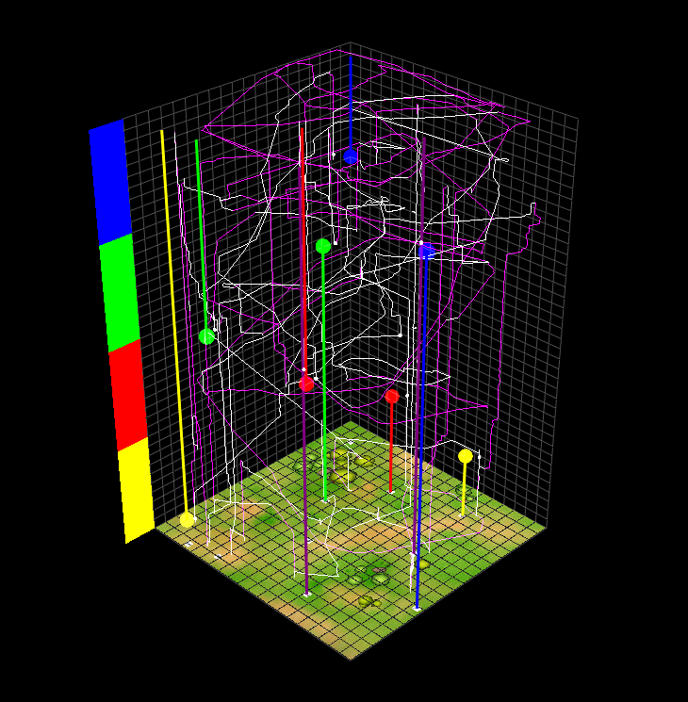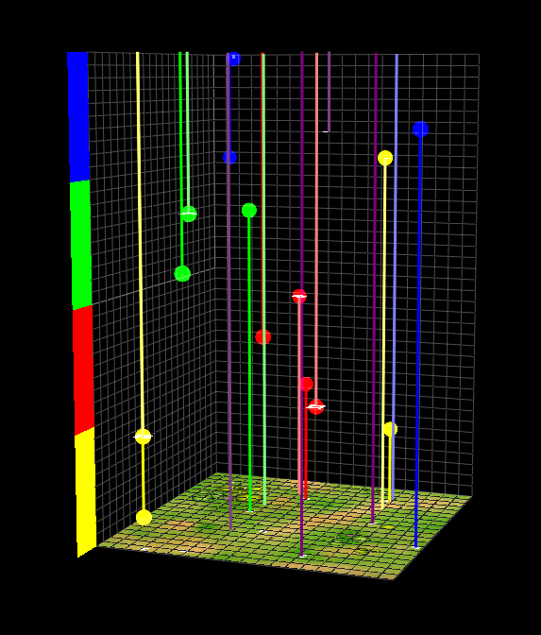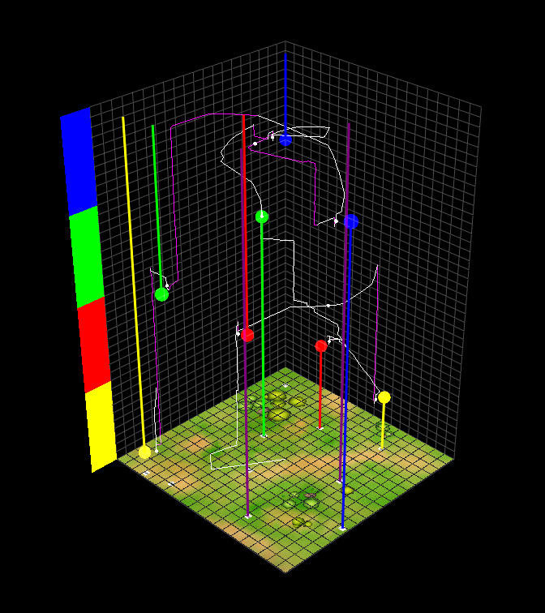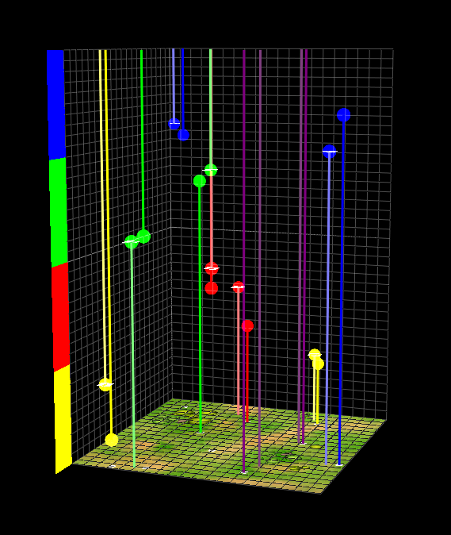

**Figure 1**: A schematic of spatiotemporal navigation and reconstruction results from an example participant’s trial 1 and trial 4. The 3D volume represents both axes of space (horizontal axes) and the axis of time (vertical axis). The colored bars on the left indicate the temporal context at each vertical moment in time. The colored circles denote the moments in time in which an event occurred and the line denotes if the item associated with the event would’ve been present at that moment in time. A white exploration line represents forward temporal motion while purple represents backwards. The vertical purple lines are objects with no temporal information (always present). The small white dots during study represent moments of interaction with items. The second set of event dots in test represent the reconstructed spatiotemporal locations of each event. Note the path in Trial 1 study is complex and inefficient while the path in trial 4 is efficient, roughly temporally ordered (D🡪B🡪C🡪F🡪G🡪H🡪E🡪A; where 5/8 items were visited in the appropriate temporal order) but not in a strict temporal order. Also note the improvement in reconstruction placement between trials 1 and 4.

Participants’ looking direction and location in space and time were logged at every time point in the simulation (~16ms intervals). If the participant reached the beginning or end of the simulation’s time course, time was paused but the participant was still allowed to freely move about the spatial axes in the environment. During practice and study, participants were instructed to find the locations of each item in space and time, specifically when their events happened. To signify they had found the item at its event, there was a 0.5 second window during which participants could see the item’s event (if close enough) and press a button on the controller to acknowledge they witnessed the event. Participants were given unlimited time to explore the environment, find each item, and acknowledge they had viewed each event.

During test, participants were asked to reconstruction the spatiotemporal location and identity information associated with each event. See chapter two for more description on test-time data and analyses.

### Proposed Navigation Analysis Metrics

The study and test time navigation data will be analyzed in a variety of ways, leveraging previous work into spatial navigation but extending these analyses to spatiotemporal navigation and determining if study-time navigation relates to later test performance. Previous Chapters (Chapter 2) have shown the most basic method of analysis, a measurement of the distance travelled in space and time. The analysis of the relationship between these high-level metrics and the various test metrics of interest is planned, however, there are many other measures of exploration and navigation which could be of interest and should be compared to test performance in this data set.

Path complexity as an index of landmark mapping has been used in ecological research for over a decade, and, more recently a specific measure of path complexity, fractal dimension (FD), has been linked to improved performance in navigation independent of sex and age differences seen in typical measures such as distance and time taken to perform the task (a virtual Morris Water Maze; Daugherty et al., 2015). Additionally, both the hippocampus and parahippocampal gyrus volumes in healthy adults were related to FD but not distance and time. As such, this is an excellent target for a study-time variable which might relate to test-time variables of relational memory such as misassignments and swaps. Moreover, this metric could be evaluated within the different contextual regions and potentially relate to the relational memory errors due to context. The FD measure will be one which is emphasized in these analyses.

Beyond the previously mentioned measures, few other navigation metrics have stood the test of time. Path crossing, path classification, visual inspection of paths, and heading error have all been previously applied to navigation data, but each has non-ideal computational properties, especially in the context of a 3D environment. Path crossing virtually never occurs in a 3D volume (space X by space Y by time) and is less meaningful when a 2D projection of a 3D volume is used. Path classification is promising, but many design and hyperparameter choice issues exist which can accidentally impose experimenter bias on the analyses. Visual inspection does not provide an objective measure of path information. Finally, heading error may be meaningful in later trials, but it involves imposing an assumption that the item the participant ultimately interacts with next was the one which was intended. This assumption may be true some of the time, but the results of such an analysis would be heavily contingent upon the truth of this assumption (which cannot be evaluated concretely without further participant feedback). That being said, there are many quantitative measures of navigation which have not been fully explored in the cognitive literature. Alternative measures of the complexity of a path such as the degree to which is uniformly fills the space (related to, but not equivalent to FD), the average size of unexplored regions (especially on trial 1 when no information is known of event locations), and the amount of time spent simultaneously traversing space and time (as opposed to standing still and exploring time or navigating space without movement in time) all could be of potential interest in this task given the increase difficult compared to more traditional spatial navigation tasks. Additionally, because context boundaries may be crossed multiple times, the number of boundary crossings could be of distinct interest in relation to the magnitude of the context boundary effect or its relationship to relational memory errors.

Finally, typical spatial navigation tasks like the virtual Morris Water Maze do not generally involve multiple target locations. Because of the added reconstruction elements of this task and the fidelity with which we can measure behavior, it is possible to (in much the same way as an eye tracking study) determine the amount of time any particular item (or its associated event) is in the field of view. This provides a fairly direct measure of sampling of an event’s spatiotemporal location which might relate to memory for that item. Unfortunately, no eye tracking data was collected for this experiment, so it cannot be guaranteed that because an item is in the field of view it will be the focus of the participant, but given the size of the overall environment in space and time, it may act as a reasonable proxy for attending to the events. Table 1 provides a summary of the proposed analyses and their associated hypotheses.

|  |  |  |  |
| --- | --- | --- | --- |
| **Measure** | **Comparison** | **Support** | **Hypotheses** |
| Spatial Distance | All Test Measures | (Maguire et al., 1999; Moffat, 2009; Moffat & Resnick, 2002) | None (exploratory) |
| Temporal Distance | All Test Measures | (B. J. Kraus et al., 2015a) | None (exploratory) |
| Fractal Dimension | Relational Memory Error | (Daugherty et al., 2015) | Higher FD will relate to poorer relational memory performance. |
| Context Boundary Crossings | Context Boundary Effect & Context-Relational Errors | (Ezzyat & Davachi, 2014; Zacks et al., 2007b) | More context crossings will relate to greater context boundary effects and more context-relational errors. |
| Item Sampling | Item Misplacement | (Deborah E. Hannula, 2010) | In early trials, more sampling will relate to better memory. In later trials, less sampling will relate to better memory. |

**Table 1**: Proposed high-level navigation analyses. These analyses can and will be run on space and time in isolation of one another as well as together, when appropriate given the comparisons to test-time metrics.

### Proposed Order Analyses

In addition to the simple navigation metrics which evaluate large amounts of the path (or the entire path) simultaneously, it may be of particular interest to look at the interactions the participants have with the events (and associated navigation) as related to the order of exploration. For instance, one prediction made in a previous chapter is that time cells might represent an allocentric perspective on a timeline of events. Indirect evidence for an allocentric timeline might be found in observing the order of study and order of reconstruction of items after the first trial. If participants reliably converge towards reconstruction of the events in the implied “forward” direction of time, this could serve as preliminary evidence that this allocentric perspective on the timeline is what is being maintained in memory (rather than a perspective based on an egocentric attempt to replay the series of events as they happened to be seen in the first or second trials).

Analyzing order in this way can be a complex issue. Recency, contiguity, and primacy effects could lead to particular items receiving specialized treatment by chance (or due to an overall bias towards allocentric patterns of reconstruction in time). One potentially robust way to compare reconstruction order is to develop a distance metric for the relative order of events. In other words, given two reconstructed orders (for instance, given A🡪B🡪D🡪C and B🡪D🡪A🡪C, which sequence is closer to the intended A🡪B🡪C🡪D ordering and by how much?). Considerable interest has been given to similar problems in comparing the similarity of sequences of DNA, word strings, and compressed data sequences. However, many of these involve a much more general case in which no guarantee of uniqueness of elements in the sequences is provided. Because the task requires each item to be placed precisely once, instead, the distance metric of interest should focus on three primary properties which might define the differences between two permutations. First, the elementwise-agreement of the lists can be used as a general distance metric. More generally, the Kendall-Tau distance metric is appropriate for this, and it has the added benefit of providing a positive or negative correlation value which, if positive, suggests a closer distance to the forward order and, if negative, suggests a closer distance to the reverse order. Unfortunately, Kendall-Tau is incredibly unforgiving to contiguity effects. As such, a second distance metric which measures the number of contiguous sublists can be applied to generate a 2D space of potential distances between a hypothesized and observed order. This distance can be visualized and its probabilities for a fixed length permutation can be calculated explicitly:



**Figure 2**: Simulated data in proposed 2D distance metric for evaluating order of exploration and reconstruction. Each dot represents a possible distance value for a permutation of length 8 (i.e. the number of temporal items in the task). The height/color of the dot corresponds to its probability of occurring in the space of all length 8 permutations. The dots represent trial-over-trial simulated data, sampled from the original, random distribution transitioning via an exponential learning curve to a hypothesized allocentric distribution (centered on the front, (1, 0) coordinate). The trials are color coded such that red=trial 1, green=trial 2, blue=trial 3, and yellow=trial 4. Note that in this simulated data, the net motion of the dots is towards the hypothesized point, suggesting an allocentric strategy being used by participants.

In summary, this proposed framework for evaluating order information will be used to observe changes in distance of exploration and reconstruction to the allocentric order across trials. I predict that both study-time navigation and test-time reconstruction order will trend towards allocentric order across trials (i.e. the low-probability location of (1, 0) on the above figure).

### Statistical Analysis

All analyses which compare trial-by-trial performance use repeated measures analysis of variance (rANOVA) using SPSS with Huynh-Feldt correction. Hierarchical Linear Modeling will be used in cases of navigation metrics being compared to test performance across trials. Comparisons which collapsed trials together used either paired-sample, two-tailed t-tests or one-sample, two-tailed t-tests (for comparison to expected chance values). All tests used an alpha value of 0.05 to determine significance.

## Results

### Overall Accuracy and Navigation

Although the relationship of overall accuracy across trials has not been established, the general finding that accuracy and navigation time and distance improve across trials in both space and time was established in Chapter 2.

### Proposed Navigation Analysis Metrics Predictions

See Table 1 for hypotheses.

### Proposed Order Analyses Predictions

As stated in the analysis section, it is predicted that both study-time navigation and test-time reconstruction order will trend towards allocentric order across trials, suggesting that the participant is acquiring an allocentric temporal representations which is independent of their incidental exploration and navigation behaviors during learning. This result would be highly suggestive that time cells in the hippocampus may code for an allocentric representation of time, much in the same way that place cells code for allocentric spatial locations related to distal cues.

## Discussion

As the results for these analyses are unknown at this point, the Discussion section will be kept brief. The fidelity and power of this task begin to show in this proposed section as the amount of information in the data is enormous. The meaningfulness of this information in advancing a theoretical understanding of memory and the hippocampus is an empirical question which this section will attempt to answer. Coarse navigation metrics such as those proposed in Table 1 miss an enormous amount of the information in this task, however, much of this moment-to-moment decision making is currently beyond the reach of our ability to make inferences. Even in the simplest cases (such as heading error), the inference of the intention of the participant becomes a critical one. In future studies modelled after this one, I propose two primary strategies: first, careful task design can give our analyses more power by restricting some possible strategies and intentions. For instance, restricting the spatial axis to 1D gives us a much better sense of which items are not being targeted. Secondly, as artificial intelligence via Deep Learning continues to advance, we are presented with the unique opportunity to use these systems as points of comparison to real neural systems. Deep Learning systems (such as Asynchronous Advantage Actor-Critic, A3C models; Juliani, 2016; Mirowski et al., 2017) can now perform astounding navigation tasks such as solving mazes using only visual input, motor output, and a simple reward signal (i.e. with no special knowledge of the environment or system beyond some sense of “good” and “bad” results of behavior). These systems may be modelled after biological systems, but they operate in very distinct ways. Nonetheless, they are now capable of performing may of the same complex navigation tasks that simple organisms can, and moreover, we can manipulate them in any way imaginable (and as often as we’d like). This provides a fantastic test platform for theoretical approaches to navigation analysis which should not be ignored by cognitive science. Collaborations with deep learning researchers and cognitive scientists do exist (such as the collaboration between Kumaran, Hassabis and McClelland; Kumaran, Hassabis, & McClelland, 2016), but they are not nearly as common as one would hope given the power of these systems to make and test predictions about information processing and behavior.

This Chapter proposes not just to examine spatiotemporal navigation in the same way as other researchers, but it also proposes a novel method of gathering early evidence on an incredibly complex neural representation issue which is of hot debate in the hippocampal literature – i.e. what do cells in the hippocampus which fire in conjunction with particular spatiotemporal information actually represent? Although it is widely accepted that place cell firing is related to allocentric information relative to distal cues in the environment, other cell types which fire related to a variety of other relations have been identified. These include grid cells which fire in accordance with periodic spatial location arrays, cells that fire in accordance with goal vectors (Sarel et al., 2017), head-direction cells (Ranck Jr, 1984; Taube, Muller, & Ranck, 1990), time cells (B. Kraus et al., 2013), distance cells (B. J. Kraus et al., 2015a), time-distance cells (that fire in relation to both variables), and cells that signal borders and speed (T. Hartley, Lever, Burgess, & O’Keefe, 2013; Kropff, Carmichael, Moser, & Moser, 2015). A naïve view of these cells might say that various tissues in the hippocampus are dynamically mapping to navigation (and only navigation). However, substantial evidence links hippocampal function to far more than just navigation (see Cohen & Eichenbaum, 1991 for a review of these arguments). A much more robust perspective would suggest that the hippocampus performs arbitrary binding and does so with any and all relevant domains of information. In the navigation view, one might interpret time cell firing as a simple navigatorion pattern related to the egocentric time an organism has experienced in a particular context. However, if a more relational view of information processing is used, the time cells might be thought to be performing a more general binding operation – relating events within the temporal domain to create a map of a series of events. Electrophysiological evidence in rodents supports this as hippocampal networks have been shown to associated spatial and nonspatial dimensions (McKenzie et al., 2014). Task demands will, of course, dictate the degree to which such a map is necessary (as has been proposed by other; Ekstrom & Ranganath, 2017), but given the consistency with which causal temporal patterns in natural environments occur, forming an allocentric understanding of events has a clear advantage in the flexible use of that information. Indeed, in rodents, humans, and monkeys, recording studies have shown hippocampal involvement in mapping the time course of events independent of space (B. J. Kraus et al., 2015a; B. Kraus et al., 2013; Naya & Suzuki, 2011; Pastalkova, Itskov, Amarasingham, & Buzsaki, 2008; Paz et al., 2010; Spiers, Burgess, Hartley, Vargha-Khadem, & O’Keefe, 2001). Ultimately, these questions will have to be answered via electrophysiological evidence, but early behavioral work like the work presented here may provide hints that this evidence exists.

In summary, I believe this task and the associated proposed methods provide a unique opportunity to study navigation and information sampling in space and time to further our understanding of navigation and memory organization. Moreover, if this experimental paradigm is to be used in follow-up experiments as have been suggested throughout this document, the exploratory elements suggested in the methods section will help us understand what aspects of navigation in the task will be good targets for further examination. Many metrics and approaches were described in this chapter which are not being included in the proposed analyses. Although the currently proposed metrics are those which I believe have the best theoretical foundation and are, therefore, the best targets for analysis, I am open to suggestions about other analyses which might address theoretical points of interest.

# General Discussion

## Summary of Results

The previous three chapters have shown a variety of data from both hippocampal damaged individuals as well as healthy adults which together establish a methodological framework which can be used to analyze and understand behavior in reconstruction tasks in any domain. Critically, certain error metrics associated with the ability to retain arbitrary relational information are identified as being related to hippocampal function via observing differences in these metrics between hippocampal damaged patients and controls. Once such an evaluation has been established, these same errors can be evaluated in healthy individuals in other domains to determine if two, omnipresent domains, i.e. space and time, have any differences in the relative commonality of these errors. In order to study space and time simultaneously, however, one additional manipulation was required to allow sampling of spatial and temporal information to be on more equal footing. By allowing participants to “time travel”, a bias which would have been present on temporal information (namely the typical inability to control what temporal information to sample and when) is balanced to allow for a more direct comparison of spatial and temporal memory. Finally, because this manipulation provides a new axis upon which sampling can occur, this sampling behavior can also be studied in time independently of spatial sampling. Together, the results show that arbitrary relational information (whose representation relies on the hippocampus) critically underpins reconstruction performance in both domains, but relational information in time may be represented with different constraints than spatial information, causing unique biases in the ability to retain relational representations in each domain. The presence of contextual information also biases the representation such that both distance judgements errors and relational memory errors occur more often (with distance judgement errors occurring across contextual boundaries and relational memory errors occurring within them). Finally, the sampling of the temporal domain may hint at the fact that substrates of the hippocampus which bind temporal relational information (i.e. “time” cells; B. Kraus et al., 2013) are, under some circumstances, mapping an allocentric representation of time which is fundamentally relational in nature.

In the first chapter, a framework for the analysis of reconstruction errors which attempts to assess many of the same informational metrics of previous work (Jeneson et al., 2010; Watson et al., 2013) but from a first-principled approach with minimal assumptions was introduced. Within this framework, misplacement, i.e. the sum of the Euclidean error in space in reconstruction, is treated as a coarse but fundamental measure of error. Misplacement, under this assumption, can then be broken into different error metrics in accordance with aspects of information which were not present in the reconstruction. Most importantly, identity information (i.e. the information which allows items to be distinguished from one another) is removed from the reconstruction during the first step of analysis to determine aspects of the spatial relationships between items and environment which are impaired. This includes evaluating the overall amount of translation, scaling, and rotation shared by items as well as the remaining local misplacement and accuracy for each item’s location information. Once these spatial errors are determined, the identity-related errors can be reinstated within this informational framework to determine if item identity is being misrepresented in a systematic way. The finding in this chapter shows that hippocampal damage impairs the ability to bind arbitrary identity information to locations, but it does not impair the ability to remember the locations themselves. Moreover, this impairment in identity information is fundamental, in that there is no evidence that it is due to compound identity errors in which multiple identities are systematically swapped/cycled amongst different positions. Although swaps and cycles are evaluated in this work and do uniquely occur at low item set sizes in hippocampal damaged patients, once both patients and comparison participants begin making the prerequisite error (i.e. any identity-location misassignment), there is no difference in the number of compound errors between groups. This finding is distinct from previous work on spatial reconstruction which showed significant differences in swapping at all set sizes (though most significantly at low set sizes; Watson, Voss, Warren, Tranel, & Cohen, 2013). The reason for this difference is in the increased sensitivity and specificity of the methods presented in this first chapter over those previous methods.

In the second chapter, the methodology established in the first chapter is applied to a more complex task in which both space and time are explorable domains, simultaneously; this task is known as a Spatiotemporal Reconstruction Task, or, if the path of the participant through the environment is of interest, a Spatiotemporal Navigation Task. In this task, participants were asked to reconstruct events in space and time while being allowed to simultaneously explore both domains. Although space was explored via translation, as usual, time was also allowed to be explored translationally via a “time travel” button which allowed the reversal of the direction of the flow of time. Participants performed this task on the same timeline of events, 4 times, and their performance on spatial, temporal, and item identity information improved across all trials. The identity-location misassignment metric introduced in the first chapter was used to assess difference between spatial and temporal relational memory across trials and found that significantly more temporal misassignments (i.e. events placed at the moment in time of another event) were committed that spatial misassignments. Additionally, the task contained 4 distinct temporal contexts (denoted by a change in the background color of the environment every 15 seconds) which could be used to help organize memory for temporal location information. A Context Boundary Effect (DuBrow & Davachi, 2013) was observed which showed a bias created by the contextual information such that items within the same temporal context were placed closer together than items which were in adjacent temporal contexts despite being equidistant. This effect did not diminish across trials, suggesting it reflects an underlying organizational principle for the temporal information. Moreover, this contextual information biased the misassignment information such that events were far more likely to be misassigned to another temporal location of an event with which it shared a context than would be expected by chance. Together, this evidence shows the critical interplay of contextual and relational information in the temporal domain and hints at differences in the ability to form relations in the temporal domain when compared to the spatial domain. Additionally, it shows that the influence of contextual information is likely not due to an error per se, but it reflects an organizational principle guiding memory.

In the third and final chapter, the Spatiotemporal Navigation task presented in chapter two is examined through the lens of navigation, rather than reconstruction, in order to determine the degree to which differences in exploration behavior can predict differences in test time performance. This chapter is currently incomplete (though the data has been collected), but several analyses are suggested based on prior work in spatial navigation (Daugherty et al., 2015; Eichenbaum, 2017b; Kolarik et al., 2017) and some predictions are made based on work in space and time representations in the hippocampus (Eichenbaum, 2017d). Moreover, analyses of the order information contained within navigation and reconstruction are suggested which might reveal whether an allocentric form of navigation is present for temporal navigation in much the same way as spatial navigation. This would, therefore, make the prediction that “time” cells in the hippocampus (B. Kraus et al., 2013) map an allocentric perspective on time, representing relational information between temporal events.

## Separable vs. Separate Hippocampal Representations

There has been a great deal of debate in the literature over the separateness of different informational domains in the hippocampus. A common perspective is that major domains such as space and time provide a scaffolding in which binding of information from and to other domains might be embedded (Ekstrom & Ranganath, 2017). Relatedly, tasks which show hippocampal involvement of relations outside of the spatial or temporal domain have recently shown that hippocampal representations may be even more flexible (Eichenbaum, 2015; Tavares et al., 2015; Warren et al., 2015). However, one crucial question has yet to be completely addressed: are different domains represented separately in the hippocampus or in some sort of alternate, overlapping representation? The data here cannot completely disentangle these possibilities (or the spectrum of possibilities in-between), but the techniques presented here, in addition to neuroimaging and patient behavior studies, may eventually elucidate the answer to this question. In the Spatiotemporal Reconstruction task, differences in relational information were seen in space and time, suggesting these domains may, in fact, be separate. They may be, for instance, multiplexed versions of the same representational ideal with cells switching between representing spatial and temporal information. Alternatively, the representations may overlap insofar as the task demands warrant it. This would suggest that in a task such as the spatiotemporal navigation task, cells which code for time and space should fire together. However, if temporal or spatial information were biased in some way (via attention, task manipulation, reward, or some other method), the degree of overlap between the domain representations may change. This hypothesis leads to a wider suggestion about domain representations in the hippocampus, namely, that hippocampal relational representations are *separable* but not necessary *separate*. This idea is consistent with relational memory theory (Neal J. Cohen & Eichenbaum, 1993) but extends the prediction that all arbitrary relationships are obligatorily bound in the hippocampus to say that the cell firing in association with the domain of information will depend on demands related to that domain (such as task, reward, attention, context, and emotion). Some recording evidence along these lines has already come to light in that time-selective cells can be shown to fire in overlap with distance-selective cells exactly as often as would be suggested by a joint distribution of both variables (B. J. Kraus et al., 2015b). The behavioral evidence here also suggests a variable degree of interaction between spatial and temporal relational information as well as variable interactions with contextual information.

## Artificial Intelligence and Spatial Reconstructions

One field which is intimately related to the work presented in this document which has yet to be addressed is Machine Learning and Artificial Intelligence. These cognitive and behavioral concepts may become more critical to the development of artificially intelligent (AI) systems in the coming decades as advances in deep learning systems which go beyond reinforcement learning begin to emerge. Spatial reconstruction, as a task, is an incredibly difficult one for AI systems to perform. In particular, the incredible degree of variability in environments makes navigation in general a challenge. To add on to this the requirement that specific, arbitrary information about elements of the environment need to be remembered and used flexibly at some unknown point in the future makes the task beyond the scope of what current AI can successfully do. Recent advances in deep learning have developed systems which can navigate environments in an end-to-end fashion (i.e. mapping visual input to motor output without any additional “cheating” information provided by the programmer; Mirowski et al., 2017). These systems, however, likely lack the flexible, relational memory representations necessary to perform reconstruction. Some recent work has shown networks which can be trained to understand spatial relational information (Santoro et al., 2017), however, it is unclear how related these representations are to real brain representations (despite the attempts of some authors often make to architect their systems similarly to biological systems at a coarse level). Spatial reconstruction tasks which also involve navigation may serve as a crucial test platform for future AI to determine the degree of flexibility of their representations. Moreover, spatial reconstruction in humans typically involve only one viewing of the information in question. Although so-called “one-shot” learning (Shaban, Bansal, Liu, Essa, & Boots, 2017; van der Spoel et al., 2015) is a topic of intense interest in AI, the ability for navigation systems to perform one-shot learning is still lacking. Representational systems which can perform computational like what is thought to occur in the hippocampus may serve as one of the major improvements on deep learning AI in the coming decades, bridging the performance gap on general tasks (and potentially tasks which require creativity) between humans and AI.

## Behavioral Inference, Sampling, and Task Richness

Two additional, more subtle contributions of this work are worth mentioning. First, the methodological framework presented in Chapter 1 and utilized in Chapter 2 approaches the issue of understanding information present in a spatial reconstruction from a principled perspective. That is to say, an attempt is made to make as few assumptions as possible about the nature of the high-level structure of the performance and subsequent data in the task, treating it as an information-containing system with no other significant preconceptions. The assumptions are enumerated in that chapter, any of which imply a particular set of choices for analysis. This means that in cases like the comparison of hippocampal damaged patients to comparison participants, adjustments to the assumptions (i.e. the assumption that participants will generally be accurate at placing items back in roughly the right positions) have associated adjustments in the methodology (i.e. using the accuracy threshold from the comparisons in which the assumption should be valid as the threshold for the patients). Similarly, other aspects of the method assume certain transformations might be present within the item-item and item-environment relational information (i.e. translation, scaling, and rotation), but the method allows for different transformations to be tested together or in isolation of one-another. Most importantly, by keeping the methodology general, it can be easily applied to other domains (i.e. time), domains with even more dimensions (i.e. 3D space), or even domains with stranger properties (see the Introduction for more information on possible properties of domains). In this way, the tools used to study representations in reconstruction do not have to change as we expand the domains into which we would like to perform these analyses.

The second contribution which has not been emphasized up until now is the combination of navigation behavior with reconstruction in multiple domains, simultaneously. This allows for three important secondary impacts on the study of memory. 1) The ability to navigate domains other than space allows the study of the impact of exploration and navigation in different domains on subsequent memory. 2) The ability to simultaneously navigate multiple domains means that exploration/navigation behaviors and preferences between domains can be examined (i.e. is there a “hierarchy” of domains and how flexible is such a domain preference; McKenzie et al., 2014). 3) The overall richness of this task as well as the resulting findings shows that many of the effects observed in more restrictive behavioral tasks will still be present when the task is more ecologically realistic (and more difficult). This added richness also affords more information and control with which to make observations and predictions about the interplay of different behaviors (navigation and reconstruction) and the brain systems which may support different types of information (scene sampling, contextual information, relational information, and more). In summary, by embracing the rich, complex possibilities available with modern behavioral platforms such as Virtual Reality, we obtain an equal richness and complexity of scientific inquiry.

## Conclusion

Our understanding of hippocampally-dependent memory organization has come a long way in the past several decades, and with the advent of new technologies and theoretical frameworks, the pace of discovery does not seem to be abating. Here, it has been shown using a new methodological framework that the hippocampus is necessary for some, but not all, relational information (critically, the arbitrary information but not the location information). These same methods were then applied to a novel task, the Spatiotemporal Reconstruction tasks, which allows for spatial and temporal relational memory and the influence of context to be examined simultaneously. Far more temporal relational memory errors are present in this task than spatial relational memory errors despite the ability to freely navigate time and space, and these errors are heavily influenced by contextual information. The Context Boundary Effect, in which events in time are placed closer together within a context and further apart when separated by a boundary despite being equidistant, is observed in time despite the ability of participants to cross the boundaries in either direction and as often as desired and despite repeated restudy of the same events. Moreover, the relational memory errors are far more common within a context than would be expected by chance, suggesting that the contextual information is not just biasing distance judgements but also order information in a disadvantageous way. Finally, navigation behavior in spatiotemporal navigation is examined to determine if particular aspects of navigation is space and time predict later performance and relational or contextual memory errors. This same navigation behavior can provide hints as to whether or not temporal representations in the hippocampus are allocentric in nature, with navigation tending towards an allocentric perspective (i.e. exploring a timeline in an A🡪B🡪C order rather than an egocentric order based on when particular events happen to be seen). The richness of Spatiotemporal Navigation and Reconstruction has provided (and will likely to continue to provide) interesting findings on the interplay between navigation in space, navigation in time and how these ultimately may relate to navigation in memory.

# References

Abbott, E. A. (1884). *Flatland: A Romance in Multiple Dimensions*. New York: Dover Thrift.

Aggleton, J. P., & Brown, M. W. (1999). Episodic memory, amnesia, and the hippocampal-anterior thalamic axis. *The Behavioral and Brain Sciences*, *22*(3), 425-44-89. Retrieved from http://www.ncbi.nlm.nih.gov/pubmed/11301518

Allen, J. S., Tranel, D., Bruss, J., & Damasio, H. (2006). Correlations between Regional Brain Volumes and Memory Performance in Anoxia. *Journal of Clinical and Experimental Neuropsychology*, *28*(4), 457–476. http://doi.org/10.1080/13803390590949287

Allen, R. J., Vargha-Khadem, F., & Baddeley, A. D. (2014). Item-location binding in working memory: Is it hippocampus-dependent? *Neuropsychologia*, *59*(1), 74–84. http://doi.org/10.1016/j.neuropsychologia.2014.04.013

Astur, R. S., Taylor, L. B., Mamelak, A. N., Philpott, L., & Sutherland, R. J. (2002). Humans with hippocampus damage display severe spatial memory impairments in a virtual Morris water task. *Behavioural Brain Research*, *132*(1), 77–84. http://doi.org/10.1016/S0166-4328(01)00399-0

Bartsch, T., Schonfeld, R., Muller, F. J., Alfke, K., Leplow, B., Aldenhoff, J., … Koch, J. M. (2010). Focal Lesions of Human Hippocampal CA1 Neurons in Transient Global Amnesia Impair Place Memory. *Science*, *328*(5984), 1412–1415. http://doi.org/10.1126/science.1188160

Besi, P. J., & Mckay, N. D. (1991). A Method for Registration of 3-D Shapes 1 Introduction 2 Literature Review. In *SPIE Vol. 1611 Sensor Fusion IV* (Vol. 1611, pp. 586–606). http://doi.org/10.1117/12.57955

Brodeur, M. B., Guérard, K., & Bouras, M. (2014). Bank of Standardized Stimuli (BOSS) Phase II: 930 New Normative Photos. *PLoS ONE*, *9*(9), e106953. http://doi.org/10.1371/journal.pone.0106953

Buchanan, T. W., Tranel, D., & Adolphs, R. (2005). Emotional Autobiographical Memories in Amnesic Patients with Medial Temporal Lobe Damage. *The Journal of Neuroscience*, *25*(12), 3151–3160. http://doi.org/10.1523/JNEUROSCI.4735-04.2005

Bunsey, M., & Eichenbaum, H. (1993). Critical role of the parahippocampal region for paired-associate learning in rats. *Behavioral Neuroscience*, *107*(5), 740–7. Retrieved from http://www.ncbi.nlm.nih.gov/pubmed/8280384

Burkard, R., Dell’Amico, M., & Martello, S. (2012). *Assignment Problems*. Society for Industrial and Applied Mathematics. http://doi.org/10.1137/1.9781611972238

Buzsáki, G. (2005). Theta rhythm of navigation: Link between path integration and landmark navigation, episodic and semantic memory. *Hippocampus*, *15*(7), 827–840. http://doi.org/10.1002/hipo.20113

Carlsson, G. (2009). *Topology and data*. *Bulletin of the American Mathematical Society* (Vol. 46). http://doi.org/10.1090/S0273-0979-09-01249-X

Cederberg, J. N. (2001). Chapter 3.12 Similarity Transformations. In *A Course in Modern Geometries* (pp. 183–189). Springer.

Clark, R., Tahan, A. C., Watson, P. D., Severson, J., Cohen, N. J., & Voss, M. (2017). Aging affects spatial reconstruction more than spatial pattern separation performance even after extended practice. *Hippocampus*, *0*(October 2016), 1–11. http://doi.org/10.1002/hipo.22727

Cline, A. K., & Dhillon, I. S. (2006). Computation of the Singular Value Decomposition. *Handbook of Linear Algebra*, 1–14. http://doi.org/10.1007/BF02251248

Cohen, N. J., & Banich, M. T. (2003). Memory. In *Cognitive Neuroscience and Neuropsychology* (2nd ed., pp. 322–364). Boston: Houghton-Mifflin.

Cohen, N. J., & Eichenbaum, H. (1991). The theory that wouldn’t die: a critical look at the spatial mapping theory of hippocampal function. *Hippocampus*, *1*(3), 265–268. http://doi.org/10.1002/hipo.450010312

Cohen, N. J., & Eichenbaum, H. (1993). *Memory, Amnesia, and the Hippocampal System.* Cambridge: MIT Press.

Collett, T. S., Cartwright, B. A., & Smith, B. A. (1986). Landmark learning and visuo-spatial memories in gerbils. *Journal of Comparative Physiology A Sensory, Neural, and Behavioral Physiology*, *158*(6), 835–851. http://doi.org/10.1007/BF01324825

Corsi, P. M. (1972). *Human Memory and the Medial Temporal Region of the Brain*. McGill University.

Coxeter, H. S. M. (Harold S. M. (2008). Non-Euclidean geometry, 336.

Damasio, A. R. (1989). The Brain Binds Entities and Events by Multiregional Activation from Convergence Zones. *Neural Computation*, *1*(1), 123–132. http://doi.org/10.1162/neco.1989.1.1.123

Daugherty, A. M., Yuan, P., Dahle, C. L., Bender, A. R., Yang, Y., & Raz, N. (2015). Path complexity in virtual water maze navigation: Differential associations with age, sex, and regional brain volume. *Cerebral Cortex*, *25*(9), 3122–3131. http://doi.org/10.1093/cercor/bhu107

Davachi, L., & DuBrow, S. (2015). How the hippocampus preserves order: the role of prediction and context. *Trends in Cognitive Sciences*, *19*(2), 92–99. http://doi.org/10.1016/j.tics.2014.12.004

Davis, C. P., Franklin, L. M., Johnson, G. S., & Schrott, L. M. (2010). Prenatal oxycodone exposure impairs spatial learning and/or memory in rats. *Behavioural Brain Research*, *212*(1), 27–34. http://doi.org/10.1016/j.bbr.2010.03.022

Dede, A. J. O., Frascino, J. C., Wixted, J. T., & Squire, L. R. (2016). Learning and remembering real-world events after medial temporal lobe damage. *Proceedings of the National Academy of Sciences*, *113*(47), 13480–13485. http://doi.org/10.1073/pnas.1617025113

DeVito, L. M., & Eichenbaum, H. (2011). Memory for the Order of Events in Specific Sequences: Contributions of the Hippocampus and Medial Prefrontal Cortex. *Journal of Neuroscience*, *31*(9), 3169–3175. http://doi.org/10.1523/JNEUROSCI.4202-10.2011

DuBrow, S., & Davachi, L. (2013). The influence of context boundaries on memory for the sequential order of events. *Journal of Experimental Psychology. General*, *142*(4), 1277–86. http://doi.org/10.1037/a0034024

DuBrow, S., & Davachi, L. (2014). Temporal Memory Is Shaped by Encoding Stability and Intervening Item Reactivation. *Journal of Neuroscience*, *34*(42), 13998–14005. http://doi.org/10.1523/JNEUROSCI.2535-14.2014

Duchowski, A. T., Shivashankaraiah, V., Rawls, T., Gramopadhye, A. K., Melloy, B. J., & Kanki, B. (2000). Binocular eye tracking in virtual reality for inspection training. In *Proceedings of the symposium on Eye tracking research & applications - ETRA ’00* (pp. 89–96). New York, New York, USA: ACM Press. http://doi.org/10.1145/355017.355031

Dudchenko, P. (2010). *Why People Get Lost : The Psychology and Neuroscience of Spatial Cognition Abstract and Keywords Taxonomies of wayfinding*. http://doi.org/10.1093/acprof

Eichenbaum, H. (2004). Hippocampus: Cognitive processes and neural representations that underlie declarative memory. *Neuron*, *44*(1), 109–120. http://doi.org/10.1016/j.neuron.2004.08.028

Eichenbaum, H. (2014). Time cells in the hippocampus: a new dimension for mapping memories. *Nature Reviews. Neuroscience*, *15*(11), 732–44. http://doi.org/10.1038/nrn3827

Eichenbaum, H. (2015). The Hippocampus as a Cognitive Map ... of Social Space. *Neuron*, *87*(1), 9–11. http://doi.org/10.1016/j.neuron.2015.06.013

Eichenbaum, H. (2016). Memory: Organization and Control. *Annual Review of Psychology*, (September), 1–27. http://doi.org/10.1146/annurev-psych-010416-044131

Eichenbaum, H. (2017a). Barlow versus Hebb: When is it time to abandon the notion of feature detectors and adopt the cell assembly as the unit of cognition? *Neuroscience Letters*. http://doi.org/10.1016/j.neulet.2017.04.006

Eichenbaum, H. (2017b). The role of the hippocampus in navigation is memory. *Journal of Neurophysiology*, *20*(11), jn.00005.2017. http://doi.org/10.1152/jn.00005.2017

Eichenbaum, H. (2017c). The role of the hippocampus in navigation is memory, *2215*, 1785–1796. http://doi.org/10.1152/jn.00005.2017

Eichenbaum, H. (2017d). Time (and space) in the hippocampus. *Current Opinion in Behavioral Sciences*, *17*, 65–70. http://doi.org/10.1016/j.cobeha.2017.06.010

Eichenbaum, H., & Cohen, N. J. (2001). *From Conditioning to Conscious Recollection: Memory Systems of the Brain*. New York: Oxford University Press.

Eichenbaum, H., & Cohen, N. J. (2014, August). Can We Reconcile the Declarative Memory and Spatial Navigation Views on Hippocampal Function? *Neuron*. Elsevier Inc. http://doi.org/10.1016/j.neuron.2014.07.032

Einstein, A. (1905). Zur Elektrodynamik bewegter Körper. *Annalen Der Physik*, *322*(10), 891–921. http://doi.org/10.1002/andp.19053221004

Einstein, A. (1908). Über das Relativitätsprinzip und die aus demselben gezogenen Folgerungen. *Jahrbuch Der Radioaktivität Und Elektronik*, *4*, 411–462.

Ekstrom, A. D., & Ranganath, C. (2017). Space, time, and episodic memory: The hippocampus is all over the cognitive map. *Hippocampus*, *93052*, 1–16. http://doi.org/10.1002/hipo.22750

Epstein, R. A. (2014). Neural Systems for Visual Scene Recognition. *Scene Vision*, 105–134. http://doi.org/10.7551/mitpress/9780262027854.001.0001

Ezzyat, Y., & Davachi, L. (2014). Similarity breeds proximity: Pattern similarity within and across contexts is related to later mnemonic judgments of temporal proximity. *Neuron*, *81*(5), 1179–1189. http://doi.org/10.1016/j.neuron.2014.01.042

Fortin, N. J., Agster, K. L., & Eichenbaum, H. B. (2002). Critical role of the hippocampus in memory for sequences of events. *Nature Neuroscience*. http://doi.org/10.1038/nn834

Franz, M. O., & Mallot, H. A. (2000). Biomimetic robot navigation. *Robotics and Autonomous Systems*, *30*(1–2), 133–153. http://doi.org/10.1016/S0921-8890(99)00069-X

Gallistel, C. R. (1990). *The organization of learning*. *MIT Press series in learning, development, and conceptual change*.

Garcia, F., Carrère, P., Soussana, J. F., & Baumont, R. (2005). Characterisation by fractal analysis of foraging paths of ewes grazing heterogeneous swards. *Applied Animal Behaviour Science*, *93*(1–2), 19–37. http://doi.org/10.1016/j.applanim.2005.01.001

Gautestad, A. O. (2011). Memory matters: Influence from a cognitive map on animal space use. *Journal of Theoretical Biology*, *287*, 26–36. http://doi.org/10.1016/j.jtbi.2011.07.010

Gautestad, A. O., & Mysterud, I. (2010). Spatial memory, habitat auto-facilitation and the emergence of fractal home range patterns. *Ecological Modelling*, *221*(23), 2741–2750. http://doi.org/10.1016/j.ecolmodel.2010.08.014

Geva-Sagiv, M., Las, L., Yovel, Y., & Ulanovsky, N. (2015). Spatial cognition in bats and rats: from sensory acquisition to multiscale maps and navigation. *Nature Reviews Neuroscience*, *16*(2), 94–108. http://doi.org/10.1038/nrn3888

Ghrist, R. (2007). Barcodes: The persistent topology of data. *Bulletin of the American Mathematical Society*, *45*(1), 61–76. http://doi.org/10.1090/S0273-0979-07-01191-3

Gilbert, P. E., Kesner, R. P., & DeCoteau, W. E. (1998). Memory for spatial location: role of the hippocampus in mediating spatial pattern separation. *The Journal of Neuroscience : The Official Journal of the Society for Neuroscience*, *18*(2), 804–10. Retrieved from http://www.ncbi.nlm.nih.gov/pubmed/9425021

Giovanello, K. S., Verfaellie, M., & Keane, M. M. (2003). Disproportionate deficit in associative recognition relative to item recognition in global amnesia. *Cognitive, Affective & Behavioral Neuroscience*, *3*(3), 186–94. http://doi.org/10.3758/CABN.3.3.186

Golub, G., & Kahan, W. (1965). CALCULATING THE SINGULAR VALUES AND PSEUDO-INVERSE OF A MATRIX. *J. SIAM Numer, Anal, Ser. B*, *2*(2), 205–224.

Gothard, K. M., Skaggs, W. E., & McNaughton, B. L. (1996). Dynamics of mismatch correction in the hippocampal ensemble code for space: interaction between path integration and environmental cues. *The Journal of Neuroscience : The Official Journal of the Society for Neuroscience*, *16*(24), 8027–40. Retrieved from http://www.ncbi.nlm.nih.gov/pubmed/8987829

Gothard, K. M., Skaggs, W. E., Moore, K. M., & McNaughton, B. L. (1996). Binding of hippocampal CA1 neural activity to multiple reference frames in a landmark-based navigation task. *The Journal of Neuroscience : The Official Journal of the Society for Neuroscience*, *16*(2), 823–35. Retrieved from http://www.ncbi.nlm.nih.gov/pubmed/8551362

Hannula, D. E. (2010). Worth a glance: using eye movements to investigate the cognitive neuroscience of memory. *Frontiers in Human Neuroscience*, *4*(October), 1–16. http://doi.org/10.3389/fnhum.2010.00166

Hannula, D. E., & Ranganath, C. (2009). The Eyes Have It: Hippocampal Activity Predicts Expression of Memory in Eye Movements. *Neuron*, *63*(5), 592–599. http://doi.org/10.1016/j.neuron.2009.08.025

Hannula, D. E., Ryan, J. D., Tranel, D., & Cohen, N. J. (2007). Rapid Onset Relational Memory Effects Are Evident in Eye Movement Behavior, but Not in Hippocampal Amnesia. *Journal of Cognitive Neuroscience*, *19*(10), 1690–1705. http://doi.org/10.1162/jocn.2007.19.10.1690

Hannula, D. E., Tranel, D., & Cohen, N. J. (2006). The Long and the Short of It: Relational Memory Impairments in Amnesia, Even at Short Lags. *Journal of Neuroscience*, *26*(32), 8352–8359. http://doi.org/10.1523/JNEUROSCI.5222-05.2006

Hartley, T., Bird, C. M., Chan, D., Cipolotti, L., Husain, M., Vargha-Khadem, F., & Burgess, N. (2007). The hippocampus is required for short-term topographical memory in humans. *Hippocampus*, *17*(1), 34–48. http://doi.org/10.1002/hipo.20240

Hartley, T., Lever, C., Burgess, N., & O’Keefe, J. (2013). Space in the brain: how the hippocampal formation supports spatial cognition. *Philosophical Transactions of the Royal Society B: Biological Sciences*, *369*(1635), 20120510–20120510. http://doi.org/10.1098/rstb.2012.0510

Hawking, S. W., & Ellis, G. F. R. (1973). The large scale structure of space-time. *Book*. http://doi.org/10.1017/CBO9780511524646

Hayes, S. M., Ryan, L., Schnyer, D. M., & Nadel, L. (2004). An fMRI Study of Episodic Memory: Retrieval of Object, Spatial, and Temporal Information. *Behavioral Neuroscience*, *118*(5), 885–896. http://doi.org/10.1037/0735-7044.118.5.885

Hopcroft, J., & Tarjan, R. (1973). Algorithm 447: efficient algorithms for graph manipulation. *Communications of the ACM*, *16*(6), 372–378. http://doi.org/10.1145/362248.362272

Howard, M. W., Fotedar, M. S., Datey, A. V, & Hasselmo, M. E. (2005). The Temporal Context Model in spatial navigation and relational learning: Toward a common explanation of medial temporal lobe function across domains. *Psychol Rev*, *112*(1), 75–116. http://doi.org/10.1037/0033-295X.112.1.75

Howard, M. W., & Kahana, M. J. (2002). A Distributed Representation of Temporal Context. *Journal of Mathematical Psychology*, *46*(3), 269–299. http://doi.org/10.1006/jmps.2001.1388

Howard, M. W., MacDonald, C. J., Tiganj, Z., Shankar, K. H., Du, Q., Hasselmo, M. E., & Eichenbaum, H. (2014). A Unified Mathematical Framework for Coding Time, Space, and Sequences in the Hippocampal Region. *Journal of Neuroscience*, *34*(13), 4692–4707. http://doi.org/10.1523/JNEUROSCI.5808-12.2014

Howard, M. W., & Natu, V. S. (2005). Place from time: Reconstructing position from a distributed representation of temporal context. *Neural Networks*, *18*(9), 1150–1162. http://doi.org/10.1016/j.neunet.2005.08.002

Howard, M. W., Shankar, K. H., Aue, W. R., & Criss, A. H. (2015). A distributed representation of internal time. *Psychological Review*, *122*(1), 24–53. http://doi.org/10.1037/a0037840

Howard, M. W., Viskontas, I. V, Shankar, K. H., & Fried, I. (2012). Ensembles of human MTL neurons “jump back in time” in response to a repeated stimulus. *Hippocampus*, *22*(9), 1833–47. http://doi.org/10.1002/hipo.22018

Huth, J. E. (2013). *The Lost Art of Finding Our Way*. Cambridge, MA and London, England: Harvard University Press. http://doi.org/10.4159/harvard.9780674074811

Huttenlocher, J., & Presson, C. C. (1979). The coding and transformation of spatial information. *Cognitive Psychology*, *11*(3), 375–394. http://doi.org/10.1016/0010-0285(79)90017-3

Insausti, R., Amaral, D. G., & Cowan, W. M. (1987). The entorhinal cortex of the monkey: II. Cortical afferents. *The Journal of Comparative Neurology*, *264*(3), 356–395. http://doi.org/10.1002/cne.902640306

Jeneson, A., Mauldin, K. N., & Squire, L. R. (2010). Intact Working Memory for Relational Information after Medial Temporal Lobe Damage. *Journal of Neuroscience*, *30*(41), 13624–13629. http://doi.org/10.1523/JNEUROSCI.2895-10.2010

Julian, J. B., Ryan, J., Hamilton, R. H., Epstein, R. A., Julian, J. B., Ryan, J., … Epstein, R. A. (2016). The Occipital Place Area Is Causally Involved in Representing Environmental Boundaries during Report The Occipital Place Area Is Causally Involved in Representing Environmental Boundaries during Navigation, 1104–1109.

Juliani, A. (2016). Simple Reinforcement Learning with Tensorflow Part 8: Asynchronous Actor-Critic Agents (A3C). Retrieved from https://medium.com/emergent-future/simple-reinforcement-learning-with-tensorflow-part-8-asynchronous-actor-critic-agents-a3c-c88f72a5e9f2

Kesner, R. P., Gilbert, P. E., & Barua, L. A. (2002). The role of the hippocampus in memory for the temporal order of a sequence of odors. *Behavioral Neuroscience*, *116*(2), 286–290. http://doi.org/10.1037/0735-7044.116.2.286

Kessels, R. P. C., van Zandvoort, M. J. E., Postma, A., Kappelle, L. J., & de Haan, E. H. F. (2000). The Corsi Block-Tapping Task: Standardization and Normative Data. *Applied Neuropsychology*, *7*(4), 252–258. http://doi.org/10.1207/S15324826AN0704\_8

Knierim, J. J., & Neunuebel, J. P. (2016). Tracking the flow of hippocampal computation: Pattern separation, pattern completion, and attractor dynamics. *Neurobiology of Learning and Memory*, *129*, 38–49. http://doi.org/10.1016/j.nlm.2015.10.008

Kolarik, B. S., Baer, T., Shahlaie, K., Yonelinas, A. P., & Ekstrom, A. D. (2017). Close but no cigar: Spatial precision deficits following medial temporal lobe lesions provide novel insight into theoretical models of navigation and memory. *Hippocampus*, (August), 1–11. http://doi.org/10.1002/hipo.22801

Kolarik, B. S., Shahlaie, K., Hassan, A., Borders, A. A., Kaufman, K. C., Gurkoff, G., … Ekstrom, A. D. (2016). Impairments in precision, rather than spatial strategy, characterize performance on the virtual Morris Water Maze: A case study. *Neuropsychologia*, *80*, 90–101. http://doi.org/10.1016/j.neuropsychologia.2015.11.013

Konkel, A. (2009). Relational memory and the hippocampus: Representations and methods. *Frontiers in Neuroscience*, *3*(2), 166–174. http://doi.org/10.3389/neuro.01.023.2009

Konkel, A., Warren, D. E., Duff, M. C., Tranel, D. N., & Cohen, N. J. (2008). Hippocampal amnesia impairs all manner of relational memory. *Frontiers in Human Neuroscience*, *2*(October), 15. http://doi.org/10.3389/neuro.09.015.2008

Kraus, B. J., Brandon, M. P., Robinson, R. J., Connerney, M. A., Hasselmo, M. E., & Eichenbaum, H. (2015a). During Running in Place, Grid Cells Integrate Elapsed Time and Distance Run. *Neuron*, *88*(3), 578–589. http://doi.org/10.1016/j.neuron.2015.09.031

Kraus, B. J., Brandon, M. P., Robinson, R. J., Connerney, M. A., Hasselmo, M. E., & Eichenbaum, H. (2015b). During Running in Place, Grid Cells Integrate Elapsed Time and Distance Run. *Neuron*, *88*(3), 578–589. http://doi.org/10.1016/j.neuron.2015.09.031

Kraus, B., Robinson, R., White, J., Eichenbaum, H., & Hasselmo, M. (2013). Hippocampal “Time Cells”: Time versus Path Integration. *Neuron*, *78*(6), 1090–1101. http://doi.org/10.1016/j.neuron.2013.04.015

Kropff, E., Carmichael, J. E., Moser, M.-B., & Moser, E. I. (2015). Speed cells in the medial entorhinal cortex. *Nature*, *523*(7561), 419–424. http://doi.org/10.1038/nature14622

Kuhn, H. W. (1956). Variants of the hungarian method for assignment problems. *Naval Research Logistics Quarterly*, *3*(4), 253–258. http://doi.org/10.1002/nav.3800030404

Kuhn, H. W. (2010). The Hungarian Method for the Assignment Problem. In *50 Years of Integer Programming 1958-2008* (pp. 29–47). Berlin, Heidelberg, Heidelberg: Springer Berlin Heidelberg. http://doi.org/10.1007/978-3-540-68279-0\_2

Kuliga, S. F., Thrash, T., Dalton, R. C., & Hölscher, C. (2015). Virtual reality as an empirical research tool - Exploring user experience in a real building and a corresponding virtual model. *Computers, Environment and Urban Systems*, *54*, 363–375. http://doi.org/10.1016/j.compenvurbsys.2015.09.006

Kumaran, D., Hassabis, D., & McClelland, J. L. (2016). What Learning Systems do Intelligent Agents Need? Complementary Learning Systems Theory Updated. *Trends in Cognitive Sciences*, *20*(7), 512–534. http://doi.org/10.1016/j.tics.2016.05.004

Kveraga, K., & Bar, M. (2015). *Scene Vision: Making Sense of What We See*. http://doi.org/10.1177/0301006615600645

Lee, A. C. H., Buckley, M. J., Pegman, S. J., Spiers, H., Scahill, V. L., Gaffan, D., … Graham, K. S. (2005). Specialization in the medial temporal lobe for processing of objects and scenes. *Hippocampus*, *15*(6), 782–797. http://doi.org/10.1002/hipo.20101

Leutgeb, J. K., Leutgeb, S., Moser, M.-B., & Moser, E. I. (2007). Pattern Separation in the Dentate Gyrus and CA3 of the Hippocampus. *Science*, *315*(5814), 961–966. http://doi.org/10.1126/science.1135801

Levitt, T. S., & Lawton, D. T. (1990). Qualitative navigation for mobile robots. *Artificial Intelligence*, *44*(3), 305–360. http://doi.org/10.1016/0004-3702(90)90027-W

Libby, L. A., Hannula, D. E., & Ranganath, C. (2014). Medial Temporal Lobe Coding of Item and Spatial Information during Relational Binding in Working Memory. *Journal of Neuroscience*, *34*(43), 14233–14242. http://doi.org/10.1523/JNEUROSCI.0655-14.2014

Lucas, H. D., Duff, M. C., & Cohen, N. J. (2017). The hippocampus promotes effective saccadic information gathering in humans. In *Cognitive Neuroscience Society 24th Annual Meeting*. San Francisco.

Lucas, H. D., Monti, J. M., Mcauley, E., Watson, P. D., Kramer, A. F., & Cohen, N. J. (2016). Relational Memory and Self-Efficacy Measures Reveal Distinct Profiles of Subjective Memory Concerns in Older Adults. *Neuropsychology* , *30*(5), 568–578. http://doi.org/10.1037/neu0000275

M.Cover, T. (2006). *Elements Of Information Theory* (2nd ed.). Wiley. Retrieved from http://books.google.fr/books?id=VWq5GG6ycxMC&printsec=frontcover&dq=intitle:Elements+of+Information+Theory&hl=&cd=1&source=gbs\_api%5Cnpapers2://publication/uuid/BAF426F8-5A4F-44A4-8333-FA8187160D9B

Maguire, E. A., Burgess, N., O’Keefe, J., & O’Keefe, J. (1999). Human spatial navigation: cognitive maps, sexual dimorphism, and neural substrates. *Current Opinion in Neurobiology*, *9*(2), 171–7. http://doi.org/10.1016/S1474-4422(08)70216-3

Mandelbrot, B. (1967). How Long Is the Coast of Britain? Statistical Self-Similarity and Fractional Dimension. *Science*, *156*(3775), 636–638. http://doi.org/10.1126/science.156.3775.636

Marr, D. (1971). *Simple Memory: A Theory for Archicortex*. Cambridge, MA: Royal Society Publishing. http://doi.org/10.1098/rspa.1983.0054

McHugh, T. J., Jones, M. W., Quinn, J. J., Balthasar, N., Coppari, R., Elmquist, J. K., … Tonegawa, S. (2007). Dentate Gyrus NMDA Receptors Mediate Rapid Pattern Separation in the Hippocampal Network. *Science*, *317*(5834), 94–99. http://doi.org/10.1126/science.1140263

McKenzie, S., Frank, A. J., Kinsky, N. R., Porter, B., Rivière, P. D., & Eichenbaum, H. (2014). Hippocampal Representation of Related and Opposing Memories Develop within Distinct, Hierarchically Organized Neural Schemas. *Neuron*, *83*(1), 202–215. http://doi.org/10.1016/j.neuron.2014.05.019

Mirowski, P., Pascanu, R., Viola, F., Soyer, H., Ballard, A. J., Banino, A., … London, D. (2017). Learning To Navigate in Complex Environments.

Moffat, S. D. (2009). Aging and spatial navigation: What do we know and where do we go? *Neuropsychology Review*, *19*(4), 478–489. http://doi.org/10.1007/s11065-009-9120-3

Moffat, S. D., & Resnick, S. M. (2002). Effects of age on virtual environment place navigation and allocentric cognitive mapping. *Behavioral Neuroscience*, *116*(5), 851–9. Retrieved from http://www.ncbi.nlm.nih.gov/pubmed/12369805

Monti, J. M., Cooke, G. E., Watson, P. D., Voss, M. W., Kramer, A. F., & Cohen, N. J. (2015). Relating Hippocampus to Relational Memory Processing across Domains and Delays. *Journal of Cognitive Neuroscience*, *27*(2), 234–245. http://doi.org/10.1162/jocn\_a\_00717

Morris, R. G. M. (1981). Spatial localization does not require the presence of local cues. *Learning and Motivation*, *12*(2), 239–260. http://doi.org/10.1016/0023-9690(81)90020-5

Morris, R. G. M., Garrud, P., Rawlins, J. N. P., & O’Keefe, J. (1982). Place navigation impaired in rats with hippocampal lesions. *Nature*, *297*(5868), 681–683. http://doi.org/10.1038/297681a0

Muller, R. U., & Kubie, J. L. (1987). The effects of changes in the environment on the spatial firing of hippocampal complex-spike cells. *The Journal of Neuroscience : The Official Journal of the Society for Neuroscience*, *7*(7), 1951–68. Retrieved from http://www.ncbi.nlm.nih.gov/pubmed/3612226

Munkres, J. (1957). Algorithms for the Assignment and Transportation Problems. *Journal of the Society for Industrial and Applied Mathematics*, *5*(1), 32–38. http://doi.org/10.1137/0105003

Murray, E. A., Gaffan, D., & Mishkin, M. (1993). Neural substrates of visual stimulus-stimulus association in rhesus monkeys. *The Journal of Neuroscience : The Official Journal of the Society for Neuroscience*, *13*(10), 4549–61. Retrieved from http://www.ncbi.nlm.nih.gov/pubmed/8410203

Nakazawa, K., Quirk, M. C., Chitwood, R. A. R. A., Watanabe, M., Yeckel, M. F. M. F., Sun, L. D. L. D., … Tonegawa, S. L. B. science. 297. 2002. 21. (2002). Requirement for Hippocampal CA3 NMDA Receptors in Associative Memory Recall. *Science*, *297*(5579), 211–218. http://doi.org/10.1126/science.1071795.Requirement

Naya, Y., & Suzuki, W. A. (2011). Integrating What and When Across the Primate Medial Temporal Lobe. *Science*, *333*(6043), 773–776. http://doi.org/10.1126/science.1206773

Neunuebel, J. P., & Knierim, J. J. (2014). CA3 Retrieves Coherent Representations from Degraded Input: Direct Evidence for CA3 Pattern Completion and Dentate Gyrus Pattern Separation. *Neuron*, *81*(2), 416–427. http://doi.org/10.1016/j.neuron.2013.11.017

Nielson, D. M., Smith, T. A., Sreekumar, V., Dennis, S., & Sederberg, P. B. (2015). Human hippocampus represents space and time during retrieval of real-world memories. *Proceedings of the National Academy of Sciences*, *112*(35), 11078–11083. http://doi.org/10.1073/pnas.1507104112

Noether, E. (1971). Invariant variation problems. *Transport Theory and Statistical Physics*, *1*(3), 186–207. http://doi.org/10.1080/00411457108231446

O’Keefe, J. (1991). An allocentric spatial model for the hippocampal cognitive map. *Hippocampus*, *1*(3), 230–235. http://doi.org/10.1002/hipo.450010303

O’Keefe, J., & Burgess, N. (1996). Geometric determinants of the place fields of hippocampal neurons. *Nature*, *381*(6581), 425–428. http://doi.org/10.1038/381425a0

O’Keefe, J., & Dostrovsky, J. (1971). The hippocampus as a spatial map. Preliminary evidence from unit activity in the freely-moving rat. *Brain Research*, *34*(1), 171–175. http://doi.org/10.1016/0006-8993(71)90358-1

O’Keefe, J., & Nadel, L. (1978). *The Hippocampus as a Cognitive Map*. Oxford: Oxford University Press.

O’Reilly, R. C., & Rudy, J. W. (2001). Conjunctive Representations in Learning and Memory: Principles of Cortical and Hippocampal Function. *Psychological Review*, *108*(1), 83–95. http://doi.org/10.1037//0033-295X.

Pastalkova, E., Itskov, V., Amarasingham, A., & Buzsaki, G. (2008). Internally Generated Cell Assembly Sequences in the Rat Hippocampus. *Science*, *321*(5894), 1322–1327. http://doi.org/10.1126/science.1159775

Paz, R., Gelbard-Sagiv, H., Mukamel, R., Harel, M., Malach, R., & Fried, I. (2010). A neural substrate in the human hippocampus for linking successive events. *Proceedings of the National Academy of Sciences*, *107*(13), 6046–6051. http://doi.org/10.1073/pnas.0910834107

Perrett, D. I., & Oram, M. W. (1993). Neurophysiology of shape processing. *Image and Vision Computing*, *11*(6), 317–333. http://doi.org/10.1016/0262-8856(93)90011-5

Poucet, B. (1993). Spatial cognitive maps in animals: New hypotheses on their structure and neural mechanisms. *Psychological Review*, *100*(2), 163–182. http://doi.org/10.1037/0033-295X.100.2.163

Ranck Jr, J. B. (1984). Head direction cells in the deep cell layer of dorsal presubiculum in freely moving rats. *Soc Neurosci Abstr.*, *10*(176), 12.

Ranganath, C., & Blumenfeld, R. S. (2005). Doubts about double dissociations between short- and long-term memory. *Trends in Cognitive Sciences*, *9*(8), 374–380. http://doi.org/10.1016/j.tics.2005.06.009

Ranganath, C., & D’Esposito, M. (2001). Medial Temporal Lobe Activity Associated with Active Maintenance of Novel Information. *Neuron*, *31*(5), 865–873. http://doi.org/10.1016/S0896-6273(01)00411-1

Ranganath, C., & Ritchey, M. (2012). Two cortical systems for memory-guided behaviour. *Nature Reviews Neuroscience*, *13*(10), 713–726. http://doi.org/10.1038/nrn3338

Rolls, E. T., & Kesner, R. P. (2006). A computational theory of hippocampal function, and empirical tests of the theory. *Progress in Neurobiology*, *79*(1), 1–48. http://doi.org/10.1016/j.pneurobio.2006.04.005

Ryan, J. D., & Cohen, N. J. (2004). Processing and short-term retention of relational information in amnesia. *Neuropsychologia*, *42*(4), 497–511. Retrieved from http://www.ncbi.nlm.nih.gov/pubmed/14728922

Ryan, L., Lin, C.-Y., Ketcham, K., & Nadel, L. (2009). The role of medial temporal lobe in retrieving spatial and nonspatial relations from episodic and semantic memory. *Hippocampus*, NA-NA. http://doi.org/10.1002/hipo.20607

Santoro, A., Raposo, D., Barrett, D. G. T., Malinowski, M., Pascanu, R., Battaglia, P., & Lillicrap, T. (2017). A simple neural network module for relational reasoning, 1–16. Retrieved from http://arxiv.org/abs/1706.01427

Sarel, A., Finkelstein, A., Las, L., & Ulanovsky, N. (2017). Vectorial representation of spatial goals in the hippocampus of bats. *Science*, *355*(6321), 176–180. http://doi.org/10.1126/science.aak9589

Schapiro, A. C., Turk-Browne, N. B., Botvinick, M. M., & Norman, K. A. (2017). Complementary learning systems within the hippocampus: a neural network modelling approach to reconciling episodic memory with statistical learning. *Philosophical Transactions of the Royal Society B: Biological Sciences*, *372*(1711), 20160049. http://doi.org/10.1098/rstb.2016.0049

Schultheis, M. T., Himelstein, J., & Rizzo, A. a. (2002). Virtual reality and neuropsychology: upgrading the current tools. *The Journal of Head Trauma Rehabilitation*, *17*(5), 378–394. http://doi.org/10.1097/00001199-200210000-00002

Schwarb, H., Johnson, C. L., Daugherty, A. M., Hillman, C. H., Kramer, A. F., Cohen, N. J., & Barbey, A. K. (2017a). Aerobic fitness, hippocampal viscoelasticity, and relational memory performance. *NeuroImage*, *153*(March), 179–188. http://doi.org/10.1016/j.neuroimage.2017.03.061

Schwarb, H., Johnson, C. L., Daugherty, A. M., Hillman, C. H., Kramer, A. F., Cohen, N. J., & Barbey, A. K. (2017b). Aerobic fitness, hippocampal viscoelasticity, and relational memory performance. *NeuroImage*, *153*(March), 179–188. http://doi.org/10.1016/j.neuroimage.2017.03.061

Schwarb, H., Johnson, C. L., McGarry, M. D. J., & Cohen, N. J. (2016). Medial temporal lobe viscoelasticity and relational memory performance. *NeuroImage*, *132*, 534–541. http://doi.org/10.1016/j.neuroimage.2016.02.059

Sederberg, P. B., Howard, M. W., & Kahana, M. J. (2008). A context-based theory of recency and contiguity in free recall. *Psychological Review*, *115*(4), 893–912. http://doi.org/10.1037/a0013396

Sei, Y., Arora, P. K., Skolnick, P., & Paul, I. A. (1992). Spatial learning impairment in a murine model of AIDS. *FASEB Journal*, *6*(11).

Shaban, A., Bansal, S., Liu, Z., Essa, I., & Boots, B. (2017). One-Shot Learning for Semantic Segmentation. Retrieved from http://arxiv.org/abs/1709.03410

Shankar, K. H., & Howard, M. W. (2015). Neural mechanism to simulate a scale-invariant future timeline, 5. http://doi.org/10.1162/NECO\_a\_00891

Shannon, C. E. (1948). A mathematical theory of communication. *The Bell System Technical Journal*, *27*(July 1928), 379–423. http://doi.org/10.1145/584091.584093

Smith, A. D., McKeith, L., & Howard, C. J. (2013). The development of path integration: Combining estimations of distance and heading. *Experimental Brain Research*, *231*(4), 445–455. http://doi.org/10.1007/s00221-013-3709-8

Smith, M. Lou, & Milner, B. (1981). The role of the right hippocampus in the recall of spatial location. *Neuropsychologia*, *19*(6), 781–793. http://doi.org/10.1016/0028-3932(81)90090-7

Snyder, J. P. (1987). *Map Projections: A Working Manual*. *U.S. Geological Survey Professional Paper 1395*. http://doi.org/10.2307/1774978

Spiers, H. J., Burgess, N., Hartley, T., Vargha-Khadem, F., & O’Keefe, J. (2001). Bilateral hippocampal pathology impairs topographical and episodic memory but not visual pattern matching. *Hippocampus*, *11*(6), 715–725. http://doi.org/10.1002/hipo.1087

Squire, L. R., & Zola-Morgan, S. (1991). The medial temporal lobe memory system. *Science (New York, N.Y.)*, *253*(5026), 1380–6. Retrieved from http://www.ncbi.nlm.nih.gov/pubmed/1896849

Stern, C. E., Sherman, S. J., Kirchhoff, B. A., & Hasselmo, M. E. (2001). Medial temporal and prefrontal contributions to working memory tasks with novel and familiar stimuli. *Hippocampus*, *11*(4), 337–346. http://doi.org/10.1002/hipo.1048

Taube, J. S., Muller, R. U., & Ranck, J. B. (1990). Head-direction cells recorded from the postsubiculum in freely moving rats. I. Description and quantitative analysis. *The Journal of Neuroscience : The Official Journal of the Society for Neuroscience*, *10*(2), 420–35. http://doi.org/10.1212/01.wnl.0000299117.48935.2e

Tavares, R. M., Mendelsohn, A., Grossman, Y., Williams, C. H., Shapiro, M., Trope, Y., & Schiller, D. (2015). A Map for Social Navigation in the Human Brain. *Neuron*, *87*(1), 231–243. http://doi.org/10.1016/j.neuron.2015.06.011

Tolman, E. C. (1948). Cognitive maps in rats and men. *Psychological Review*, *55*(4), 189–208. http://doi.org/10.1037/h0061626

TRULLIER, O., WIENER, S. I., BERTHOZ, A., & MEYER, J.-A. (1997). BIOLOGICALLY BASED ARTIFICIAL NAVIGATION SYSTEMS: REVIEW AND PROSPECTS. *Progress in Neurobiology*, *51*(5), 483–544. http://doi.org/10.1016/S0301-0082(96)00060-3

Tulving, E. (2002a). Episodic Memory: From Mind to Brain. *Annual Review of Psychology*, *53*(1), 1–25. http://doi.org/10.1146/annurev.psych.53.100901.135114

Tulving, E. (2002b). Episodic Memory: From Mind to Brain. *Annual Review of Psychology*, *53*(1), 1–25. http://doi.org/10.1146/annurev.psych.53.100901.135114

Umeyama, S. (1991). Least-Squares Estimation of Transformation Parameters Between Two Point Patterns. *IEEE Transactions on Pattern Analysis and Machine Intelligence*. http://doi.org/10.1109/34.88573

Uttal, D. H., & Chiong, C. (2004). Seeing space in more than one way: Children’s use of higher order patterns in spatial memory and cognition. In G. L. Allen (Ed.), *Human spatial memory: Remembering where* (pp. 125–142). Mahwah, NJ: Erlbaum.

van der Spoel, E., Rozing, M. P., Houwing-Duistermaat, J. J., Eline Slagboom, P., Beekman, M., de Craen, A. J. M., … van Heemst, D. (2015). Siamese Neural Networks for One-Shot Image Recognition. *Aging*, *7*(11), 956–963. http://doi.org/10.1017/CBO9781107415324.004

Van Hoesen, G. W., Rosene, D. L., & Mesulam, M. M. (1979). Subicular input from temporal cortex in the rhesus monkey. *Science (New York, N.Y.)*, *205*(4406), 608–10. Retrieved from http://www.ncbi.nlm.nih.gov/pubmed/109926

Vargha-Khadem, F. (1997). Differential Effects of Early Hippocampal Pathology on Episodic and Semantic Memory. *Science*, *277*(5324), 376–380. http://doi.org/10.1126/science.277.5324.376

Voss, J. L., Bridge, D. J., Cohen, N. J., & Walker, J. A. (2017). A Closer Look at the Hippocampus and Memory. *Trends in Cognitive Sciences*. http://doi.org/10.1016/j.tics.2017.05.008

Wang, J. X., Cohen, N. J., & Voss, J. L. (2015). Covert rapid action-memory simulation (CRAMS): A hypothesis of hippocampal-prefrontal interactions for adaptive behavior. *Neurobiology of Learning and Memory*, *117*, 22–33. http://doi.org/10.1016/j.nlm.2014.04.003

Warren, D. E., Duff, M. C., Cohen, N. J., & Tranel, D. (2015). Hippocampus contributes to the maintenance but not the quality of visual information over time. *Learning & Memory*, *22*(1), 6–10. http://doi.org/10.1101/lm.037127.114

Warren, D. E., Duff, M. C., Jensen, U., Tranel, D., & Cohen, N. J. (2012). Hiding in plain view: Lesions of the medial temporal lobe impair online representation. *Hippocampus*, *22*(7), 1577–1588. http://doi.org/10.1002/hipo.21000

Watson, P. D., Voss, J. L., Warren, D. E., Tranel, D., & Cohen, N. J. (2013). Spatial reconstruction by patients with hippocampal damage is dominated by relational memory errors. *Hippocampus*, *23*(7), 570–580. http://doi.org/10.1002/hipo.22115

Wolbers, T., & Hegarty, M. (2010). What determines our navigational abilities? *Trends in Cognitive Sciences*, *14*(3), 138–146. http://doi.org/10.1016/j.tics.2010.01.001

Wolf, M. J. P. (2010). Theorizing Navigable Space in Video Games. *Logic and Structure of the Computer Game*, 36–62.

Yee, T. S. L. (2012). *Medial Temporal Lobe and Prefrontal Cortex Contributions to Memory Expressed on Short Timescales*. University of Illinois Urbana-Champaign.

Yonelinas, A. P. (2013a). The hippocampus supports high-resolution binding in the service of perception, working memory and long-term memory. *Behavioural Brain Research*, *254*, 34–44. http://doi.org/10.1016/j.bbr.2013.05.030

Yonelinas, A. P. (2013b). The hippocampus supports high-resolution binding in the service of perception, working memory and long-term memory. *Behavioural Brain Research*, *254*, 34–44. http://doi.org/10.1016/j.bbr.2013.05.030

Zacks, J. M., Speer, N. K., Swallow, K. M., Braver, T. S., & Reynolds, J. R. (2007a). Event perception: A mind-brain perspective. *Psychological Bulletin*, *133*(2), 273–293. http://doi.org/10.1037/0033-2909.133.2.273

Zacks, J. M., Speer, N. K., Swallow, K. M., Braver, T. S., & Reynolds, J. R. (2007b). Event perception: A mind-brain perspective. *Psychological Bulletin*, *133*(2), 273–293. http://doi.org/10.1037/0033-2909.133.2.273